What is Inclusive Education
The 2026 SEND White Paper Inclusion Think Tank 16th Sept 2026
Based on the Article 24 of UNCRPD the UK Government accepted the following definition of inclusive education
“Inclusive education for disabled children is the practice of educating all students, regardless of ability, together in mainstream, age-appropriate classrooms. It adapts the education system to the child, rather than requiring the child to adapt to the system, removing barriers to participation and providing necessary support”.
https://assets.publishing.service.gov.uk/media/5c6eb77340f0b647b214c599/374_Implementing_Inclusive_Education.pdf

There are some key points that have to be covered by any definition of inclusive education. These were exemplified by Ainscow and Miles in 2009 based on examining many school systems.
“• Inclusion is a process. That is to say, inclusion has to be seen as a never-ending search to find better ways of responding to diversity. It is about learning how to live with difference, and, learning how to learn from difference. In this way differences come to be seen more positively as a stimulus for fostering learning, amongst children and adults.
• Inclusion is concerned with the identification and removal of barriers. Consequently, it involves collecting, collating and evaluating information from a wide variety of sources in order to plan for improvements in policy and practice. It is about using evidence of various kinds to stimulate creativity and problem-solving,
• Inclusion is about the presence, participation and achievement of all students. Here ‘presence’ is concerned with where children are educated, and how reliably and punctually they attend; ‘participation’ relates to the quality of their experiences whilst they are there and, therefore, must incorporate the views of the learners themselves; and ‘achievement’ is about the outcomes of learning across the curriculum, not merely test or examination results.
• Inclusion involves a particular emphasis on those groups of learners who may be at risk of marginalisation, exclusion or underachievement. This indicates the moral responsibility to ensure that those groups that are statistically most at risk are carefully monitored, and that, where necessary, steps are taken to ensure their presence, participation and achievement within the education system.”
The Index for Inclusion (2002) came up with a similar definitional thinking based on including the social model of disability.
“The Index definition of inclusion in education involves :
- Valuing all students and staff equally.
- Increasing the participation of students in, and reducing their exclusion from, the cultures, curricula and communities of local schools.
- Restructuring the cultures, policies and practices in schools so that they respond to the diversity of students in the locality.
- Reducing barriers to learning and participation for all students, not only those with impairments or those who are categorised as `having special educational needs’.
- Learning from attempts to overcome barriers to the access and participation of particular students to make changes for the benefit of students more widely.
- Viewing the difference between students as resources to support learning, rather than as problems to be overcome.
- Acknowledging the right of students to an education in their locality.
- Improving schools for staff as well as for students.
- Emphasising the role of schools in building community and developing values, as well as in increasing achievement.
- Fostering mutually sustaining relationships between schools and communities.
- Recognising that inclusion in education is one aspect of inclusion in society

The UNCRPD Committee in General Comment No. 4 2016 also summarised thinking on inclusion for children and young people with disabilities after a consultation and open day of discussion on implementing Article 24 of the UNCRPD.

Paragraph 11 is of particular importance

“The Committee highlights the importance of recognising the differences between segregation, integration and inclusion. Segregation occurs when the education of students with disabilities is provided in separate environments designed [or used] to respond to a particular or various impairments, in isolation from students without disabilities. Inclusion involves a process embodying changes and modifications in content, approaches, structures and strategies in education, with a common vision that serves to include all students of the relevant age range. Integration is a process of placing persons with disabilities in existing mainstream educational institutions, and requiring them to adapt and accommodate to a pre-determined environment. The Committee emphasizes that placing students with disabilities within mainstream classes without appropriate support does not constitute inclusion. Similarly, creating discrete and isolated units for students with particular disabilities within a mainstream school environment remains a form of segregation, and cannot be defined as inclusive education. Integration is not a necessary transition from segregation to inclusion”.

The Inclusion Think Tank recognises things have moved on in the UK since the above statement of principle and wishes to put forward the following as a working definition

“Inclusion is a relational, ongoing educational practice in which every child is recognised as fully human, valued, and entitled to participate, belong, and flourish within their local school and community. It is not a static placement or a set of interventions, but a dynamic process that is co-created through the interactions of people, policies, material environments, documentation, and everyday practices. Inclusion requires schools to adapt to the children who are in the setting, not children to schools. It acknowledges that difference is not a deficit to be managed but that disabled children's presence can and should reshape educational spaces, relationships, and possibilities.
Inclusion is realised when:
- Belonging is actively produced, not assumed: where children are welcomed, valued, and missed when absent.
- Documentation and processes enable, rather than hinder, participation and dignity.
- Schools take responsibility for creating accessible, flexible, and responsive environments, rather than expecting children to “fit” pre-existing norms.
- Differences are understood as part of the shared human condition, not reasons for segregation.
Inclusion is a collective ethical commitment to ensuring that disabled children can live, learn, and thrive in the same spaces as their peers, without having to prove their worthiness or humanity”.

There is a serious learning gap where schools fail to teach properly but maybe there is a wider gap - the inclusion gap - where students are expected to fit in or disappear and mainstream schools just raise their hands and say they can't help this or that student. This or that student then becomes all students who might threaten their statistical status with the DfE/government/OFSTED who measure the success of school against non-disabled norms, denying the success of schools with disabled students which might lead to a different measure and a different overall assessment of the school if different/better analysis were employed .

Inclusion is NOT:
- A placement. Being physically present in a mainstream classroom is not inclusion if belonging, participation, and dignity are absent.
- A cost-saving strategy. Inclusion cannot be used to justify reducing specialist support, narrowing provision, or pushing children into settings that cannot meet their needs.
- A parental burden. Inclusion should not be achieved by parents fighting, navigating hostile systems, or performing endless advocacy to secure basic rights.
- A reward for “good behaviour”, “readiness”, or compliance. Inclusion is not conditional on a child appearing easy, convenient, or non-disruptive. Nor being able to keep up with their peers.
- A deficit-based process. Inclusion is not about identifying what a child cannot do and building provision around perceived lack.
- A euphemism for integration. Integration asks children to fit into unchanged systems; inclusion requires systems to change.
- A rhetorical device. Inclusion is not achieved through policy language, mission statements, or values posters. It must be lived in practice.
- A way to obscure exclusion. Calling segregated or restrictive practices “inclusive” does not make them so.
- A one-size-fits-all model. Inclusion is not about sameness; it is responsiveness to difference.
- A future aspiration. Inclusion is not something that will happen “when resources allow”. It is a current obligation.
Appendix
How much of Article 24 of UNCRPD is aligned with the White Paper Reforms?
Article 24 of the UNCRPD covers Education
‘1. States Parties recognize the right of persons with disabilities to education. With a view to realizing this right without discrimination and on the basis of equal opportunity, States Parties shall ensure an inclusive education system at all levels and lifelong learning directed to:
a. The full development of human potential and sense of dignity and self-worth, and the strengthening of respect for human rights, fundamental freedoms and human diversity;
b. The development by persons with disabilities of their personality, talents and creativity, as well as their mental and physical abilities, to their fullest potential;
c. Enabling persons with disabilities to participate effectively in a free society’.
The White Paper represents a move to a more inclusive education system, but it is only seeking to get numbers of the those in separate special schools down to where they were in 2006 after 10 years. We have already pointed out the significant evidence that special schools are less effective at preparing disabled young people for employment, social life and academic achievement than inclusive mainstream schools.
‘2. In realizing this right, States Parties shall ensure that:
a) Persons with disabilities are not excluded from the general education system on the basis of disability, and that children with disabilities are not excluded from free and compulsory primary education, or from secondary education, on the basis of disability’;
The complex need formulation and the expectation that most of those awarded the seven packages of resources will be placed in separate provision away from mainstream peers means this will be on the basis of disability.
‘b) Persons with disabilities can access an inclusive, quality and free primary education and secondary education on an equal basis with others in the communities in which they live’;
This will not be complied with, as the system being adopted is based on rationing of more expensive provision based on generic views of experts working from a deficit model. Back in 1994 myself and Micheline Mason in ‘Altogether Better’ contrasted the fixed geographic continuum model of provision based on the medical model with the constellation of services model supporting the inclusion of the disabled child or young person. See Diagrams 1 +2 below.
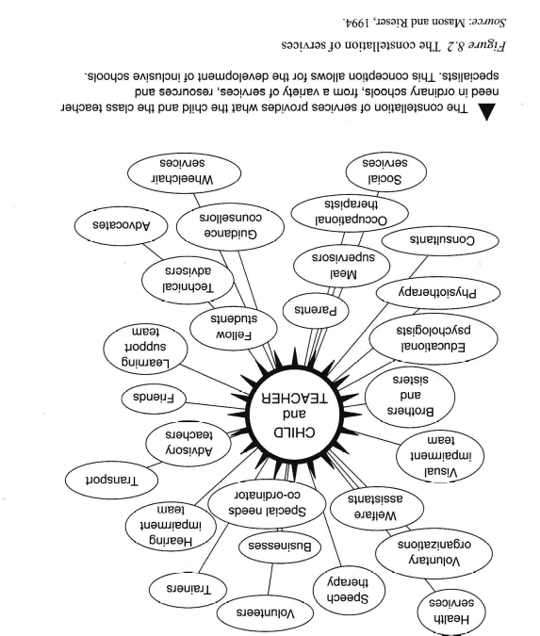
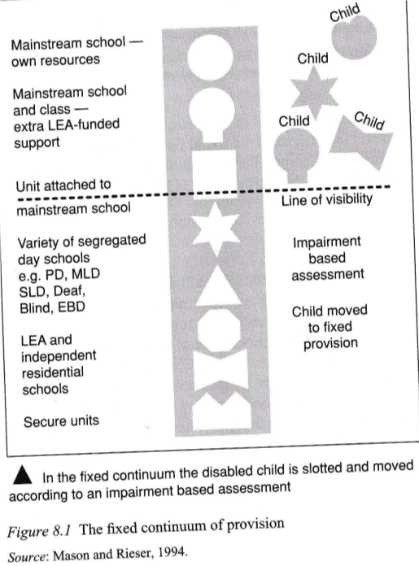
Over many years of struggling for a Rights based approach towards us the Disabled People’s Movement: (your disabled children grown) managed to get the world to shift to adopting thinking developed by us in reaction to negative treatment, discrimination, being treated as objects of charity, often shut away from mainstream society in segregated institutions and school. The reason for such treatment was in part to make us normal through specialist treatment and education and in part out of fear. This barbaric and inhumane treatment did not work in most cases. Instead, the Disabled People’s Movement developed a critique of this medical model as denying us agency, subjecting us to the whims of professionals who do not experience the world as we do and calling their practice scientific. Disabled people supported by allies, who can be parents, community or professionals, through our struggles for equal rights have established that attitudinal, environmental and institutional barriers are our problem and that we are subjects with rights . The Social Model and Human Rights approach requires this transition from Medical to Social Model Thinking.
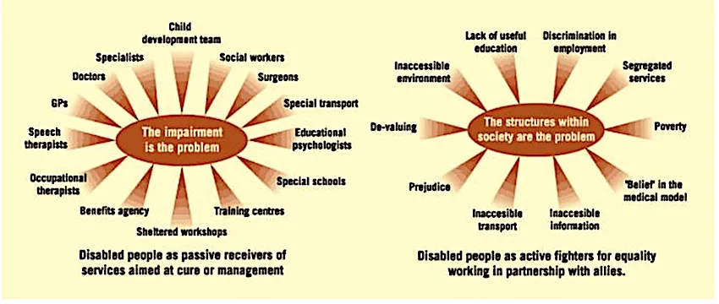
This paradigm shift lies at the heart of the United Nations Convention on the Rights of Persons with Disabilities. The approach was applied to schools by Rieser and Mason that led to the Alliance for Inclusive Education and to a whole range of resources and training by Disability Equality in Education who from 1998 to 2005 were supported by Government Grants.
‘c) Reasonable accommodation of the individual's requirements is provided’;
These will be provided, but they will be limited to those with more commonly occurring needs and conditions. Whereas legally all disabled children and students are entitled to them asap.
‘d) Persons with disabilities receive the support required, within the general education system, to facilitate their effective education’;
Under the White Paper suggestion at the universal level disabled children and young people will receive support but increasingly as they move up from Targeted to Target Plus to Specialist Support, this is increasingly more likely to be in separate rooms and the resource bases, and then as specialist it will specify the provision as alternate provision or special school so mainly not within the general education system (though parents can still express a preference for mainstream, though schools confound this wish by saying they cannot meet need).
‘e) Effective individualized support measures are provided in environments that maximize academic and social development, consistent with the goal of full inclusion’.
The resource bases or units could fit in here but the phrase about maximizing academic and social development can be linked to effective teaching but also intentional building of relations with peers, so those who are placed in these bases do not become socially isolated.
‘3. States Parties shall enable persons with disabilities to learn life and social development skills to facilitate their full and equal participation in education and as members of the community. To this end, States Parties shall take appropriate measures, including:
a) Facilitating the learning of Braille, alternative script, augmentative and alternative modes, means and formats of communication and orientation and mobility skills, and facilitating peer support and mentoring;
b) Facilitating the learning of sign language and the promotion of the linguistic identity of the deaf community;
c) Ensuring that the education of persons, and in particular children, who are blind, deaf or deafblind, is delivered in the most appropriate languages and modes and means of communication for the individual, and in environments which maximize academic and social development’.
As Sign Language is a recognised UK Language every effort needs to be made to provide sign language with a group of signing peers in the mainstream school. Specialist teachers are not mentioned in the White Paper , but the most useful method of developing good inclusive practice is to have centrally employed advisory teachers for inclusion, with expertise for different impairment groups to develop and alter whole school and individual practice.
‘4. In order to help ensure the realization of this right, States Parties shall take appropriate measures to employ teachers, including teachers with disabilities, who are qualified in sign language and/or Braille, and to train professionals and staff who work at all levels of education. Such training shall incorporate disability awareness and the use of appropriate augmentative and alternative modes, means and formats of communication, educational techniques and materials to support persons with disabilities’.
The training mentioned in the White Paper for school staff is all focussed on expertise around meeting different needs. It is also not very useful in changing the ethos of the school to being more inclusive, supportive and responsive to disabled children and students to have disability equality training delivered by trainers with lived experience of the oppression and discrimination disabled people face. It is very important for schools to recruit, train and promote disabled teachers and staff to act as positive role models and create a more disability friendly school welcoming of difference.
‘5. States Parties shall ensure that persons with disabilities are able to access general tertiary education, vocational training, adult education and lifelong learning without discrimination and on an equal basis with others. To this end, States Parties shall ensure that reasonable accommodation is provided to persons with disabilities’.
The proposals on transition may help, but there is a need for different forms of assessment other than GCSEs to enable many more disabled students, more of whom are languishing in the NEET (Not in Employment Education and Training) category. Vocational routes should be opened up much more, especially for disabled students with social emotional and mental health and learning difficulty. Apprenticeships and Job Experience also need to provide for Disabled Students to a much greater extent.
References

1., Rieser and Mason (1989/1992) Disability Equality in the Classroom – A Human Rights Issue.
Richard’s groundbreaking book, commissioned in 1990 by ILEA.
text only Full version (24MB)

2. Mason and Rieser 1994 Altogether Better
Published in association with Comic Relief. A comprehensive resources pack covering the issues surrounding Inclusive Education – aimed at teachers, school governors and others. 56 pages. download pdf

3. R.Rieser 2002 Inclusion in Schools Course Book Disability Equality in Education, Londo2 School Inclusion
Inclusion in Schools course book MS Word text only

