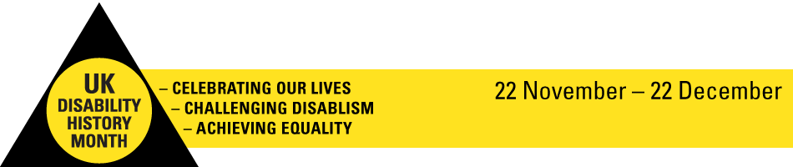

8th May 2018
Dear Friends and colleagues,
UKDHM 2018 Theme: Music and Disability
Thank you for your support last year with our theme Disability and Art. Many events were held and much work was done in schools and colleges around the theme. We collaborated with Shape Arts on the NDACA project producing 4 animations and related activities. We held a well attended conference on the theme, had an exciting launch in Parliament, produced our printed broadsheet and developed online resources featuring more than 60 artists.
In 2018 our theme is Disability and Music. We hope you will support us by spreading the word, organising activities and donating to UKDHM. We want to explore the links between the experience of disablement in a world where the barriers people with impairments face can be overwhelming. Yet the creative impulse and urge for self expression and the need to connect to our fellow human beings often ‘trumps’ the oppression we as disabled people have faced, do face and will face in the future.
Over the next few months we will be developing resources on our website and a broadsheet for the public and students in schools and colleges. These will focus on composers, musicians, singers and performers from Beethoven to Evelyn Glennie, Stevie Wonder to Gurrunul Yunupingu, including Johnnie La Vern Baker, Connie Boswell, Lili Boulanger, Sudha Channdran, Ray Charles, Vic Chesnutt, Judy Collins, Johnnie Crescendo, Ian Curtis, Delius, Ian Drury, John Kelly, Gabriela Lena Frank, Landini, Claire Lewis, Joni Mitchell , Moondog, Mozart, Paganini, Derek Paravicini, Izhak Perlman, Hikari Oe, Ravel, Django Reinhardt, Laurie Rubin, Mik Scarlet, Schumann, George Shearing, Smetana, Tom Wiggins, Hank Williams, Neil Young and many more.
UKDHM will showcase how people with every type and degree of impairment can creatively express themselves through music. UKDHM will interpret the music, lyrics, librettos and performance against social model thinking, hoping to encourage solidarity and support for disabled people’s ongoing struggle for equality.
UKDHM 2018 will launch on Monday 19th November. The Month runs from then to 22nd December 2018. Start organising and planning events and share them so we can publicise report on this website contact our coordinator 02083592855 or rlrieser@gmail.com. www.uhdhm.org
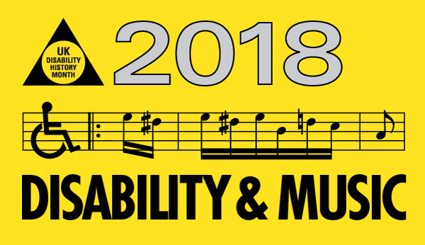
Yours sincerely, Richard Rieser, UK Disability History Coordinator

