More efforts needed to give children with disabilities equal rights to education
Blog -March 15, 2018byEleni Papakosta|
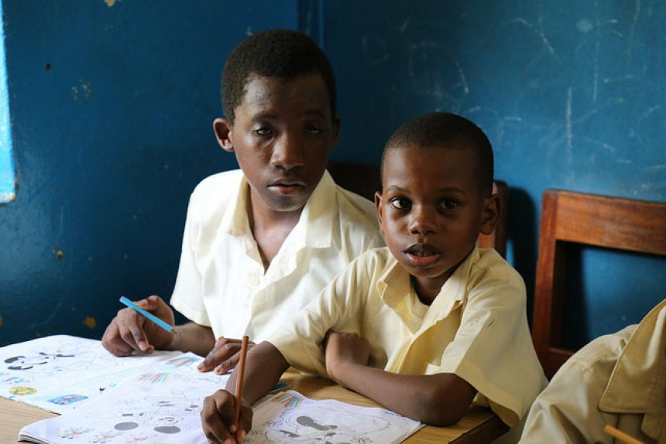
In this classroom, some students with disabilities receive more personalized attention. Kisiwandui primary school. Tanzania.
CREDIT: GPE/Chantal Rigaud
UNESCO estimates that between 93 million and 150 million children live with disabilities worldwide. They are one of the most marginalized and excluded groups of children. They are often overlooked in humanitarian action, due to the limited resources available.
According to UNICEF an estimated 90% of children with disabilities in the developing world are out of school. Even when children with disabilities are enrolled in school, they are often excluded from learning as the curriculum is not adapted to their needs and the teachers do not have the training or time to provide individualized support and learning assistance.
The new GPE stocktake report aims to document the progress made by GPE developing country partners in addressing the needs of children with disabilities in their education sector plans and GPE-funded grants.
We reviewed the education sector plans of 51 countries for this study, as well as the education sector program implementation grants (ESPIG), program documents (PDs), implementation progress reports (IPRs) and education sector analysis (ESAs) where applicable.

How education sector plans address inclusive education
In this study, 30 developing country partners identify improving the quality of learning for all children as a strategic priority in their education sector plans, with specific activities to achieve this objective, including pre-service and in-service teacher training, equipping teachers with better teaching material such as inclusive education toolkits and guidance material, instruction aids like abacuses and audio-visual dictionaries in sign language.
Subscribe to our blog alerts

>

Other activities include measuring learning achievement of children with disabilities enrolled in schools, as well as curriculum development and adaptation to respond to the diverse learning needs of students, and giving teachers the opportunity to adapt lesson plans so all students can participate, learn and succeed. Countries are also exploring the provision of information and communication technology (ICT) in education to reach all children.

Helping teachers and improving access to schools
Supporting teachers and students is vital in promoting inclusion in schools. Specific activities range from training teachers and community workers to screen children for disabilities, to providing children with disabilities with rehabilitation aids and devices, hiring support staff to assist teachers in supporting students with disabilities and creating resource centers for teachers.
Improving access is another strategic priority for 40 developing country partners in this study, with nearly all of them identifying inaccessible school buildings and facilities such as toilets as the main reason why children with disabilities are not enrolled in primary schools.
To address this issue, developing country partners plan to build new schools and special schools or renovate existing schools to make them accessible to children with disabilities.
Additionally, to address the attitudinal barrier children with disabilities face, developing country partners plan to develop communication strategies focusing on awareness raising and sensitization of parents, education stakeholders and communities, of the value of educating children with disabilities.
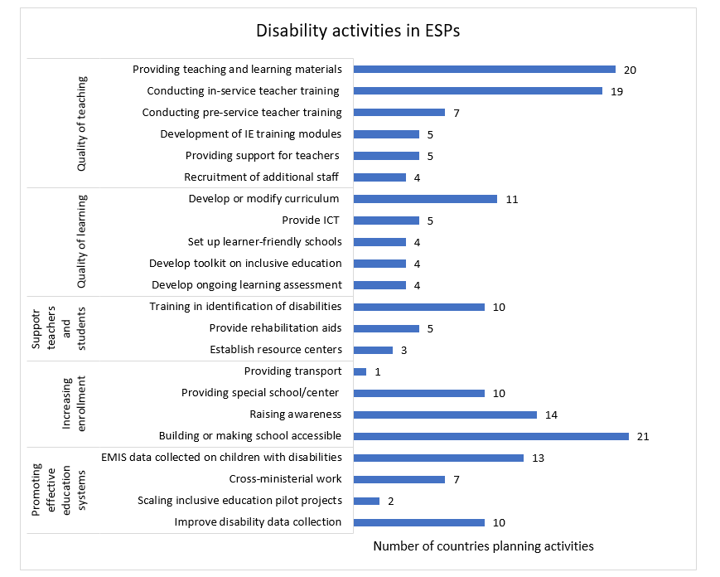
Developing country partners also plan to strengthen their education systems by addressing the educational needs of children with disabilities. Specific activities include improving disability data collection, scaling up inclusive education pilot projects, collecting data on children with disabilities and ensuring effective coordination strategies between the various ministries responsible for supporting children with disabilities.

GPE grants support inclusive education
The study goes back to 2012 and shows that since that year, GPE has provided a total of US$439 million to support the implementation of education sector plans. From that amount US$5.07 million has funded specific activities supporting children with disabilities.
Twelve countries (Cambodia, Comoros, Eritrea, Ethiopia, the Kyrgyz Republic, Lao PDR, Liberia, Nepal, Tajikistan, Tanzania, Uganda, and Zimbabwe) have received grants from GPE to support the education of children with disabilities.
The main activity to address disability and inclusion is providing equipment and learning materials to children with disabilities. Other activities include teacher support and training in special education, raising community awareness, construct new schools and expand current schools for children with disabilities, providing teacher material, early screening to identify children with disabilities as early as possible, establishing resource centers, providing financial aid to students with disabilities, implementing an equity strategy, mainstreaming children with disabilities, conducting pre-enrollment assessments, and providing support to inclusive education centers.
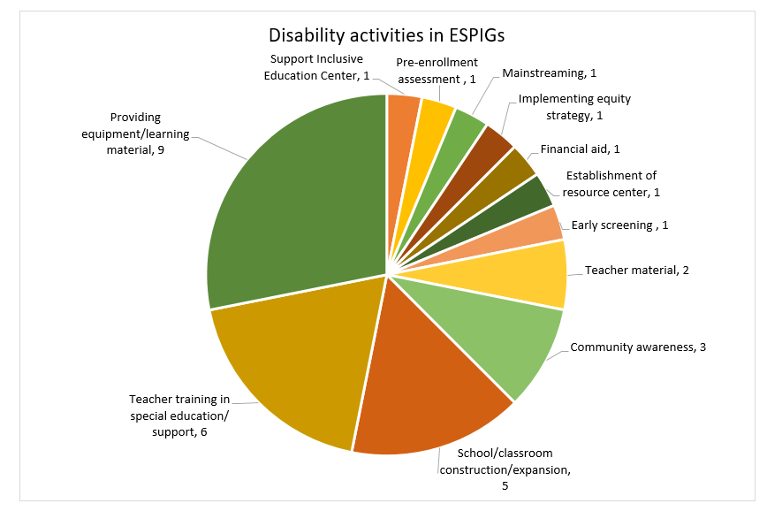

Ensuring children with disabilities can fully participate in society
Inclusive education systems have the power to amplify the voices of children with disabilities so that they can be heard in decisions that affect their lives. Inclusive education systems build on their capabilities, develop their capacities to participate meaningfully in decision making and in social, cultural, and economic life, and ensures they enjoy their full spectrum of rights.
Our report highlights the need to step up support for disability and inclusive education to developing country partners.
We need to improve consideration of issues around disability and inclusion in education sector analysis and sector planning processes to better promote the achievement of GPE 2020 strategic goal 2, and to fulfill the transformative vision of Agenda 2030.
This means ensuring that girls and boys with disabilities are not only able to access their right to a quality education in a nurturing environment, but also, through education, become empowered to participate fully in society, and enjoy full realization of their rights and capabilities.
View all blogs
Areas:Children with Disabilities

Author(s)
Eleni Papakosta
Equity, gender equality and inclusion consultant, Global Partnership for Education
Eleni Papakosta joined the Global Partnership for Education in August 2017 as an equity, gender equality and inclusion consultant, supporting the delivery of goal 2 in the GPE Strategic Plan and providing...

