FINAL REPORT March 2011
A UKDPC Project on Developing the Capacity of Disabled People’s Organisations in the South Pacific Commonwealth Island Countries, with regard to the United Nations Convention on the Rights of Persons with Disabilities, Funded by the Commonwealth Foundation
Report of Training Event held Port Moresby, Papua New Guinea 24th -29th January 2011

World of Inclusion was commissioned by UKDPC to lead on the development and delivery of the project
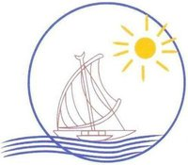

Pacific Disability Forum

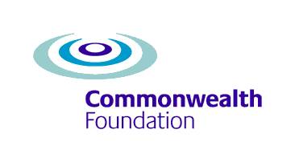
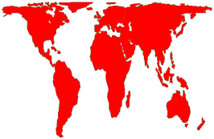
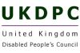
www.World of Inclusion.com Inclusion Ltd

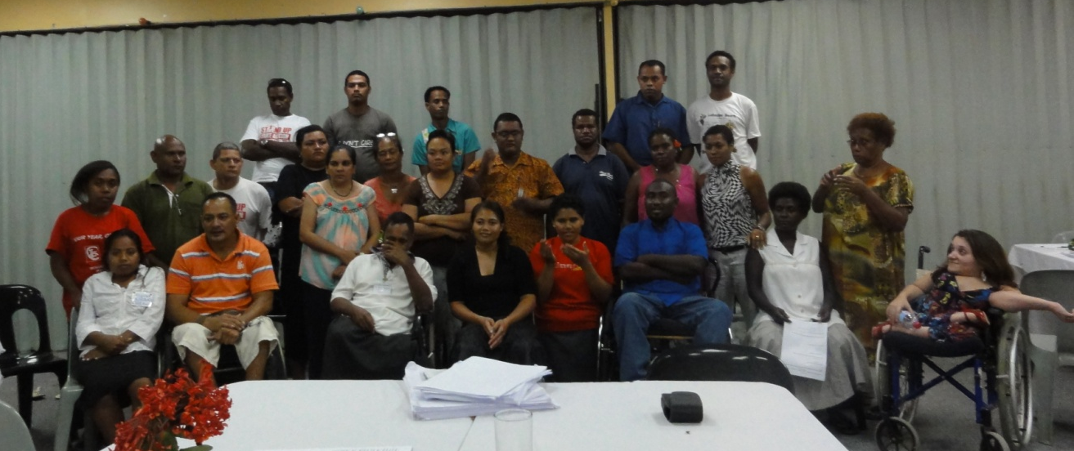

Report Author: Richard Rieser, World of Inclusion
Contents

Introduction p. 3
Accommodation and catering p. 4
Access to the course p. 4
Aims of the training p. 5
Ground Rules p. 5
Aspirations of participants’ p. 6
Traditional views of disability p. 7
The Concept of Human Rights p. 9
Tree of Rights p. 15
The Language We Use p. 17
UNCRPD p. 18
Article 24 Education p. 22
Young people’s session report back p. 25
Women’s Rights Article 6 p. 29
Negotiating for the UNCRPD p. 34
Campaigning for the Convention p. 36
Country Action Plans p. 36
Evaluation of the Course p. 45
Conclusions p. 47
Appendix 1: Programme p. 48
Appendix 2: Participants p. 52
Appendix 3 Participant Photos p. 55

Introduction
The General Objective was to promote the human rights of disabled people in the South Pacific and to undertake activities that would support the implementation of the UN Convention on the Rights of Persons with Disabilities.
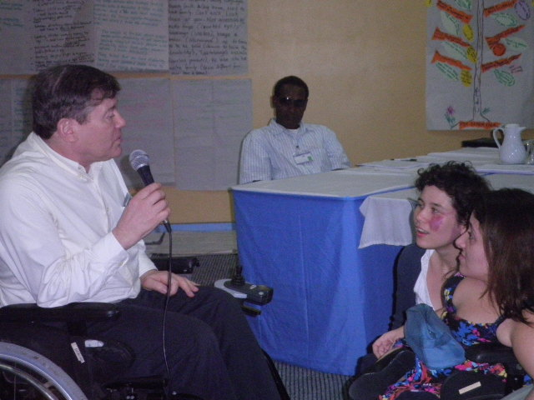
The Commonwealth Foundation awarded a contract to United Kingdom Disabled People’s Council. World of Inclusion was commissioned by UKDPC to lead on the development and delivery of the project, initial contacts, situation analysis, and training materials.
World of Inclusion provided a team of three led by Richard Rieser, an experienced trainer, educationalist and disabled rights advocate who had been a participant in the AD Hoc Committee at the United Nations in New York which drafted the UNCRPD. Lucy Mason, a professional youth worker, trainer and advocate for the rights of young people with disabilities. Moeva Rinaldo, personal assistant, graphic facilitator and young people’s right advocate. All three are disabled people.

Participants were selected from the 8 Commonwealth island countries of the South Pacific. The following were selected for each country two Disabled People’s Organisation leaders and a young leader; also two members from the Pacific Disability Forum, their training coordinator and a youth coordinator, several of the officers of the Papua New Guinea Assembly of Disabled People and three Deaf instructors from a local resource base, two personal assistants from Tuvalu and PNG.
The participating countries in the training were: - Kiribati, Nauru, Papua New Guinea, Samoa, Solomon Islands, Tonga, Tuvalu, and Vanuatu. The Pacific Disability Forum arranged selection of participants and their travel arrangements to and from Port Moresby. See Appendix 1 for a full list of participants.
It was originally envisaged that the project would allow for a follow up phase including start-up funding for young people’s projects. However, the cost of running the course was more than originally estimated and with the permission of the Commonwealth Foundation, the budget had to be re-jigged to just cover the course. However, we have the e-mail addresses of all participants and we aim to maintain on-going contact and advice electronically.

Accommodation and catering

The Papua New Guinea Assembly of Disabled People arranged the hotel booking for accommodation, food, training venue and transport to and from the airport. The accommodation and course were at the Granville Motel-6 miles from the centre of Port Moresby. Participants shared accommodation to reduce costs. The Granville had removed doors and put in temporary ramps to accommodate the four wheelchair users. The standard of the rooms was adequate, but fairly basic and there were problems with cockroaches and rats. Payment also proved time consuming and disruptive, as the hotel did not accept credit cards and wanted cash. In the end PNGADP paid and we reimbursed them.
Every breakfast and evening meal was the same. The lunches were more varied but on the first day there was insufficient food. This improved thereafter. However, there was an overwhelming request from participants to be given the money for their evening meal, rather than eat at the motel. It was decided for Tuesday, Wednesday and Thursday to give everyone 40 kina, evening meal allowance, and the ordered meal was cancelled. On the Friday evening we had a catered party and on the Saturday had a meal at a Chinese Restaurant with the Minister of Social Development. The hotel provided free transport.

The training room was laid out cabaret style with 5-6 tables and a table at the front with LCD projector linked to a lap top and sound system. This was used for PowerPoint and film clips. All walls could be used to display the work of different groups throughout the course. The room was air-conditioned and suited our purposes well. There was a dining area which doubled up as a break out space when the young people’s group withdrew.

Access to the course

All participants received a course book of 128 pages outlining the programme and activities, background material to the UNCRP and a separate booklet of an easy read version and the full version of the Convention. In the course booklet was also a Convention at a glance summary and a simplified version of the UNCRPD. So there were four different versions of the Convention available. This proved invaluable as participants had a very variable competence in English and the differing levels of complexity mean there was something for everyone.

We also produced the course book digitally for those who wanted to read along with all the materials used. (Each country could take back the materials in an accessible format to use as they wished.) Visually impaired participants could access using their lap tops with built in text to speech. We produced large print versions in 16point and 24 point text size for those who needed them. In addition the power point slides were made available for all and in a one slide per page format for the visually impaired. We used audio description of all visuals throughout. We had planned a signer for the one Deaf participant, but the signer who was a Teacher of the Deaf, in PNG, was so impressed with the course that she brought along three Deaf sign users, who were instructors of Deaf children at her Centre. They made a great input. The young person from the PDF was a fluent signer. There was also a blind participant from Tuvalu who did not use Braille and had little English. She had a PA who acted as her interpreter.

The airline had lost the World of Inclusion trainers’ luggage and Richard Rieser’s wheelchair. This caused problems, until it was all delivered after lunchtime on the Monday. We were able to start as we had the programme and PowerPoint on a laptop which we could project and the venue provided flip chart paper and pens.

Aims of the training
- To understand disability as a social oppression, rather than an individual medical or charity issue.
- To understand the Human Rights approach and how this applies to disabled people through UNCRPD.
- To be able to apply the UNCRPD to the full range of situations people with disabilities experience in life.
- To develop the empowerment and skills of leaders of DPOs.
- To develop the empowerment and skills of young disabled people.
- Develop and understand the skills to influence the public, media and government of the need to ratify and implement UNCRPD.
- To understand the importance of an independent disabled people’s movement and the role it plays in monitoring and implementation of the Convention.
Ground Rules
- Keep to time/timetable-appoint a time keeper
- If you do not understand something ask
- Respect each and each other’s access needs
- Support each other
- Only one person speaks at once in group sessions
- Allow others who have not participated in the session to do so
- Keep personal information confidential
- Undertake assignments given
- Challenge the content of what people say, not the person
The ground rules were agreed
Participants
After this each participant introduced themselves to the whole group and identified one barrier they encounter, one outcome they would like by Saturday. Below is a chart of what participants wanted to achieve by Saturday.

Aspirations of participants
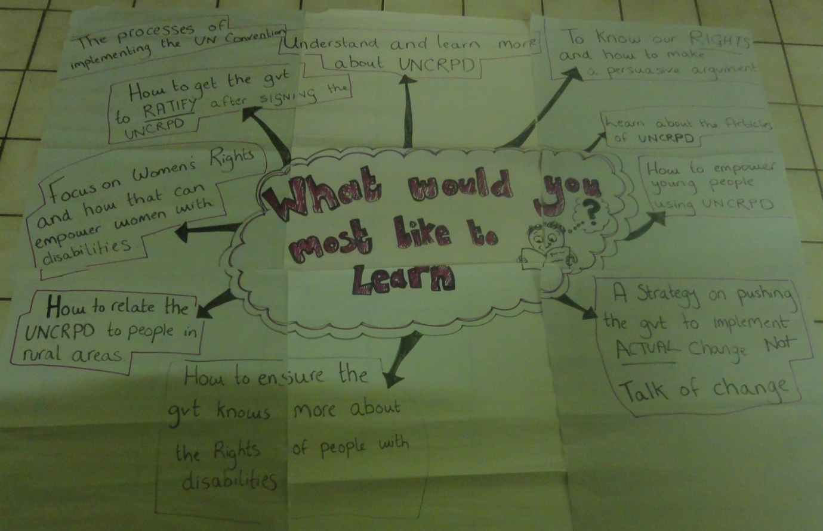

Image of Spider Diagram of what the participants most wanted to learn.

- The process of implementing the UNCRPD
- Understand and learn more about the UNCRPD
- How to get the Government to ratify after signing the UNCRPD
- Focus on Women’s Rights and how that can empower women with disabilities
- How to relate the UNCRPD to people in rural areas
- To know our Rights and how to make a persuasive argument
- Learn about the Articles of the UNCRPD
- How to empower young people using the UNCRPD
- A strategy on pushing Government to implement the actual change, not talk of change
- How to ensure the Government knows more about the rights of people with disabilities.

The programme we had prepared met all of these aspirations, but we decided to have more young people’s sessions and a separate session for men and women. We also developed a role play using a Forum Theatre technique of a negotiation with Government.

Traditional views of disability
After an introduction showing the range of traditional ideas about people with disabilities from around the world, which are predominantly negative, participants worked in groups and wrote down the traditional ideas towards disability and people with disabilities in their culture and country.
- Superstition, magic and belief-not based on a scientific understanding.
- For thousands of years in every culture and society physical and mental differences have been ascribed special meaning.
- This was usually negative and often persists today in stigma, negative attitudes and stereotypes.
- People were thought to be disabled because they or their parents had done something wrong.
- All-powerful gods, deities or fate had made them disabled (karma or sin).
- People with disabilities were often subjected to inhuman treatment.
- Being seen as bringing shame on their families, they were locked away.
- Euthanasia was widely practised on babies born with significant impairments.
- Such children were often abandoned and had to rely on begging to survive.
- It was believed that disabled people brought bad luck because they had been cursed or had had a spell placed upon them by witchcraft.
- We were often viewed as not fully human or possessed by evil spirits.
- This made it easy to make fun of or ridicule us.
- We became the butt of jokes and symbols for all the ills of the world.
- Clowns, court jesters and ‘freak shows’ are illustrations of this.

Participants identified a wide range of ideas in their cultures which are still believed based on magic, culture and superstition. This proved a very fruitful activity and identified things people do not usually talk about, but form the basis of negative attitudes which have to be tackled to bring about human rights for people with disabilities. These included:
- Mental impairment is caused by sorcerers/curses
- Slow development of children- uncaring of parents during pregnancy/during child’s development
- Physical impairment is the person’s own fault
- If they are born with a physical impairment this is because either the parents separated or there is a scandal in the family
- Disability is the fault of a sinful mother
- Breaking the taboo e.g. sleeping/doing something in a taboo place
(Taboo = restricted areas)
- Belief- if pregnant mothers eat reptiles like eel-fish cats, flying fox, their child will become disabled
- Bride price and disability: If one uses the bride price to buy food, the profit becomes a cause of disability
- Wrong marriages causes disability
- Uncivilized (rape people with disabilities)
- Culture sometimes teach that people with disabilities are possessors of evil, ancestral spirit
- Disabled people are bad, leave our families in isolation
- Laugh, teasing, label, discrimination, distance, body language, parents’ fault, a stay at home, not to have family, can’t work, look down at you, not accessible
- Mata tingo (crooked eye) / ta’ea’onga (useless)/ konga e moui (abnormal)/ ne totonu p eke ke petie (deserve to have the disability)/ ta’etokanga matua (careless parents)/ ke kehe atu koe meihe family (you’re different from your brothers and sisters)
- PNG: Disability is caused by witch craft because of jealousy or to pay back for some wrongs done in the past by the family members of a person with disabilities.
- Aia Iango aomata aika toamau ibukiia aomata aika a mwauku a rangi n aki kukurei bwa a na iein ibon ivouia mwauku. Ma Iroura ngaira mwauku ao ti bon kona n tabe ma aron ara katei (The people in Kiribati don’t want people with disability to get married because they think people with disability can’t look after themselves)
- They believe that you have a disability because your parents make sins to god (or do many wrong things)
- Tonga Worshipping Idols bring curse to person
- Disobedience to church
- Parents not followed customs will mean that children will have disability
- Taking born child out at night- will lead to evil spirits cursing it
- Shark worshipping/crocodile worshipping gone wrong will lead to a disability
- Women drinking open cut coconut will lead to her having a facial/mouth deformity
- Cooking a chicken whilst breaking its leg will lead to a physical deformity
- Pregnant mothers should not be allowed to walk alone / or should not eat certain parts of a pig
- Pointing your finger to a grave
- Taking dead bodies out at night without covering the face will cause a disability by the evil spirits.
- Disabled people cannot marry
- Tuvalu: If you do black magic or use magic in the wrong way it will kick back at you, and if not it will hit your kids
- PNG: People believe that you are disabled by angry spirits
- PNG Belief that when someone enters or passes through a sacred site, he or she is disabled
- PNG: Discrimination to people with disability is very common to them (they look down on people with disability)
- Tagata matimii (disabled persons)
- E le fai aiga (can’t marry)
- E le fanau (can’t get birth)
- Matua (parents)
- E ele tatau ona faigaiuega (can’t work)
- Disrespect (ignorant of person with disability)
- Disable person is mad too

The Concept of Human Rights as inalienable, universal, and inherent, demonstrated using the Universal Declaration of Human Rights
This was introduced by an activity looking at Indivisible: human rights cannot be separated from each other; Interdependence: human rights cannot be fully realized without each other and Interrelatedness: human rights affect each other. They had to choose an important human right, look at three important consequences of its denial and then look at how this denial then impacts on other human rights.
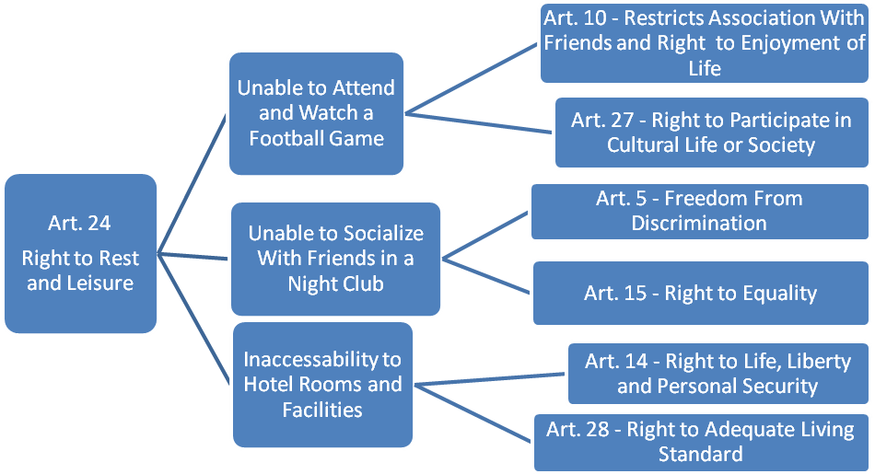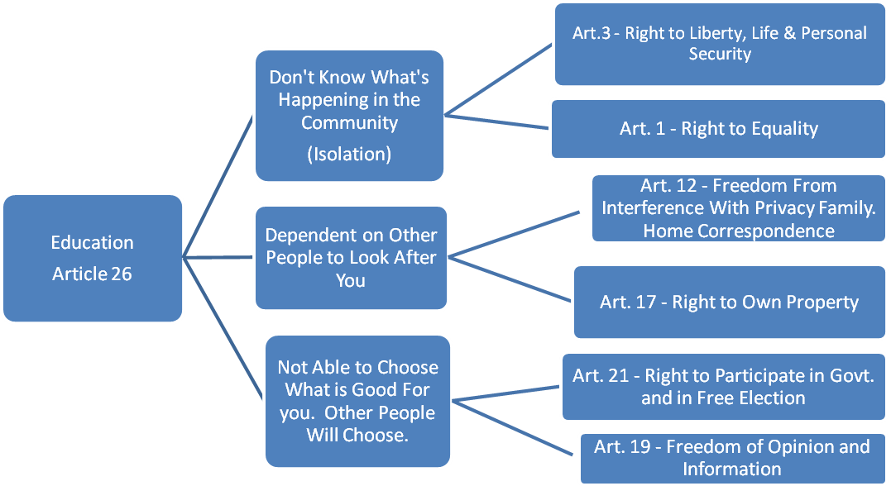

Human Rights Campaign Activity:

In your group take one of 4 scenarios (p. 44-45 course book). Work out how you would build a Human Rights Campaign to end the situation outlined and introduce the relevant part of the UN Convention on the Rights of Persons with Disabilities.

Questions: What you want to change!
What will you do?
Who you will recruit to the campaign?
How will you research and publicise your campaign?
How will you know you have succeeded?
Which parts of UNCRPD would you use?

GROUP | What you want to change! | Who you will recruit to the campaign? | How will you research and publicise your campaign? | What will you do? | How will you know you have succeeded?
GROUP 1 | Our Environment by making Govt. Responsible. | PWDs, NGOs, Churches, CBO Community | Survey – data/report, radio programs, print media workshop, march (peaceful), c/m | Follow through with our campaign until we get what we want. | If you see changes, like authorities respond positively to our campaign.
GROUP 2 | House of PWD to beg, Changes to attitude/Govt. signing/ratify CRPD/ Govt. Social Security improve | Trade Union – Ministry of Health, Family, Village Committee , Social Workers, Media | Arrange visit to beggars (interview)/photos, family members, community | Advocate/employ beggars, print of posters, media articles, join trade union | No more beggars, paid doing productive work, rights are respected, paid employment, join DPO
GROUP 3 | Education system – include disabled children, break attitude | NGO’s, Churches, Schools, PWDs, CBOs, CBR workers | Interview other PWDs, teachers, research existing papers – disabilities, use media, use politicians | Make campaigns – advocate/awareness. | Acceptance of all PWDs, education for everybody if it is ratified. Not ratified – long way to go and not successful.

Barriers, solutions and the UNCRPD
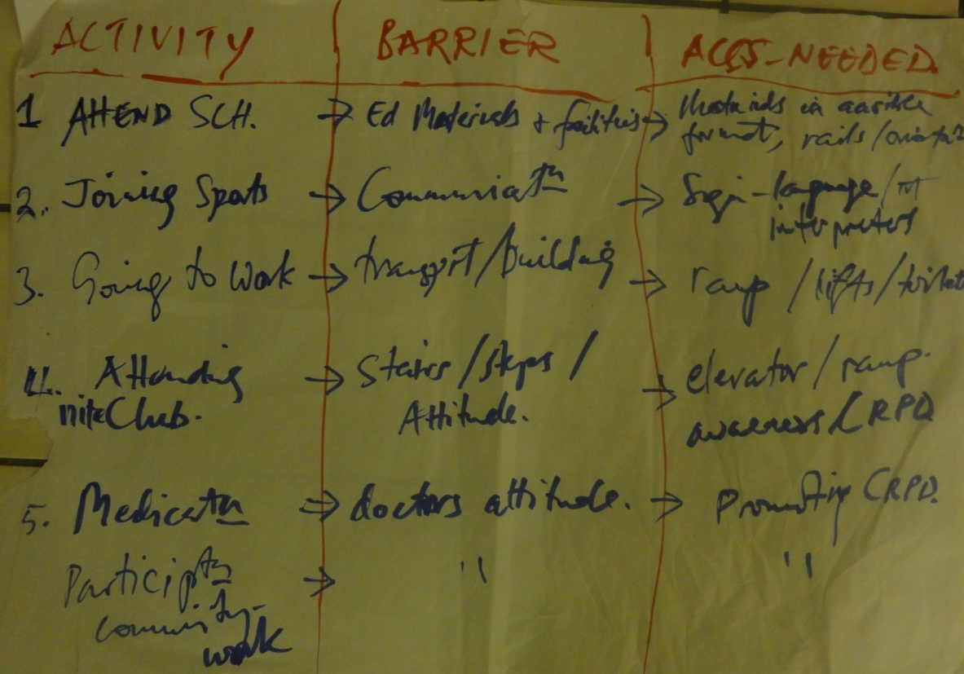
The new view or paradigm of disability central to the UNCRPD is of viewing the problems people with disabilities face as arising from society’s attitudes and practices, which create disabling environments; rather than people with disabilities primarily having problems because of their impairments and needing charity (Medical model). Therefore people with disabilities are disadvantaged because of a denial of their human rights. Therefore, a key component of understanding and implementing the UN Convention on the Rights of People with Disabilities is to identify barriers in all areas and find solutions.

Image 1 of chart on Activity/Barriers and Access needed

Activity | Barrier | Access Needed
Attending School | Educational materials and facilities | Materials in alternative format, rails
Joining in Sports activities | Communication | Sign-Language/not interpreters
Going to Work | Transport/Building | Ramp/Lifts/toilets
Attending night clubs | Steps/Attitudes | Elevator/Ramp/awareness on UNCRPD
Medication | Doctors attitudes | Promoting CRPD
Participation in community work | Peoples attitudes | Promoting CRPD

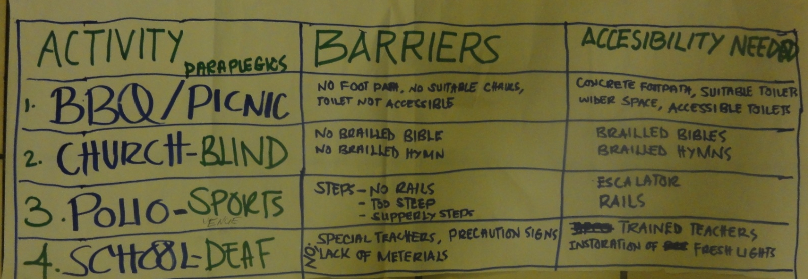
Image 2 of chart on Activity/Barriers and Access needed

Activity | Barriers | Accessibility Needed
- BBQ/Picnic | No foot path, no suitable chairs, toilet not accessible | Concrete Footpath, Suitable toilets with wider space, accessible toilets
- Church- Blind | No Brailed Bible, No brailed hymn | Brailed Bibles, Brailed hymns
- Polio- Sports | Steps- no rails, too steep, slippery steps | Escalator, Rails
- School- Deaf | Special Teachers, Precautionary signs, Lack of materials | Trained teachers, installation of fresh lights

Then we carried out activities where the different barriers had to be linked to rights in the Convention of Human Rights and the UNCRPD
- A Traditional View and 2) Barriers Identified. For each one, identify the article(s) of the UNCRPD that you can use to challenges it. How will this be a solution in your country?

Barrier | Solution | UNCRPD Article to use
E.g. Lack of accessible public transport/buildings | Transport plan and infra- structure investment that is based on access and universal design principles | Article 9 Accessibility  Article 2 Definitions  Universal Design

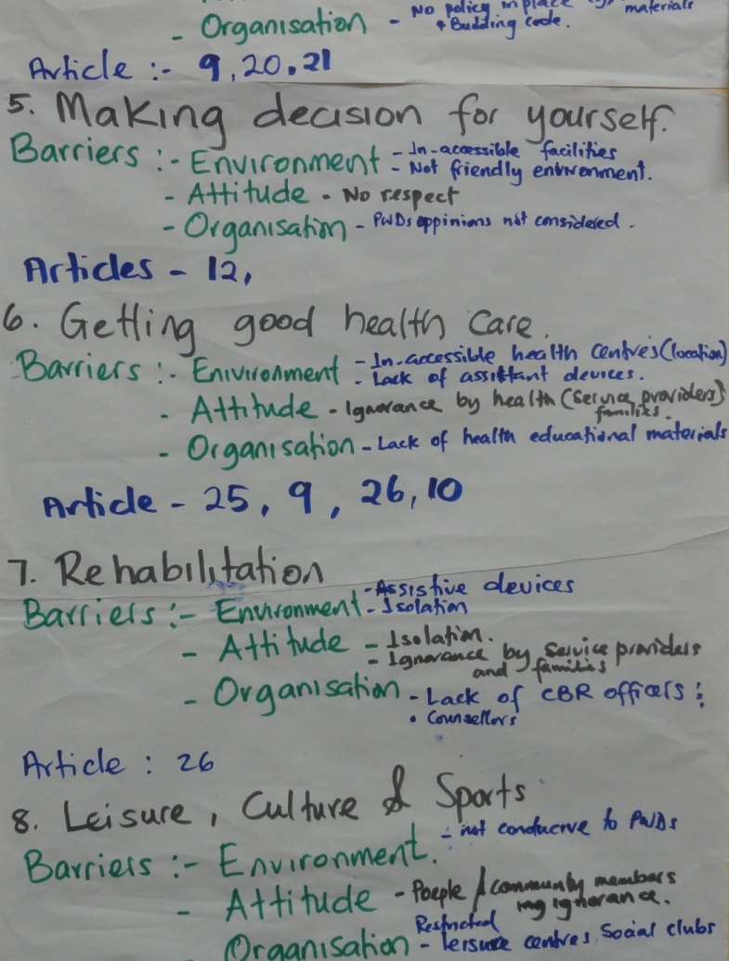
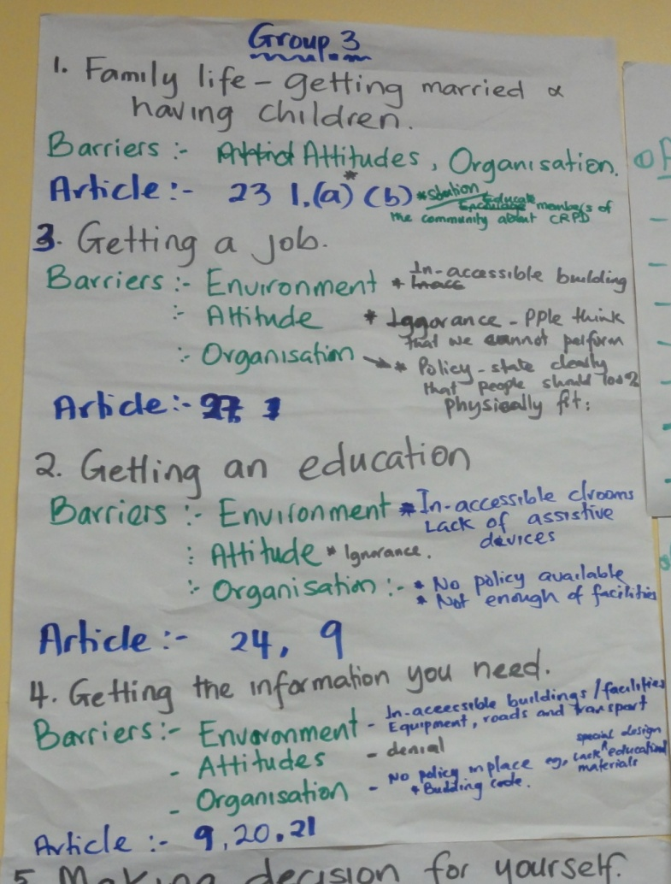
Group 3:
- Family Life: getting married and having children

The Barriers: Attitudes, Organisations
UNCRPD Article to use: 23 1. (a) (b)
- Getting a job

Barriers: Environmental: Inaccessible building
Attitude: Ignorance- people think that we cannot perform
Organisation: Policy state clearly that people should be 100% fit
UNCRPD Article to use: Article: 27
- Getting an Education:

Barriers: Environment: Inaccessible classrooms/lack of assistive devices Attitude: Ignorance
Organisation: No policy available, not enough facilities
UNCRPD Article to use: Article 24, 9
- Getting the information you need:
Barriers: Environment: Inaccessible buildings, facilities, roads, equipment and transport
Attitudes: Denial
Organisation: No policy in place e.g. lack of especially designed educational materials, building code

UNCRPD Article to use: Article 9, 20, 21

- Getting hood health care:
Barriers: Environment: Inaccessible health centres (location)
Attitude: Ignorance by health (service providers, families)
Organisation: Lack of health educational materials
UNCRPD Article to use: Article 25, 9, 26, 10
- Rehabilitation:
Barriers: Environment: Assistive devices, isolation
Attitude: Isolation/ignorance by service providers and families
Organisation: Lack of CBR officers, counsellors
UNCRPD Article to use: Article 26
- Leisure, Culture and sports:
Barriers: Environment: Not conducive to people with disabilities,
Attitudes: People/community members/ignorance
Organisations: Restricted leisure centres, social clubs
UNCRPD Article to use: Article 30

Country Convention Profile: Which Countries have Signed or Ratified

Country | Convention Instrument | Signed | Ratified
Kiribati | CEDAW  CRC |  | 17TH March 2004 a  11th December 1995 a
Nauru | CRC  CAT | 12 November 2001 | 27 July 1994 a
Papua New Guinea | CEDAW  CRC  CERD  CESCR  ICCPR | 30 September 1990 | 12th January 1995 a  2nd March 1993  27th January 1982 a  21st July 2008 a  21st July 2008 a
Samoa | CEDAW  CRC  ICCPR | 30th September 1990 | 25th September 1992 a  29th November 1994  15TH February 2008 a
Solomon Islands | CEDAW  CRC  CERD  CESCR |  | 6TH May 2002 a  10th April 1995 a  17th March 1982 d  17th March 1982 d
Tonga | CRC  CERD  CRPD | 15th November 2007 | 6th November 1995 a  16TH February 1972 a
Tuvalu | CEDAW  CRC |  | 6TH October 1999 a  22ND September 1995 a
Vanuatu | CEDAW  CRC  ICCPR  CRPD | 30th September 1990  29th November 2007  17th May 2007 | 8TH September 1995  7th July 1993  21st November 2008  23rd October 2008

Tree of Rights:
We carried out a very popular activity in groups linking the different articles of the UNCRPD, called the Tree of Rights. Each group had a tree trunk drawn on a sheet of flip chart paper. They were given 10 branches, 10 leaves and 10 fruits. The group had to select 10 articles from the UNCRPD and then on each branch attach a leaf saying what the Government must do to implement that right and one fruit that would be of benefit to people with disabilities.

Tree of Rights
ART. 23 – RESPECT FOR THE HOME AND THE FAMILY
ART. 25 - HEALTH
GROUP 1
Protect the rights of PWDs to marry and have children. To provide extra support for PWDs if necessary.

Ensure to provide equal health services to PWD’s.
PWD’s must have quality health care.
PWD’s received quality health. Access to information on sexual reproduction health.

ART. 6 – WOMEN WITH DISABILITIES
ART. 7 – CHILDREN WITH DISABILITIES
WWD will enjoy life safely in their communities with equal access to services.
Ensure that WWD have to share rights and services available to others.

Ensure that the voices of children with disabilities are heard. Children with disabilities have the same rights as others

ART. 9 - ACCESSIBILITY
ART. 10 – RIGHT TO ENJOYMENT OF LIFE
PWDs will find work
Move around freely
Access to information

Ensure that buildings and transport are accessible to everyone.
Change laws to protect and promote PWDs rights.

ART. 19 – LIVING INDEPENDENTLY AND BEING INCLUDED IN THE COMMUNITY
ART. 15 – FREEDOM FROM TORTURE OR CRUEL INHUMAN AND DEGRADING TREATMENT AND PUNISHMENT

Happy, Self reliant, Have their own homes.
Reuse building code, Accessible facilities and services.
Equality before the law
Equal law, treatment before the law
ART. 24 - EDUCATION
ART. 16 – FREEDOM FROM EXPLOITATION, VIOLENCE AND ABUSE.
Trained teacher, materials accessible, accessible school
Inclusive education, children go to school, Find jobs, have family.
Take appropriate measures to stop violence against PWDs in homes, communities and institutions.
Safe communities, no violence

The Language We Use
This was another activity which yielded a rich discussion. Participants in groups write all the words they can think of in their country’s culture to describe people with disabilities. Then they identify the words that might be thought of as positive. There were very few. This was used to reinforce the need for an attitude and paradigm shift.

- Tag
- Mataki –Visually Impaired (Kiribati)
- Gugu- Mute
- Bonetainga –Hearing Impaired (Kiribati)
- Those Katoatoa –Disability People (Tuvalu)
- Pipili-wheelchair person (Samoa)
- Vale –Mental (Samoa)
- Pamponung- Cripple Man (Papua New Guinea) -sick People ( Samoa)
- Tagata mamoi-sick people (Samoa)
- Alonga –slow learner
- Fakasesele –mad or crazy
- Mat a fingo- crooked eye
- Fakamalaia-cursed
- Mane taa- no good man
- Snake-crawling man
- Mata sad-bad eye (Vanuatu)
- Lama Kola-crooked hands
- Palo Sad- crippled legs
- Peru Raga-Deaf
- Kodo-Bad
- Ny Bien- Mentally Ill
- Lialia-Mad/Lesu mai St Giles (Fiji)
- Mataboko- Can’t See/Blind
- Galu/ Didivava-Deaf /Hearing Problem
- Lokiloki/Crippled-Physically Impaired
- Toaran Rabwatam- Sick People
- Ny Mane rodo-Can’t see / blind
- Korusu- Amputee
- Tsagata mai-sick people
- Biru-Deaf
- Ebon-Deaf/y (Nauran)
- Tino fakavalevale-Stupid People (Tuvalu)
- Tino Se Katoatoa –People with disabilities (Tuvalu)
- Kronkron Pirpir –Cripple –(Nauruan)
- Dukuron-Partially retarded (Nauruan)
- Ea nomar-Mentally retarded (Nauruan)
- Eko mwen –Blind (Nauru)
- Tutuli-Deaf ( Nauru)
- Tiabora-shovel leg
- Crab
- Cripple
- Leg Krungut-deformed/twisted leg
- Eye pas-blind
- Hed paul-mentally affected
- Emok Emok-Disabled, Helpless, Hopeless, Blind, Deaf
- Idukarang- Mental, Sick in Da Head, Abnormal

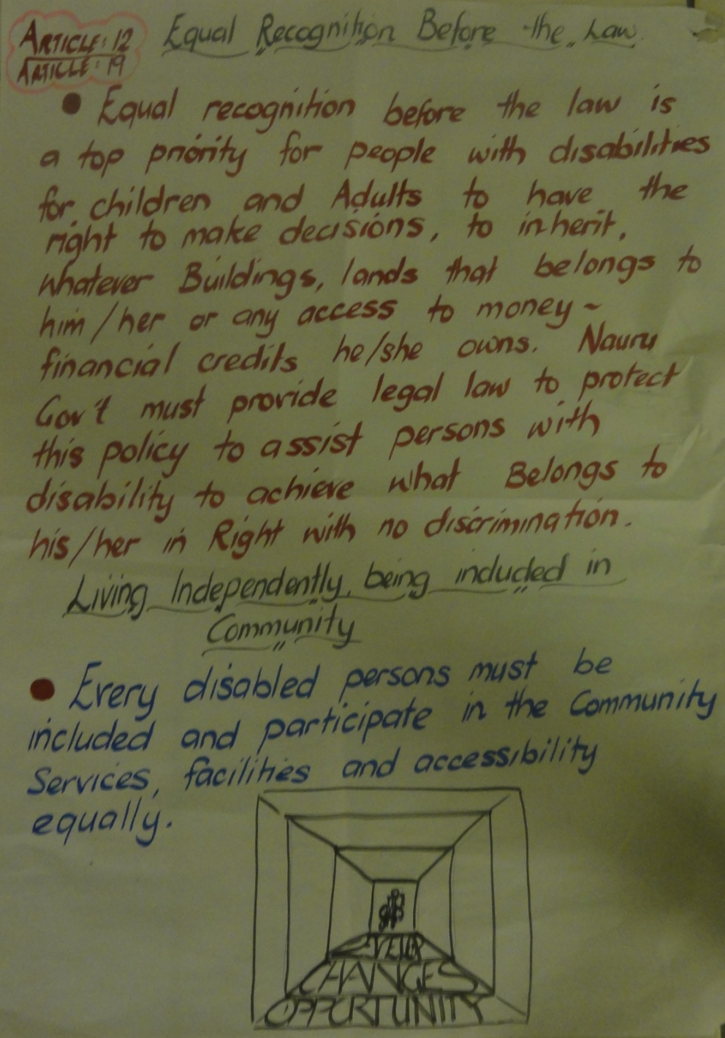
The Convention in our own words: The next two days were spent going over the structure of the Convention and the meaning of the Articles. One of the most popular activities was working in groups on the different articles of the UNCRPD, putting the rights contained into their own words and then giving a presentation to the whole group.
Article 12: Equal Recognition before the Law
- Equal recognition before the law is a top priority for people with disabilities for children and Adults to have the right to make decisions, to inherit, whatever buildings, lands that belongs to him/her or any access to money-financial credits he/she owns. Nauru Government must provide legal law to protect this policy to assist persons with disabilities to achieve what Belongs to his/her in Right with no discrimination.
Article 19: Living Independently, being included in community
- Every disabled person must be included and participate in the community services, facilities and accessibility equally

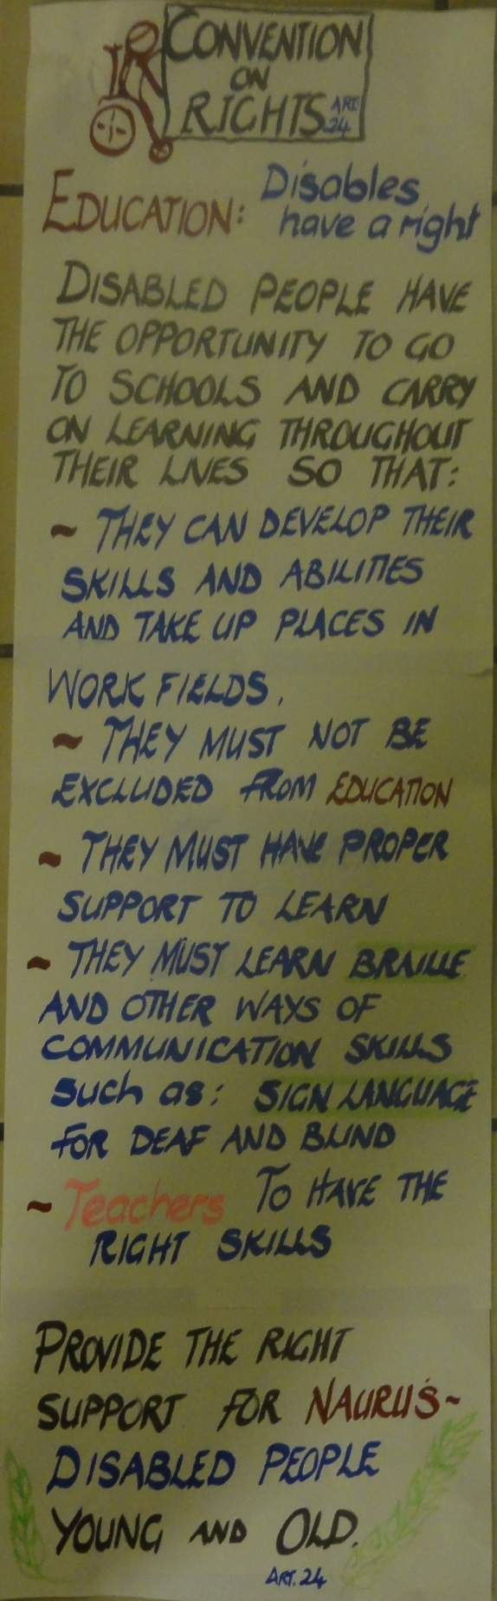

Convention on Rights of Disabled People:
Education: Disabled people have a Right.
Disabled have the opportunity to go to schools and carry on learning throughout their lives so that:
- They can develop their sills and abilities and take up laces in work fields
- They must not be excluded from Education
- They must have proper support to learn
- They must Learn Braille and other ways of communication skills such as Sign language for Deaf and Blind
- Teachers- To have the Right skills
Provide the Right support for Nauru’s- Disabled People Young and Old
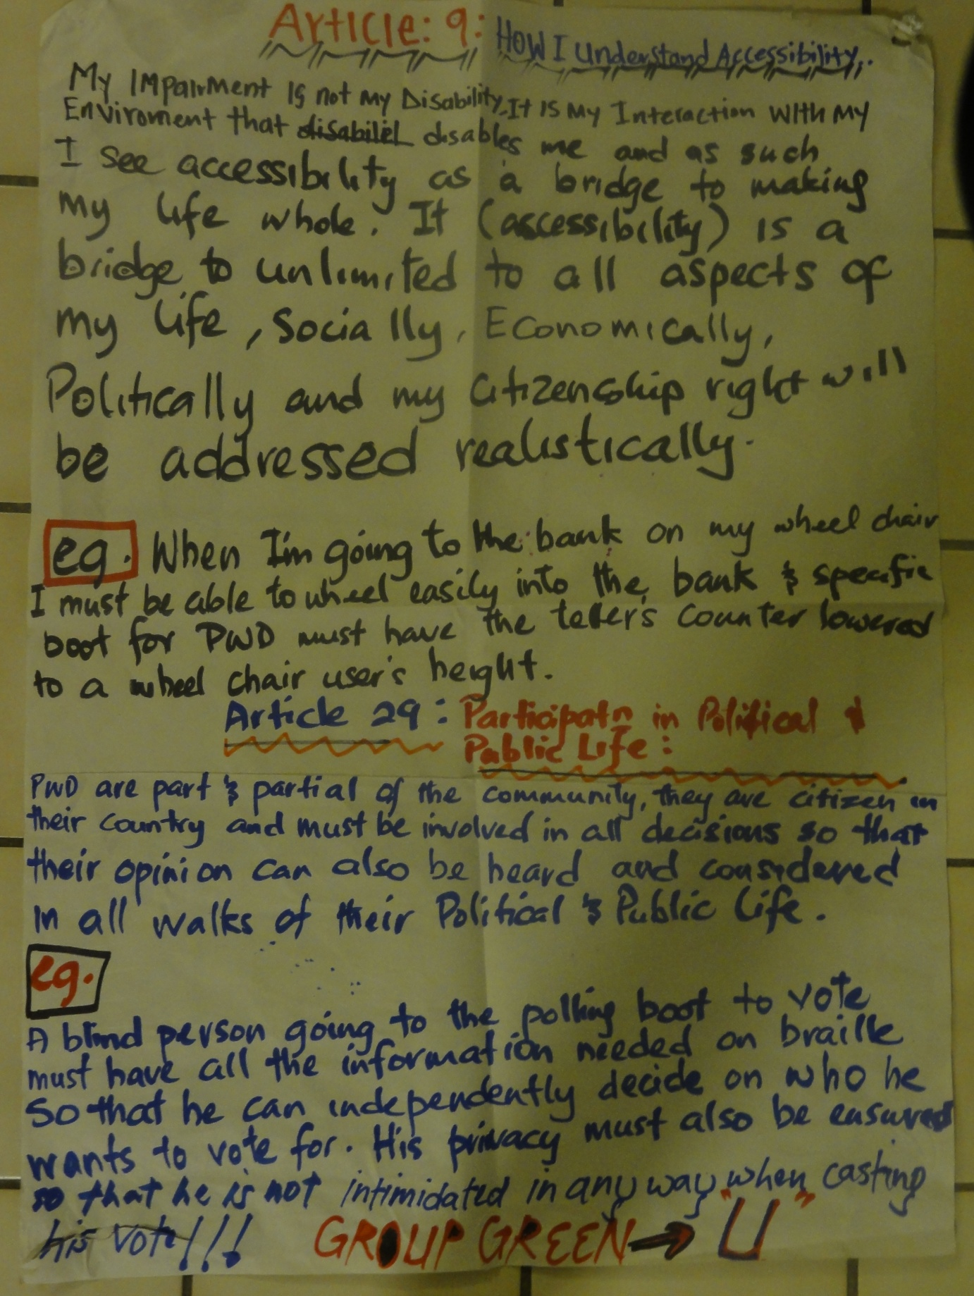

Article 9: How I understand Accessibility
My Impairment is not my disability. It is my interaction with my environment that disabled me and as such I see accessibility as a bridge to making my life whole. It (Accessibility) is a bridge unlimited to all aspects of my life, socially, economically, politically and my citizenship right will be addressed realistically.
E.g. When I’m going to the bank on my wheelchair, I must be able to wheel easily into the bank and specific booths for PWD must have the counter lowered to a wheelchair user’s height.
Article 29: Participation in Political and Public Life:
PWDs are part and partial of the community, they are citizens in their country and must be involved in all decisions so that their opinion can also be heard and considered in all walks of their political and public life.
E.g. A blind person going to the polling booth to vote must have all the information needed on Braille so that he can independently decide on who he wants to vote for. His privacy must also be ensured so that he is not intimidated in any way when casting his vote.

Another method employed was to consider the article and then make a poster or leaflet explaining the important parts and its impact on the lives of people with disabilities.
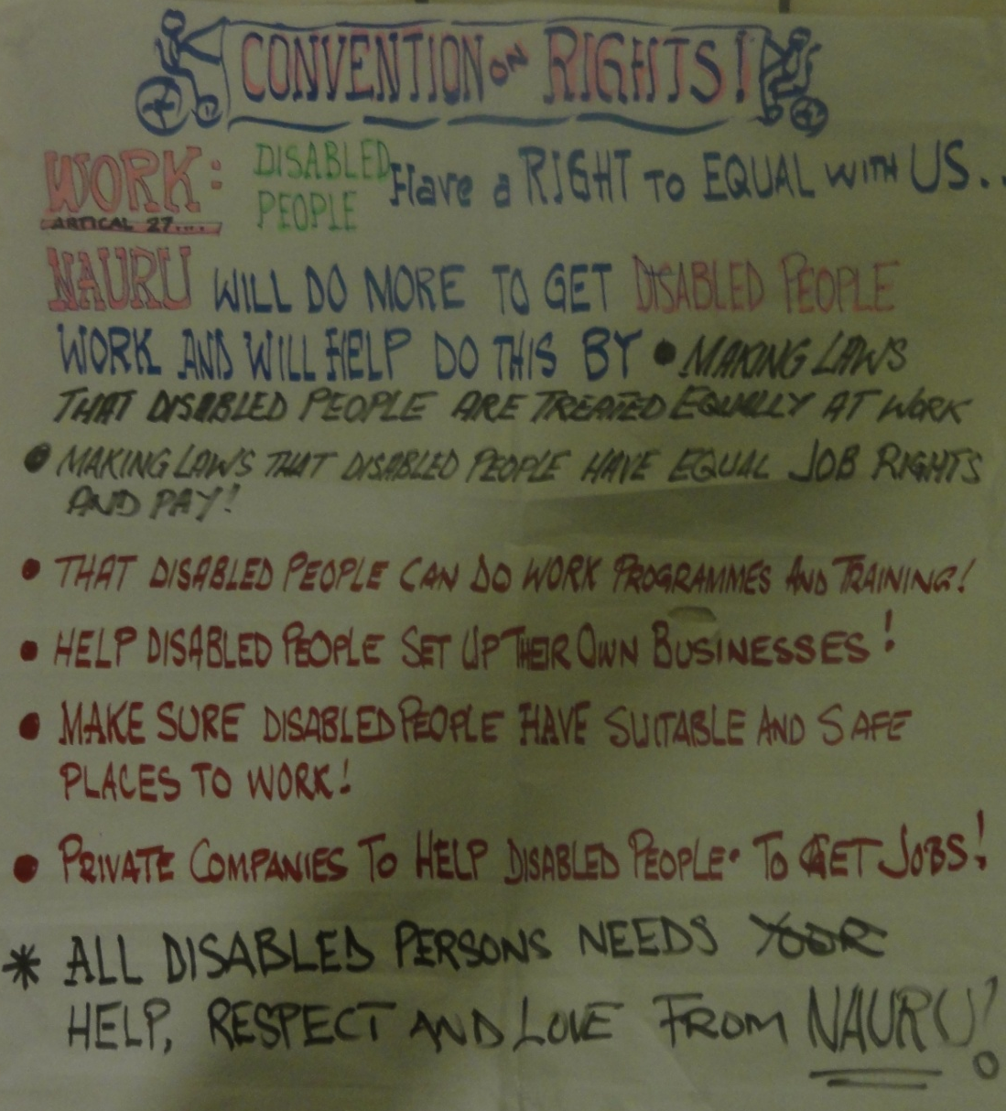
Convention on Rights!
Work: Disabled People- Have a Right to Equal with Us
Nauru: Will do more to get Disabled People in work and will help to do this by
- Making laws that disabled people are treated equally at work
- Making laws that disabled people have equal job rights and pay!
- That Disabled people can do work programmes and training!
- Help disabled people set up their own Businesses!
- Make sure disabled people have suitable and safe places to work!
- Private companies to help disabled people to get jobs
- All disabled persons need your help, respect and Love from Nauru

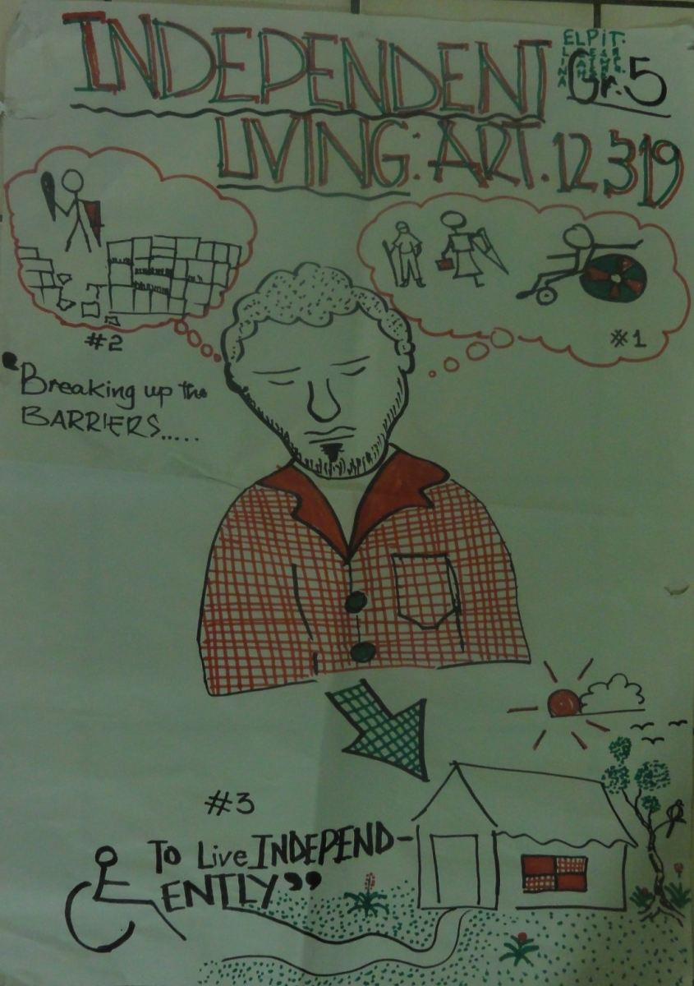
Poster on Independent Living: Article 12 and 19
Blind man in the middle with three thought bubbles coming from his head
Thought bubble one: Child living with their family
Thought bubble two: Child breaking a brick wall symbolising breaking the barriers
Thought bubble three: Wheelchair user sitting outside their own house, living independently.

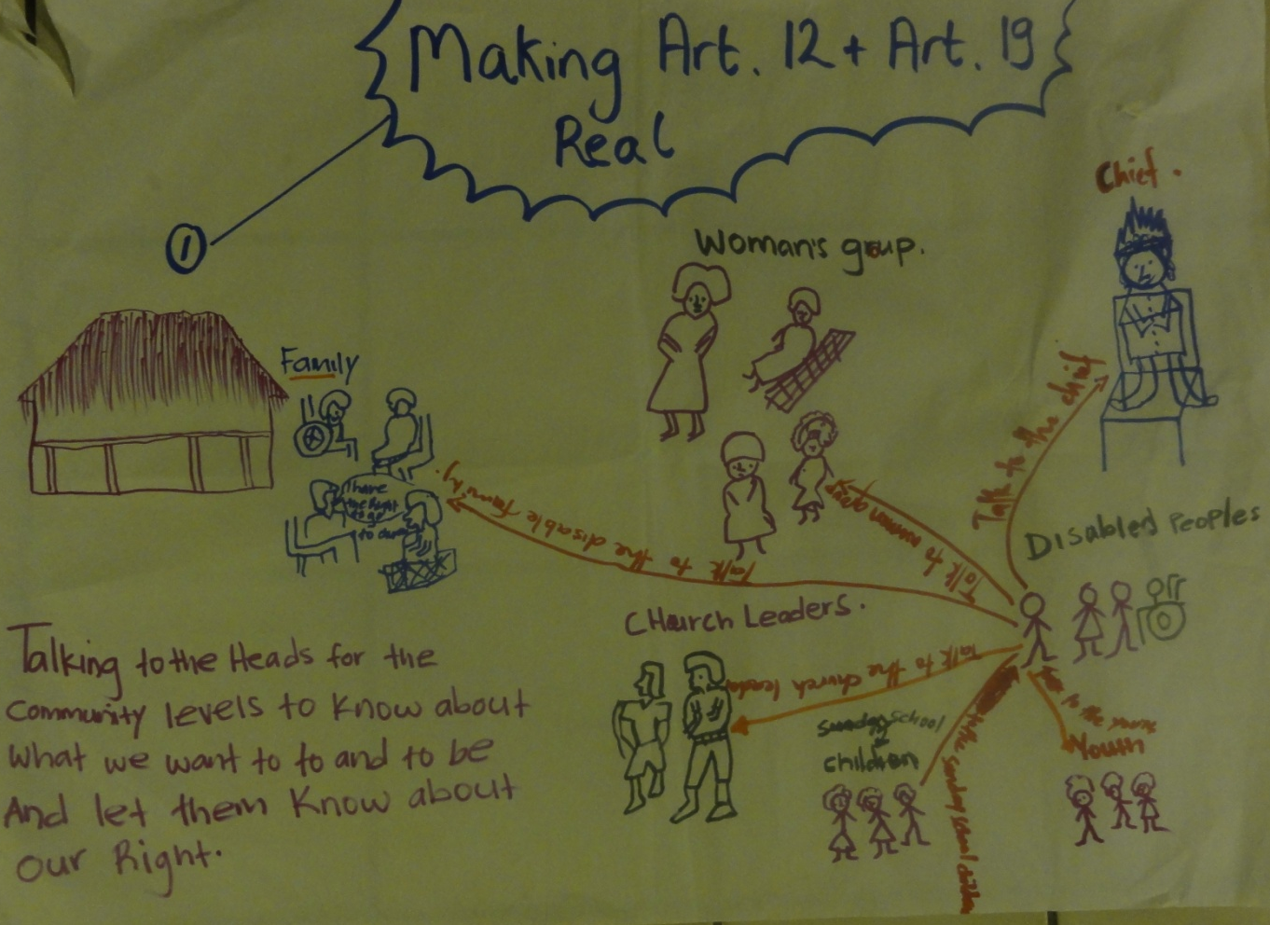

Poster for making Article 12 and Article 19 Real
A Drawing of a group of people with disabilities surrounded by several different groups of people. Each group represents a different member of a community that people with disabilities should make contact with in order to ensure that their Right is respected. The different groups are: Woman’s group, The Family, Church leaders, School children, Young People, and the Chief.
“Talking to the heads of the community, to know about what we want to do and to be and let them know about our Right”

Article 24 Education
Work on this article proved popular. An explanation of the differences between segregation, integration and inclusion with a related activity were of interest. Film clips of inclusive practice in Africa, Mumbai and the UK generated much discussion. Participants worked in groups to identify barriers and find solutions to including disabled pupils in mainstream schools.
Summary Sheet of Barriers
Environment
- Transport far from home
- No access (Steps)
- Blackboard
- Facilities
- Remoteness of residents
- No interpreters
- Poor road conditions
- Boat

Organisation, Teaching &Curriculum
- No accessible materials
- Standard print text (in accessible print)
- Facilities
- Lack of understanding
- Poor communication
- No flexible/alternative curriculum
- Teachers attitude
- No inclusive system

Attitudes & Culture
- Teachers attitude
- Making fun
- Teasing/Bullying
- Parents attitude – girls or disabled children should stay home
- Community perceptions
- Not deserve to go to school
- Useless
- Curse
- Ashamed
- Low self-esteem
- No sense of humour

Medical, Personal & Equipment Needs
- Space for medical care
- Mattress/cushion not available
- Poor service
- Accessible bathroom/toilet
- Poor hygiene
- No picture/signs to direct you

SOLUTIONS: Accessible toilet, extra student pick-up on way, accessible modifications to school building, establish local school, train sign language, employment offered for parents, CRPD campaign, accessible materials, training teachers on Inclusive Ed, create new curriculum, allocate rooms for private need, modify bathroom, provide signage posters, etc.

Barriers of Environment
- Road – direction/signs, information,
- Provide transport, facilities,
- Buildings – Get supporters/personal assistance/build accessible ramps/toilets, etc.
- Lack of Rest Rooms
- Transportation (used only for disabled student)
- Uncared
- To make Govt. aware of ‘Inclusive for All’, to rebuild proper toilets, benches, etc. for the schools
- No accessibility to school
- No ramps
- No accessible bathrooms/toilets
- Lack of provision of visual direction to deaf students to find their way in school buildings
- Lack of interpreters on schools
- Friends do not understand our needs

Solutions to Barriers of Environment:

- More visual signs to be erected or made around the building/ Deaf students teaching sign language to others/ Request Ministry to have a sign language interpreter’s course, create a buddy system.
- Make accessible school. Make ramps for wheelchairs, build bridge
- Ramps, Accessible toilets, Signboards for the deaf , Talking clock
- Accessible toilet, extra student pick-up on way, accessible modifications to school
- building, establish local school, train sign language, employment offered for parents,
- CRPD campaign, accessible materials, training teachers on inclusive ed., create new curriculum,
- Allocate rooms for private need, modify bathroom, provide signage posters, etc.

Barriers Attitudes & Culture
- Teachers attitude
- Making fun
- Teasing/Bullying
- Parents attitude – girls or disabled children should stay home
- Community perceptions
- Not deserve to go to school
- Useless
- Curse
- Ashamed
- Low self-esteem
- No sense of humour
- No need to be educated
- Mocking, teasing, laughed at
- Saying names
- Respect for others
- Discrimination for girls
- No family support
- Lack of funds
- Parents leaving deaf children in special schools
- Lack of support from parents and community because of lack of understanding of deaf culture
- Feeling pity for the person
- Parents, family members find it difficult to understand sign language

Solutions to Barriers, Attitudes & Culture

- Training in Community, Show respect and patience, Talk to family, community, men/boys, Apply to Govt. for aid/NGO’s
- Respect and Inclusive
- Make awareness on UNCRPD to schools, public or specific areas. Go to the champions to advocate plans
- Accessible toilet, extra student pick-up on way, accessible modifications to school building, establish local school, train sign language, allocate rooms for private need, modify bathroom, provide signage posters, etc.

Organisation, Teaching &Curriculum
- Small print/school rules
- High tables and chairs
- No specially trained teachers
- No use of Braille
- No Sign language teacher
- No Large print
- No Simple text
- No Picture text
- Provision of visual learning materials, e.g. Pictures for deaf students
- Lack of specialised teachers for deaf students
- No accessible materials
- No Standard print text (in accessible print)
- Facilities
- Lack of understanding
- Poor communication
- No flexible/alternative curriculum
- Teachers attitude
- No inclusive system

Solutions to Barriers in Organisations, Teaching & Curriculum
- Recruit special teachers, Brailed Syllabus, Large prints, Speaking Software
- Request teachers to provide more visual materials for deaf
- employment offered for parents, CRPD campaign, create accessible materials, training teachers on inclusive education , create new curriculum
- Put in group to work together, Go to Minister of Education to provide, Train teachers to speak sign language
- Make campaign to the National Government and the School Management

Solutions to Medical, Personal & Equipment Needs
- Request Government Ministry responsible to provide audiometers, Provision of training on the use of equipment, Have early intervention programs for deaf children
- Make campaign to the Government for more improved equipment
- Provide specific equipment for specific impairments or needs which cannot be demonstrated by a trained physician.

Medical, Personal & Equipment Needs
- No Braille
- No laptops
- No Braille machines
- No Magnifying glasses
- No Braille prints
- No fire extinguishers
- No Medical kits
- No changing rooms (divide room with curtains
- No wheelchairs – service provider, find person to help
- No repairs
- No hearing aids
- No funds for the teacher
- No Provision of audiometers for teachers to assess deaf children

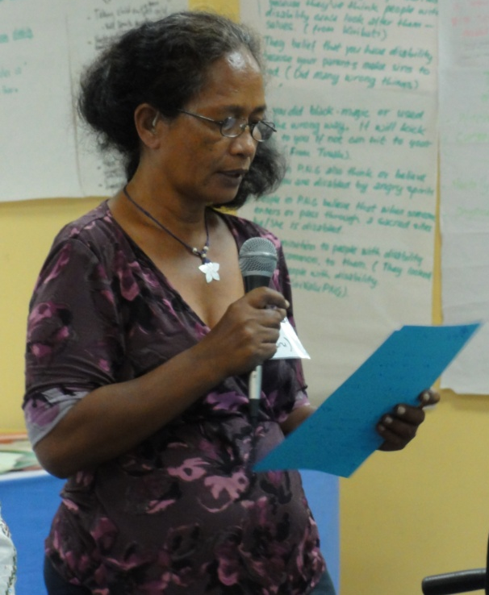
- No

Young people’s session report back
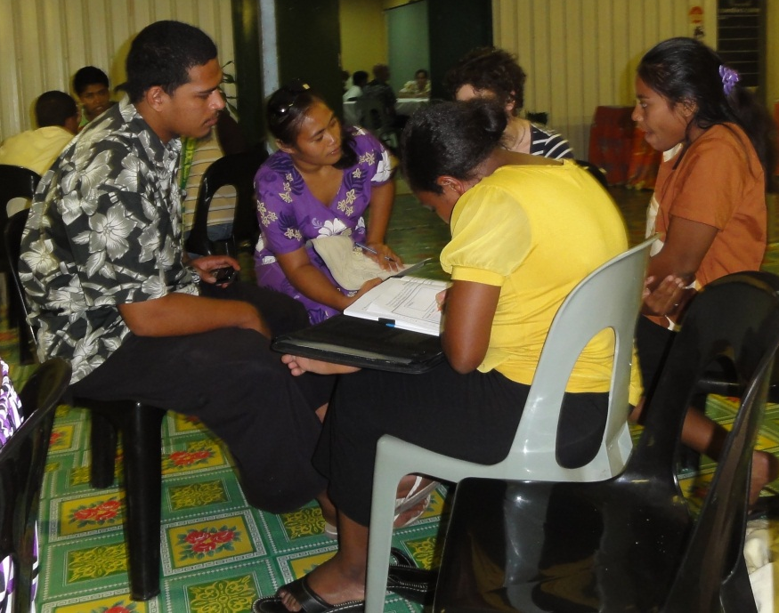
During the UNCRPD training workshop young people with disabilities (ypd) were invited to meet as a group to look specifically at the barriers faced by ypd, in the Pacific Region. The aim was to describe the economic and social context that ypd from this region typically live in. To identify the barriers ypd face to becoming leaders within firstly DPOs and secondly to becoming decision makers in the wider community. We aimed to increase the level of understanding of the UNCRPD within the group, concentrating on the articles most relevant to young people. Activities were delivered, designed to show how to practically use the convention, when organising for change.
We aimed to share good practice models of participation work between the eight countries represented, through skill sharing activities. This led us on to illustrating the hopes and aspirations of ypd, through personal reflections, and finally drafting an action plan detailing the requests of participants for further training and support that they feel is necessary, in order to continue to build the capacity of ypd to take effective leadership.
A variety of methods were used during the training. We typically worked collectively, occasionally splitting into smaller groups to enable more intimate discussions, or to work on country specific barriers. Discussion groups based on a peer support model were complimented with interactive activities that included role play, drawing and paired listening exercises.
The following describes fundamental barriers faced by ypd in the Pacific, followed by barriers to participation in decision making.
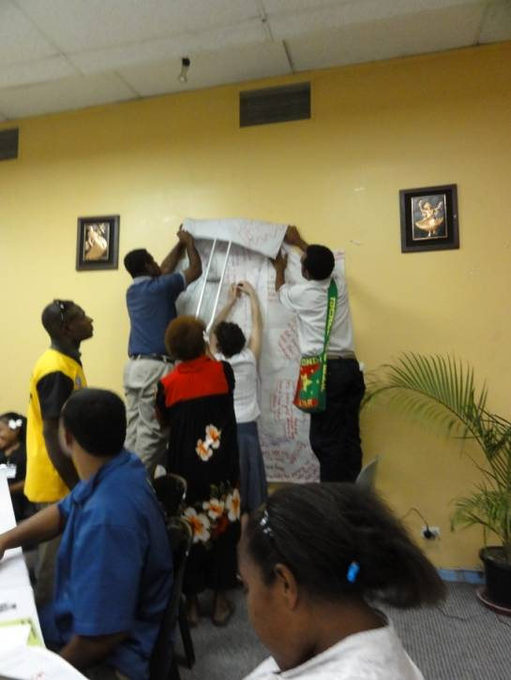
Fundamental barriers:
Often young people with disabilities find the following:-
- No access to health care
- No accessible housing/ shelter
- Not all children attend school due to cost
- Mainstream schools are often expensive and special schools charity funded and therefore free
- Not enough accessible materials in school
- Lack of high school scholarships
- No financial support for higher education
- No accessible transportation, dependence on expensive taxis
- No freedom of movement
- Men and women have different status, women are less empowered and employed, social hierarchy
- Exploitation of resources. Participants explained that if the family of a disabled person is faced with wider socio- economic barriers, living in poverty, resources given to disabled people can often be redistributed to support the needs of entire family.
Participants suggested that if the entire family is financially supported then ypwd are more likely to access education. Awareness training within local communities could help to deepen the understanding of the benefits gained by empowering disabled people.
Barriers to Participation:
- In some cultures elders traditionally make decisions for youth
- In accessible public buildings, no workshop facilities or community meeting / organising spaces.
- Information is often in English and not translated into local languages
- No interpreters, no communication
- No public deaf awareness
- Deaf young people don’t qualify for non-disabled or disabled people’s sporting events. This divides the community, especially when sporting events are some of the few activities organised where disabled people can meet together
- Not enough sign language teachers/ teachers who can sign
- No adaption to teacher training courses, lack of disabled teachers, those that do teach are not officially qualified and therefore not on government payroll. End up underpaid, exploited. PNG: Lack of disabled role models, in everyday society.
- No concept of resources to provide personal assistants
- Not enough representation of youth within DPOs/ wider community projects
- Not enough skills’ training for young people’s facilitators
This list can be used by DPOs and wider representative bodies, when developing strategies on how to increase the effective involvement of young people.
Next participants listed how they thought the lives of young disabled people could and should look within their communities, if the UNCRPD were to become fully implemented.
Hopes:
- Right to participate in all activities
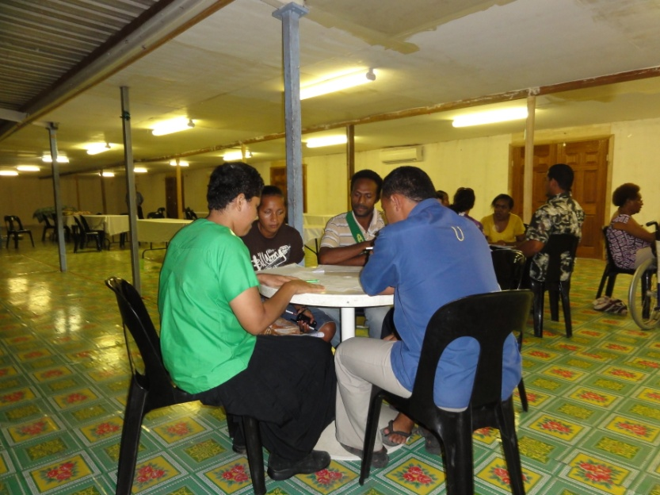
- Educated
- Choice to go into higher education
- Freedom to make decisions
- To be happy and safe
- A choice of jobs
- To have a choice to have a family, live independently
- Receiving government assistance
- Community members have disability awareness
- Raising our voices, involved in political decisions
- Socialising, having friends, going out
- Freedom of expression
- Right to marry/ love who you want/ have children
- Financial independence, right to choose what you do with your money
- Access to communication, Internet.
Lastly, participants, through discussion groups, identified what support, training and resources they felt were needed to strengthen their leadership. One issue identified by all country participants was a lack of children's participation work. It was felt that if ypd are supported and empowered early on, you increase their chances of accessing education, employment and most importantly increase their chances of having an effective voice in all matters which concern or affect them. (Article12 C.R.C)
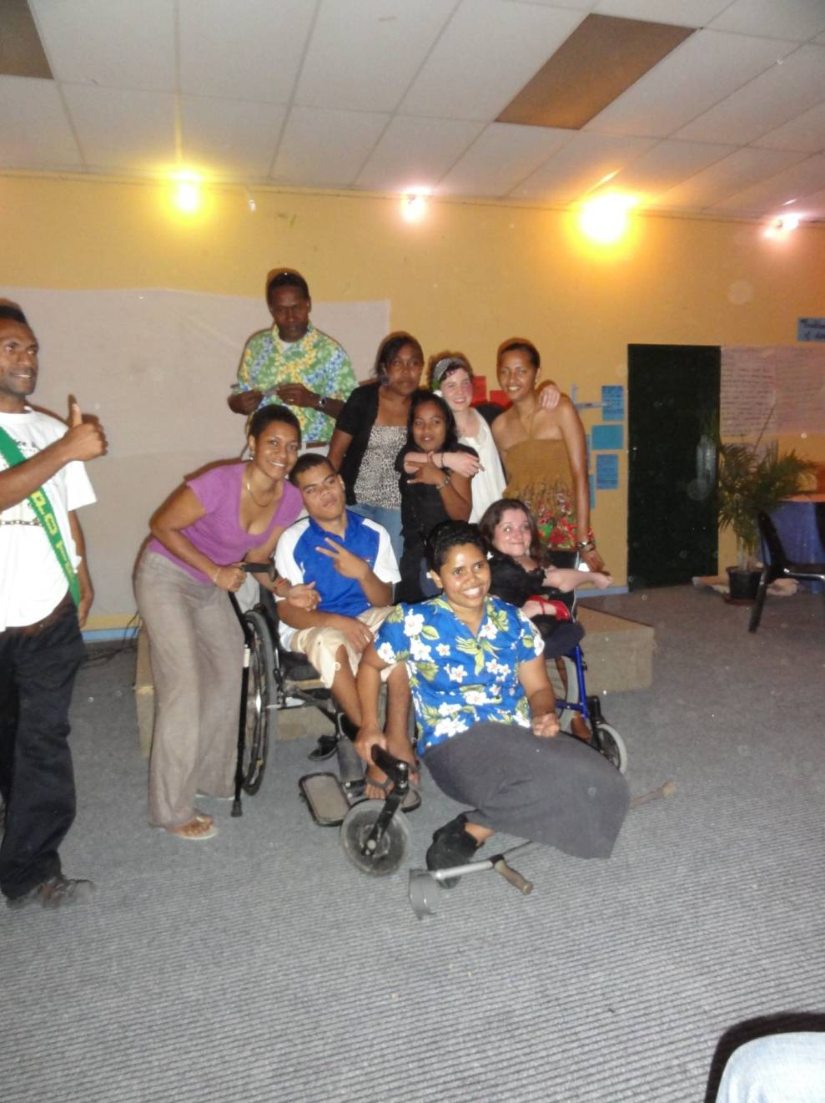
Participants were aged between 17 and 30. It was suggested that young adult leaders should form a peer support network and aim to meet together again to hold further discussions and receive requested training. Although, interim discussions can be held using email or Skype not all participants have Internet or phone access. Written English is a barrier for some, especially those using sign language. In order to involve those members fully, face to face meetings will be an integral part of furthering the development of this project.

This will enable each young person to set up a children's participation project within their DPO and equip them with the skills and confidence needed to facilitate and be an ally to children with. As a second stage inclusive youth projects will be set up. This will further develop the amount of leadership disabled youth get to take within DPOs, wider representative organisations and within the community.

What action we want to take
- Have youth lead organisation in each country, founded by young people who attended the PNG training and will hopefully attend future proposed training. Representing disabled children and youth. Build inclusive youth projects, building awareness of people with disabilities liberation struggles within wider community, breaking down barriers and isolation.
- Cross country skill sharing, e.g. theatre workshops
- North /South countries’ youth skill sharing project, building solidarity. (UK, AUS/ Pacific region)
- Training on how to facilitate the capacity building of young people
- Trip to visit models of inclusive education, playgrounds, youth participation projects (UK?)
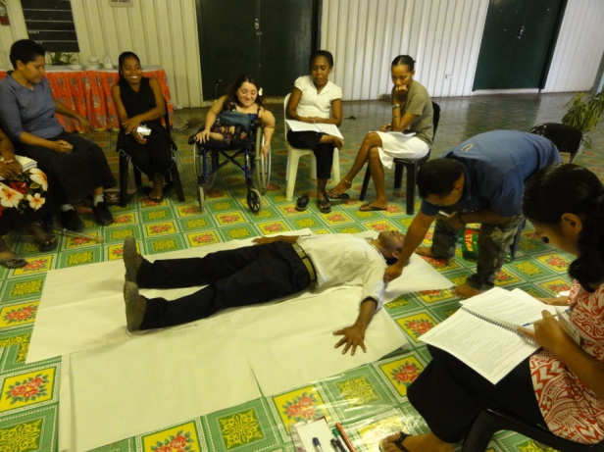
- Visit children’s rights projects; learn methods to involve younger young people.
- Develop culture specific training on disability equality
- Training around models of independent living, personal assistants
- Research and work around increasing the involvement of young people with HIV/AIDs
- Involve more young people who are labelled with learning difficulties, mental health system survivors
- Develop youth sports’ network to develop international community
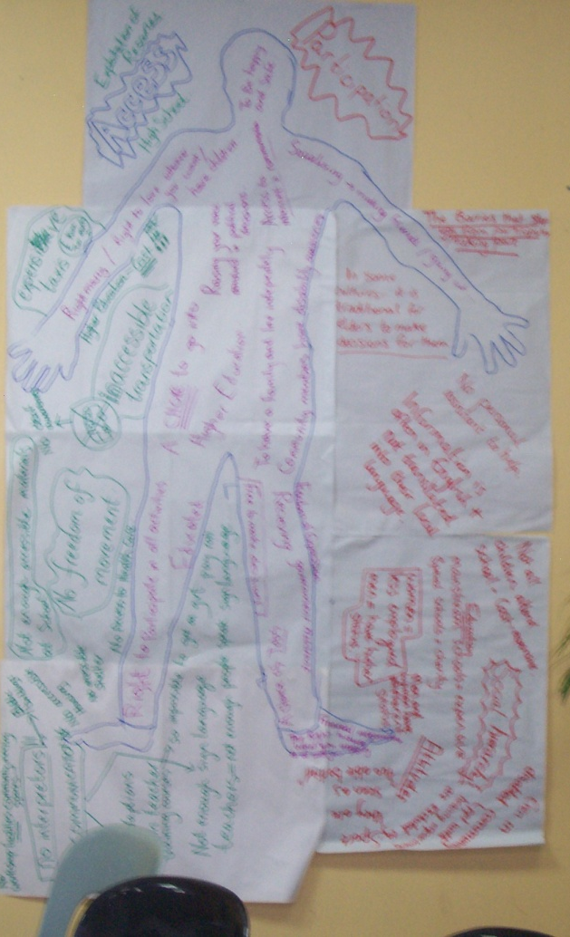
- Empower young people to speak out for inclusive education and independent living
- A Project looking at empowerment of young disabled women in DPOs, wider community
- Training on the Convention on the Rights of the Child
- Training on political advocacy, how to communicate with, lobby political leaders
Train young facilitators who can translate workshops into local languages
- Each participant has incorporated these ideas into their wider country plan and is researching ways in which to gain the resources needed to continue working as a peer support network
.

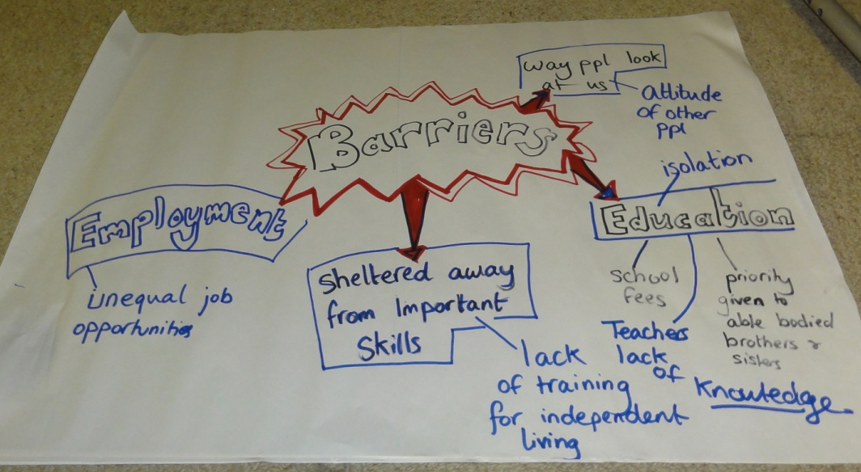

Women’s Session around Article 6 and Equality for Women throughout the UNCRPD
To introduce the topic we examined in mixed gender groups how disabled women were treated in the past, are treated currently and what difference implementation of the UNCRPD will make.
Traditional Roles and attitudes to Women and Men
Group 1:
- Women should stay at home and look after the family
- Women are treated like animals and used for sex only

Group 2:
- Men’s Role is to grow the garden, cut firewood, build houses, fishing and hunting and also they are the head of the family. They provide finance for the family
- Women’s Role is to grow the garden, weaving, and care for the kids, wash dirty clothes, cook our foods, find food, make sure we live in a clean environment, do sewing.

Group 3:
- Women are seen as kitchen maids
- Baby factories
- No right to be educated
- Objects of satisfaction for the male population

Group 5:
- Men honour women
- Men are the head of the family

Men:
      - Make the decisions and rules
- Provide food
- Work on the land
- Make many children and babies
- Give orders to everyone in family
- Are the king/masters of the family

Group 4:
Women:
- Do the cooking Look after the Children
- Household work
- Weaving mats
- Do as they are told by men
- Stay in home at night (not allowed to go out when dark)
- 3rd Class people

What is happening now in your culture with regards to the current attitudes towards men and women?
Group 1:
- Women go to schools and become teachers, police, army officers, lawyers, judges, representatives in parliaments, sport representatives
- Women respect men
- Women have crisis centre
- Women do awareness on rights and men begin to respect them

Group 3:
- Now men realise that they are the head of the family and there are some changes taking place like help to do the washing of dirty clothes, or help to clean the house, care for the kids and don’t hit women any more
- Men and women learn to help each other

Group 2:
Women:
Men:
- Drinking alcohol
- Staying home unemployed
- Commit crime or sexual abuse of women and girls
- Commit adultery
- Priests/church ministers

- Employed (both in public and private sectors)
- Involved in different trades
- Involved in decision making
- Involved in politics
- Taking leadership
- Sexual objects
- Health maintenance

Group 4:
Women:
      - Slight change
      - Differentiates with class- the haves (access to education and have the freedom to choose what they want in life)
      - Attitude is the main factor- although women seen to have a bit more freedom to make choices today

Group 5:
- Men, Women sharing responsibilities
- Dating you can date anywhere, night club, bus stops, etc.
- Wedding no longer the same as before
- Funerals can just offer flowers only. Not allowed Tongan materials

If the UNCRPD was implemented how would the attitudes towards women and girls change?
Group 1:
- Women would have access to better health services
- More than 80% of women would be getting better education
- There would be better integration of women
- Women would be recognised as equal decision makers

Group 2:
- Women will gain equal rights
- Women will be respected by men
- Women will have equal access to work and education etc.
- Women will be free from violence
- Women will be recognised highly in the CRPD
- Women will be free to walk away from abusive relationships
Extra Notes on Men:
- Men will shape family roles with women
- No Article for men in CRPD

Group 3:
- They will have more liberty and enjoy life to the fullest in making decisions for themselves
- Share equal opportunity with everyone else
- Share position/responsibility equally in work place etc.

Group 4:
- Women and girls will have higher level for education
- They will participate fully in their community activities and the society as well
- They will be treated equally
- They will have good health,
- They will feel free and safe to move and also be included in community and society

Group 5:
- Women and Girls will have the equal rights and will not be discriminated and live peacefully if UNCRPD is implemented
- Education, Health, Access to Equality would be there for them

Group 6:
- Women and girls with disabilities seen as having equal rights as men
- Women and girls with disabilities will be able to do more community awareness on their rights and feel safe
- Women and girls with disabilities will be able to have the same job opportunities as men

An analysis of these answers shows that the position of women with disabilities has changed as attitudes to the different gender roles have changed. There are great expectations placed on the implementation of the UNCRPD especially by women in the groups. However, to get deeper into understanding the process of change necessary and because of requests from women, including some sexism and sexual harassment experienced by women attending the course, we decided to split into female and male groups. The task was to design rules for the equal inclusion of women and men.
Women’s group notes
What do men do to disrespect disabled women?
- Make decisions for us
- Not respecting our wants and desires
- Low expectations
- Dictate our movement
- Men exercise their power to over rule us
- Take advantage of vulnerability
- Women have unequal legal status
- Laws to protect women are not enforced
- Rape, sexual abuse, assault of disabled women is extremely prevalent, higher than average statistics
- Only see us as sexual objects
- Men command women
- Women not allowed to show feelings
- No safe space to share experiences
- Disabled women leaders under resourced, burn out
- Inappropriate questions such as: are you married, do you have children can you have sex etc.
- Sexist comments
- Physical / psychological abuse
- Aggression

Men’s Views of Women from an anti-sexist point of view.
- Make a stand to challenge mistreatment against women and girls
- Use our power (physical) to protect our family members, particularly women and girls
- Express our love for women and girls with responsible actions
- We need women a lot. So men should fight for women to be free of abuse, slavery and violence
- Wives/women do support men unconditionally
- Men are captains but need anchors which are women or men stranded at open sea
- Make DPO as place for women/men basis of mutual respect
- Acknowledging one’s views important/useful
- Creating space for women to lead a DPO
- Review constantly to allocate position for women

Women’s rules for men:
- Never make jokes about sex or sexism. Do not assume a woman’s history
- Don’t use sexist language
- Allow women to have a safe space to share thoughts and feelings
- Consulting and making sure women are PART OF making ALL decisions
- Respect our difference and accept us for who we are
- Challenge their own way of thinking about women- lead by example
- Men should take a pro-active approach and see women’s liberation as part of their own liberation
- Develop relationships with women which are not sexualised
Additional views:

- Allow women to form a structure conducive to their concerns
- Guidelines must be imposed to prevent any disrespectful comments to any member, including women
- An environment free of sexism
- Collect data on approaches that are undemocratic for women
- Promote youth where young women are involved
- Men should respect family obligations (core strength home, should not muck about after work).

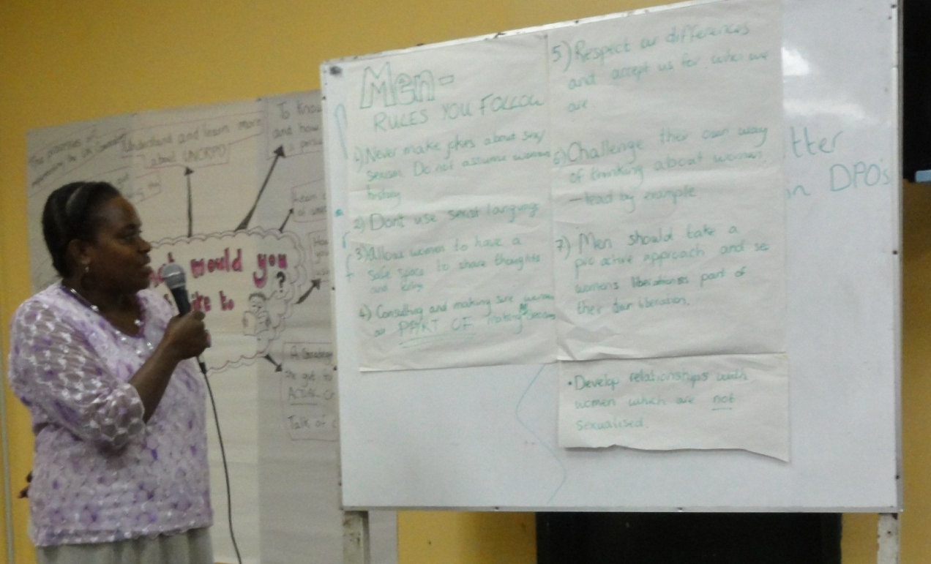

This session was highly valued. It allowed a space for the women on the course to confide in the sexism and disabilism they have to put up with throughout their lives and created a strong sense of solidarity. The men had to have some uncomfortable discussions and recognise their active part in women’s oppression. It will have a strong impact on future practice.

Negotiating for the UNCRPD
An important part of the training was getting participants to put into practice what they had learned through a forum theatre role play. Here volunteers were given a card outlining their point of view and then had to take part in a role play with a government minister on the signing/implementation of the UNCRPD.
After a period of 10 minutes the trainers give comments on the interaction, drawing attention to other arguments that could be used. Other volunteers may take over roles if they think they can do it more effectively. This is followed by a discussion of the whole group.
Forum theatre: - Role Play Cards:
You are the Government Official:
You support having the UNCRPD signed and ratified but you think it should be done slowly, because of the time it takes to sign papers and decide the legal measures.
You are the Service Provider:
You have a patronising attitude towards disabled people and think that they need looking after. You think you know better than disabled people on what they need. You are scared that the new UNCRPD will undermine your status as service provider.
You are a business man:
You are only interested in profit. You believe that by making changes for disabled people, your government will undermine profits. You don’t see why you should spend extra money as it won’t bring anything to you.
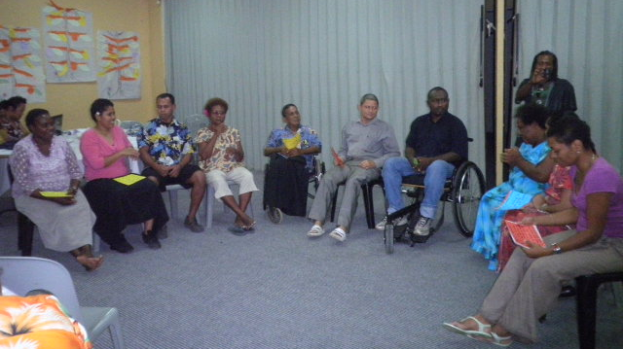
You are a young disabled sportsperson:
You are a young sporty disabled adult who is internationally well known. You don’t understand why the government is taking so long in ratifying the UNCRPD. You have seen all other countries ratify without any problems.
You are the Minister:
You agree in principle that we should adopt UNCRPD but you are worried about political effects, that you might not be re-elected if you push for it. You are also worried about the costs, so you make bad excuses, and say it is too complicated.
You are the president of a DPO:
You are passionate about the rights of people with disabilities. You are very annoyed and frustrated by the lack of progress the government are making with ratifying the UNCRPD. They only talk and make no change.
You are the leader of a disabled women’s association:
You want to challenge the disabilism and sexism towards women with disabilities. You are outraged at the police’s attitude towards women with disabilities who have been raped.
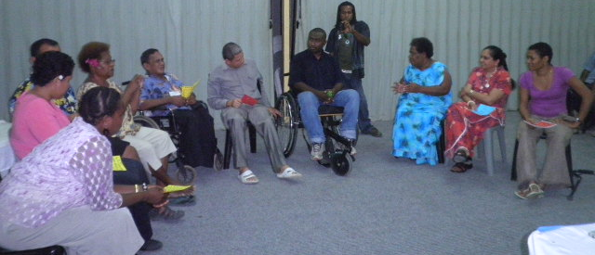

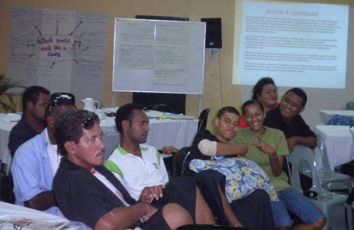

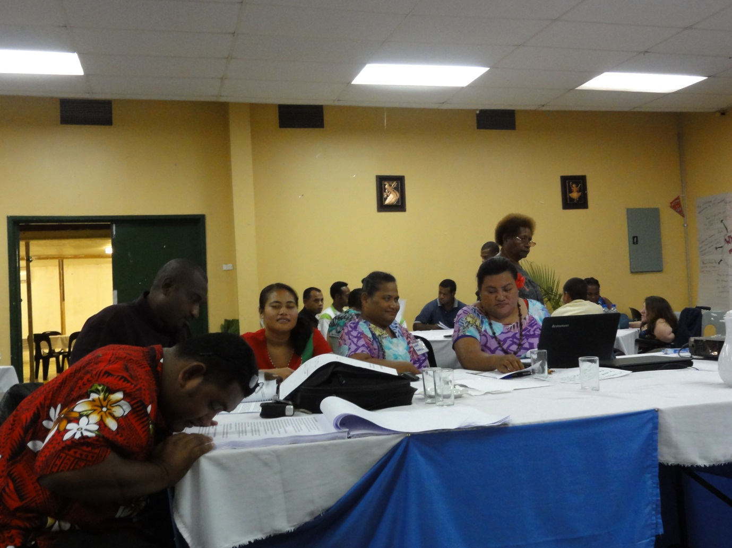

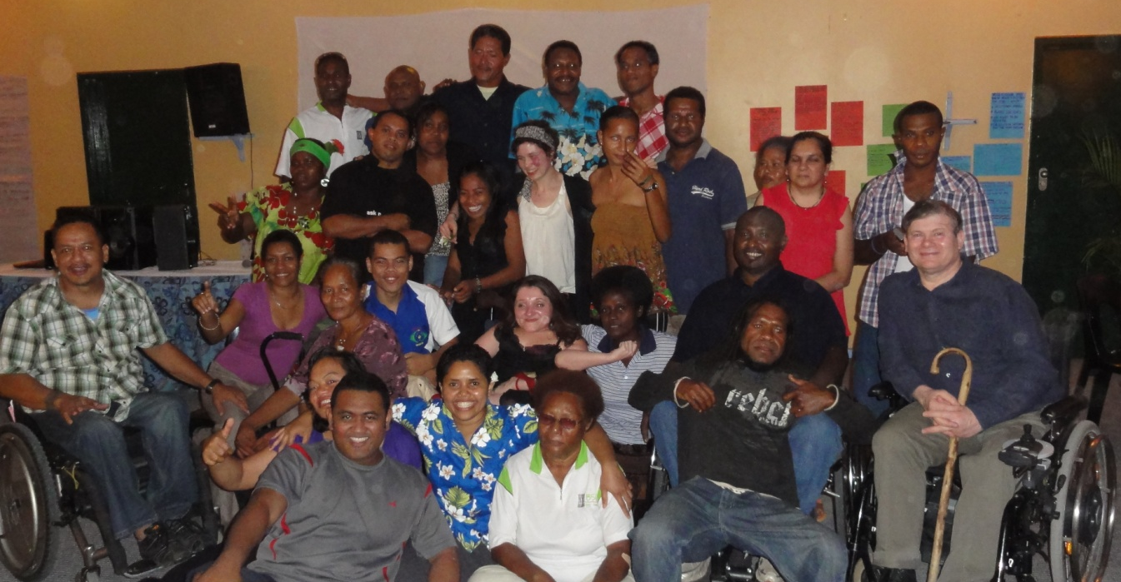

Campaigning for the Convention
We spent an afternoon with country pairs analysing their DPOs strengths, weaknesses, opportunities and threats. We then went on to examine what was needed in 5 areas to build a campaign for signature, ratification and implementation. We used the Disabled People’s International Ratification Kit. At this time the third member of each country group was with the Young Persons’ Group.
Following this, each country group spent three hours devising an Action Plan for their country. These were presented the following morning the last day of the training.
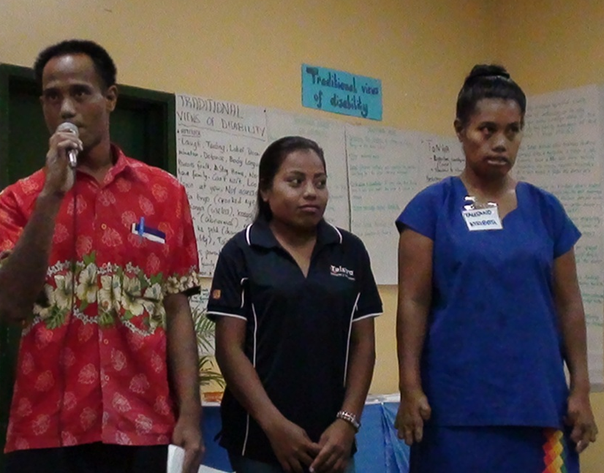
They are presented in full below.
Kiribati AREA OF ACTIVITIES | WHO WILL DO IT AND HOW | TIMESCALE
1. EDUCATION | TTM officers can talk to officer at Education Ministry | 2011-2012
2.Health | Our officers to make appointment with Secretary for Health | 2011-2012
3.Drama | TTM Member to make awareness in public areas by making drama | 2011-2012
4.Women | Our officers to make time with the director for women umbrella organisation to convince of the need to include women with disabilities and campaign for CRPD | 2011-2012
5.Youth | Youth make workshops for youth within our DPO | 2011-2012
6.Make appointments with official members in Ministry and Businesses | Invite official to our area and discuss on UNCRPD | 2011-2012
7.Make appointments with church leaders | TTM to do workshops in their area about UNCRPD and our rights | 2011-2012
8.Newspapers/Radio | An officer to contact newspaper company to include our view in their newspapers and programmes | 2011-2012
9.Workshops in the outer islands | Making workshops in the outer islands on CRPD (awareness) (look for funding) | 2011-2013
10. Make appointments with our stake holders or N.G.O. Members including Doctors | Executive Committee to lobby on CRPD during meeting for N.G.O. Members | 2011-2012

TTM =Te Toa Matoa N.B Accessibility will be included across the board.

Nauru  Area of Activity | Action Plan  Who Will Do it | Timescale
Work and Employment  Article 27 | Nauru DPO Representatives’  Workshops will take place with media involvement | Feb 2011
General Obligations  Article 4 | Nauru DPO Representatives’  Public Awareness – Running Community workshop through each constituency | Feb 2011
Equality and Non-Discrimination  Article 5 | Nauru DPO Representatives’  Public Awareness | March 2011
Education Article 24 | Nauru DPO Representatives’  Include Nauru Teachers | March 2011
Women With Disability  Article 6 | Nauru DPO Representatives  (This will be taken after our New Zealand Workshop)  - Include in Action Plan N.W.D.A | April 2011
Children With Disability  Article 7 | Nauru DPO Representative,  Conroy, to attend Disability Youth Conference in Perth, Australia and London. Conroy to start youth group on disabilities in Nauru. | April 2011
Awareness Raising Article 8 | Nauru DPO Representatives | May 2011
Health Article 25 | D.P.O. Representative with Health Dept. - NGO | May 2011

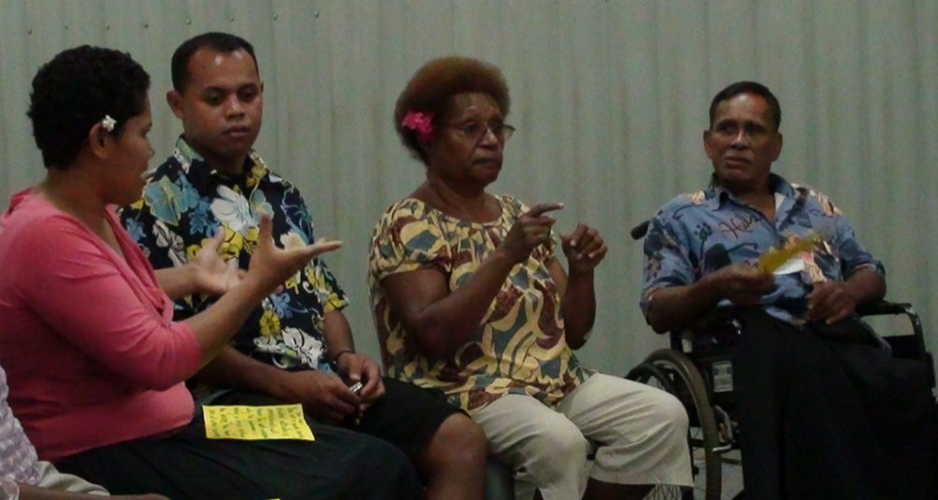
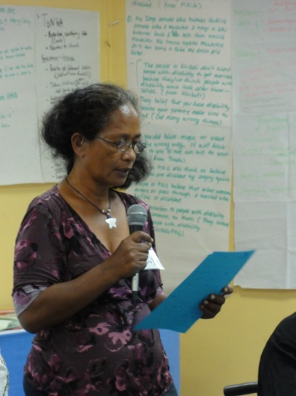

PNG Area of activity | Who will do it and how | Timescale
Create a course advocacy task team, who will be co-ordinating from port Moresby | PNGADP will identify a strong team of activists, both able bodied and pwds, who will be tasked to run and strategize | Feb 2011
Appoint a key politician to advocate on our beliefs | Key advocacy group will identify an influential politician and solicit support | Feb 2011
Mobilisation of pwds in provinces to push for the signing of CRPD | PNGADP with the provincial DPOs will use their network to lobby for support, by running awareness and advocacy programmes | March –may 2011
PNGADP to follow up key decision documents | PNGADP will monitor and push for key documents to be implemented , this making known the UNCRPD views | June 2011
Prepare sensitization package for all ministers | PNG Core group will strategize and design an awareness package for key decision makers in the Government | June 2011
PNGADP runs sensitization programs for ministers | PNGADP, in collaboration with law and justice sector and other stake holders, to identify an approachable avenue to sensitise and lobby minister’s support | July-august 2011
Mobilise community support to push for signing of UNCRPD | Provincial DPOs and PNGADP will use the media and run consultative meetings and open forum with all stakeholders to lobby for community support  Maximise awareness on UNCRPD for public support through all forms of media | August-September 2011
Seek audience with foreign affairs minister to implore his commitments | PNGADP task team meet with the Minister for Community Development, who is our champion & will meet with the Foreign Affairs Minister | October 2011
Specifically designed pamphlets on the importance of UN CRPD will be circulated to NEC before the next NEC meeting | PNGADP and community development | October 2011
The Community at large and all stake holders will hold a peaceful sit in outside parliament when NEC is meeting | PNGADP, Provincial DPOs NGOs CBOs & PWDs family members and other support resource partners | November 2011

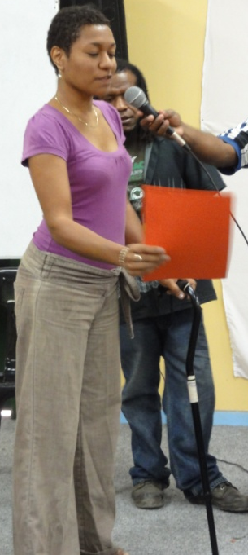
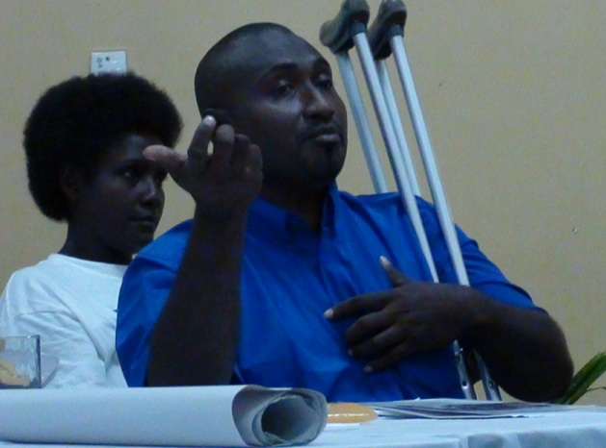
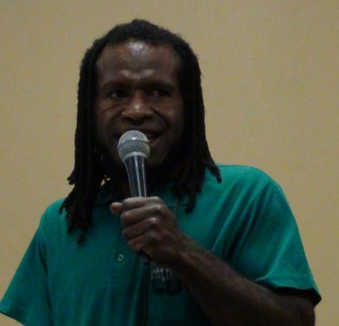

PNG Deaf Group  Area of activities | Who will do and how | Time
Identify the deaf people in the village community and registration of deaf person | Christine and Noah to visit village and promise to get information on them | During weekend in March 2011
Have enough funds (resources) for the groups activity | Current deaf members (who attend this workshop) to fundraise this activity, Noah, Josh, Felix, Christine | Two weeks in February 2011
Bring the deaf people for a meeting | Noah, Felix, Josh, Christine to arrange for transport and venue for meetings | April, May 2011
Formation of first deaf committee for the organisation | Select a president, secretary, 3 committees members, keep the minutes and records of all activities | April, May 2011
First deaf awareness, where participants in this workshop share what they learn, their experience on CRPD to other deaf members | Noah, Felix, Josh and Christine share about the rights of deaf and all other disabled people in the UNCRPD | April or May during the meeting
Register the deaf organisation to the Government | Noah, Felix, Josh to present the papers to the registration office (Elenoa, PDF will assist in providing constitution for Fiji deaf as an example and help in the process for registration) | June 2011

A deaf organisation that advocates for the rights of the deaf according to CRPD
Later PDF for funds to help PNG Deaf Associations
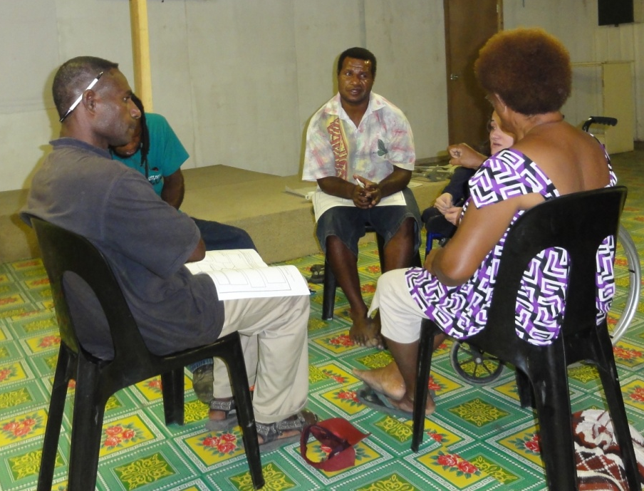
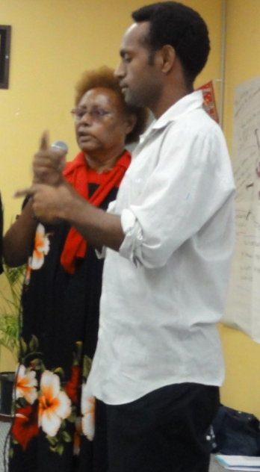

Samoa Area of Activity | Who Will Do it and How | Timescale
1.Using the Media | Syria, SA, TV, radio, newspaper interview, community  promo advert | Monthly
2.Building credibility with Bureaucrats | Chair, board members and staff through formal talk | Fortnightly
3.Domestic H-Right Law | Proposing a draft law on H-Right issues – Board/Chair/Legal advisor | Yearly
4.Alliances/Coalitions with other Civil Groups | Organize campaign against torture/abuse | Semi-annual
5. Improve Membership | Secure contacts list of PWD – Staff/Syria | Monthly
6. Good education and articulate members | To influence top level work colleagues using peer network to support CRPD | Ongoing
7.Maintain Credibility with Elected Offices | Formal talk with well prepared Docs – Board Member/Chair | Monthly
8.Members at Key Public Debates | Present our case in clear and simple but effective approach – Members/Staff | Ongoing
9.Networking with Influential Friends/Neighbours/Families | Invite them to our AGM /volunteer our campaign – Members/Staff | Ongoing
10.Human Rights Instrument | Organize with SAUD for Govt. Officials Members/Staff - TV Documentary using CRPD | Bi-annually
Nuanua O Le Alofa inc
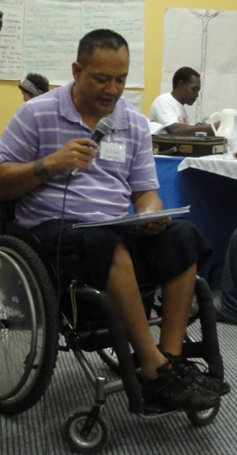
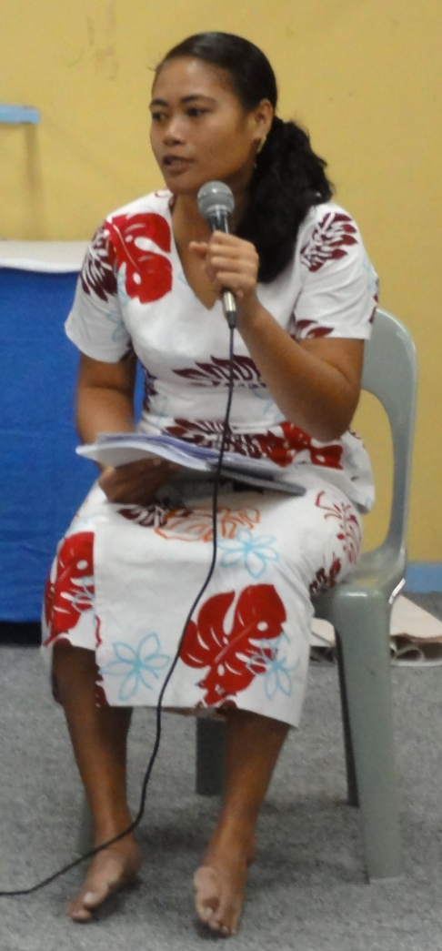
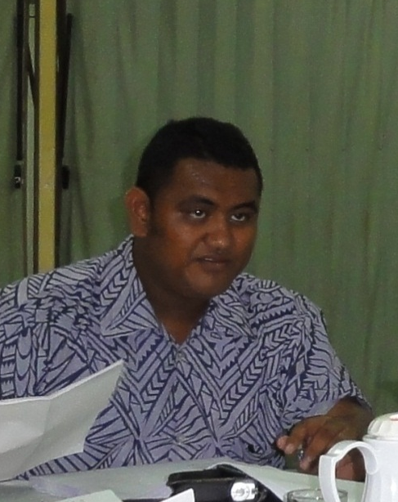

Solomon Islands Area of activity | Who will do it and how | Timescale
Research on regional agreements, international conventions and other agreements the Government has signed up to | Joel, George Naomi discuss with MFA and other organisations | Feb./March
Building capacity of DPOs | PWDSI through workshops and trainings on CRPD | On going April
Education | Meet with MEHRD (Ministry of Education)  PWDSI Executive on Inclusive | July
Policy and disability Bill | Meet with MHMs  PWDSI Executive on national disability | July/August
Moving the focal point to a different Ministry | PWDSI Executive Discuss with P and MHMs(Health Ministry) | Long Term April
Time frame | Meet with Ministry of Foreign Affairs  PWDSI Executive on ratification | Aug/Sept
Include PWDs in sports esp. in Solomon games  Setting a national for PWD | Meet with MHA/NSC /NOCSI  PWDSI Executive | March/April
Develop awareness materials on CRPD | PWDSI Executive  Posters/bill boards  TV clips  Pamphlets | ongoing
Organise rally of PWD, NGOs in front of Prime Minister’s Office | PWDSI partners NGOs, dse  For Government to ratify the CRPD | July
Workshop for women with disabilities and also church women’s groups | Naomi, Savina, Joel on CRPD, CEDAW, CRC for women | October

PWDSI=People with Disabilities Solomon Islands
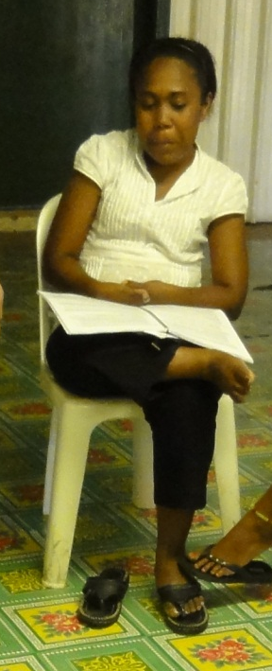
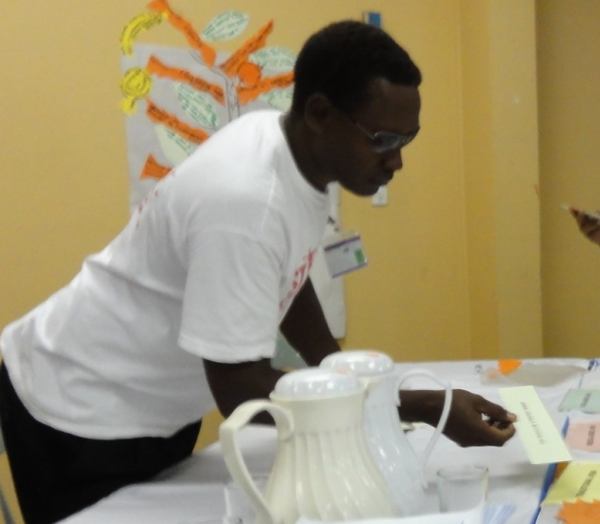
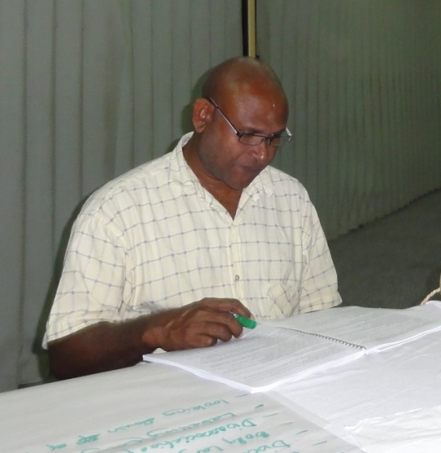
Tonga Area of activity | Who will do it how? | Time frame
Arrange a meeting with all DPOs in Tonga | Rhema talk to each DPO | 3 wks time
Have a representative from women and youth to be part of meetings | Sami from youth  Nipa from women | 5th Feb 2011
Organise meeting with head of Government | DPOs of Tonga youth reps. and women reps. | 4 weeks time
Organise meeting with minister of information | DPOs from Tonga/youth reps/women reps | 5 weeks time
Arrange meeting with women affairs and minister for youth | Rhema women reps. | 3 weeks time
Arrange meeting with people reps to parliament | DPOs of Tonga, youth reps, women reps | March 2011
Arrange meetings with donors | DPOs of Tonga women reps youth reps | April 2011 beginning
Short drama advert for media-importance of ratifying CRPD | Nipa and Sami, getting youth to meet 3 women | 5th Feb.
Awareness workshops for community churches and families | DPOs of Tonga youth reps, a women reps. | April 2011 3rd to 4th week
Panel discussion on TV and radio emphasising why its important to ratify the CRPD | DPOs of Tonga youth reps women reps ( malo alipito ) | Start in June twice a month

Note: O.TA service= Alonga service, Tonga national disability congress, independent living = naunau de akamaite (nata)

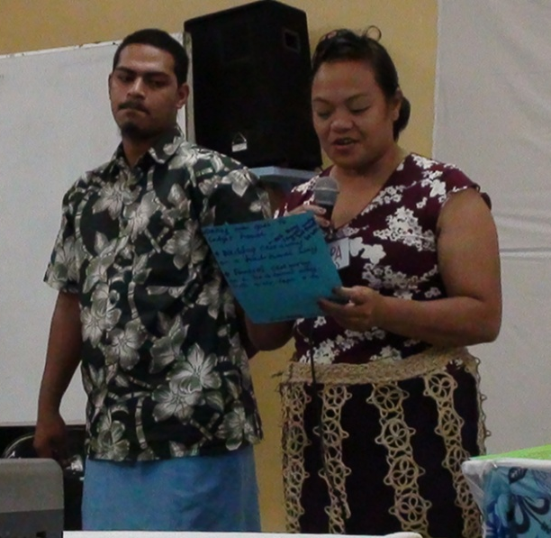
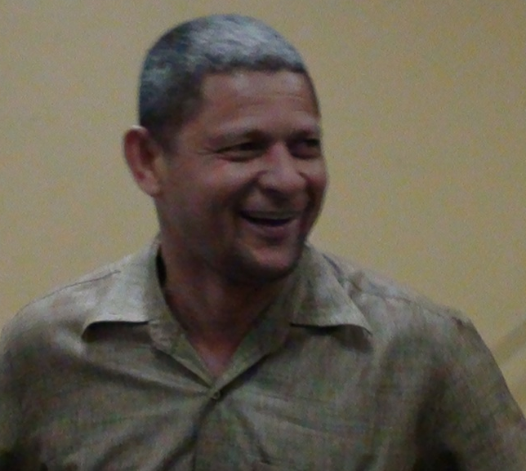

Tuvalu Area of activity | Who will do it and how | Timescale
1.Education  Conduct survey on the number of children with disabilities not attend school | FAA Tuvalu work with TCPA and Community Affairs Department | 2011
2.Building Capacity on CRPD  CRPD Nationwide training including islands | FAA Tuvalu AND TCPA | 2011
3.Producing of IEC materials on CRPD | FAA Tuvalu and TCPA small workshops already funded | 2011
4.Media-promotion on CRPD- Promos, Advertisements, New bulletins- Interviews | FAA Tuvalu-free publicity | 2011 quarterly
5.Shadow Report writing pwd in CRC CEDAW | FAA TUVALU- TCPA-Report on disability status regarding these 2 treaties already ratified | 2012
6. FAA, Tuvalu coalition cover 9 islands TCPA and our branches formed in all islands. One formed already | FAA Tuvalu- TCPA and outer island branches and tree By Consultation meetings. Red Cross will also help | 2011
7. Developing of Youth with Disabilities | FAA Tuvalu To empower youth to know their rights | 2011
8. Women with disabilities  To strengthen article 6 CRPD | FAA Tuvalu & TCPA-hold a retreat. Take women to picnic venue | 2011
9. Article 5: Equality and Non-discrimination. Health Article 25 | FAA Tuvalu & TCPA  Advocate on this. New organisation. keep medical records in our office-empower service providers to treat pwd fairly | 2011
10 Parents of Children with Disabilities | FAA Tuvalu-Educate parents to not label their children and stop hiding them. This is our 1st priority. | 2011

FAA - Fusi Alofa Association of Tuvalu. TCPA _Tuvalu Community Para-legal Association-educate people of their rights. Will help lobby Government. Have provided funding. CRC Convention on Rights of the Child.
CEDAW Convention on Women’s Rights
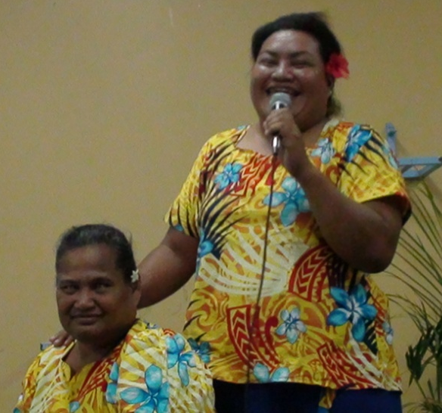
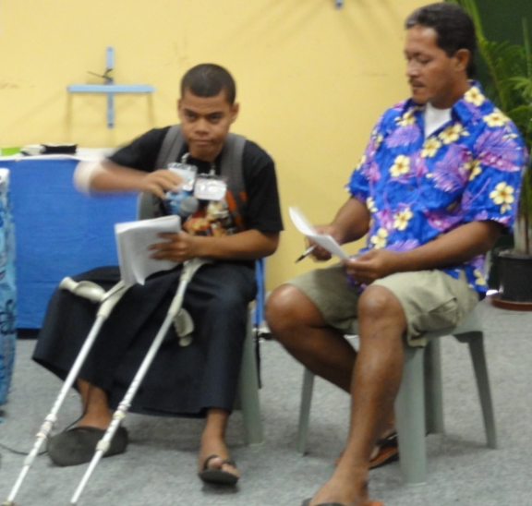
Vanuatu Area of Activity | Who Will do it and How | Timescale
1. With DPA Members.  Awareness of Different Provinces | Sub-Committee:  Shirley, Nelly, Marion, Peter  1 day training in remote areas & provinces will include women, youth leaders, chiefs | February – Finish by September 2011 in 6 provinces
2.Go to Media-Using a theatre group with actors to raise awareness | Sub-Committee /and DPA or Group/JIFS Church  30th July Independence Day-Big Events and at AGM | Once a month
3.Set a campaign committee to talk with the Government about implementation of the CRPD | We will call upon Angie and Richard to come and talk to the Government | April 2011
4. Awareness to Secondary School Primary School. Focus on Education first CRPD | A sub-committee/use office of Save the Children Vanuatu  Follow up by person who reminds us. | April 2011
5.Set up women’s with disability committee with in each province | Sub Committee and link with campaign against violence to women | May 2nd Week 2011
6.Follow up with the Ministry For Education | Make an appointment with the lead person. Sub-Committee | July 2011
7. Follow Up with Youth Challenge and employment | Sub Committee Women and Youth Challenge. Find out where pwd are employed | June 2011
8. Building Community Support for Deaf Members of the Organization on using CRPD. Many denied access. | Marion/Janet(sign interpreter) talk to the gate-keepers  Conducting workshops  Report on Activity Meeting | August 2011
9.Educate family members about CRPD to stop keeping disabled members at home | Go house to house, involve youth | June to November 2011
10. Big recap to check all programmes are being implemented | Sub-Committee report back to our DPO | 16th December 2011
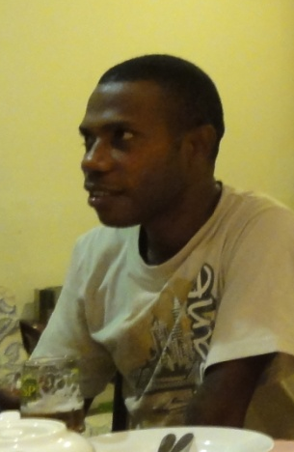
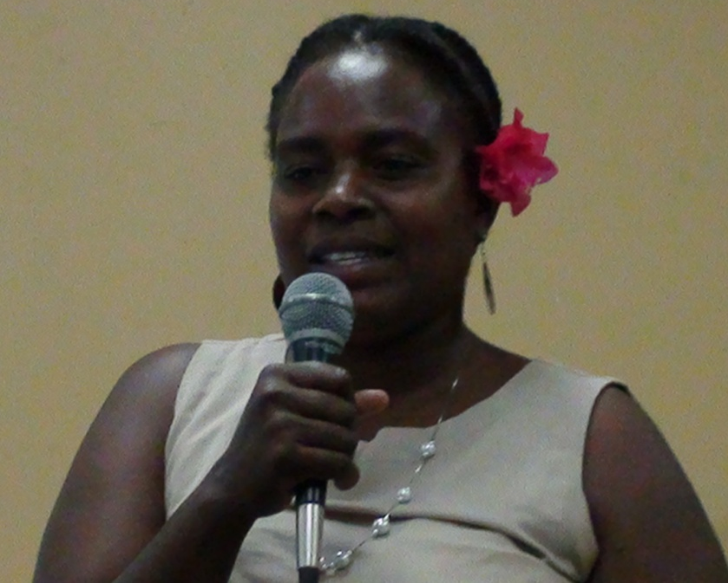
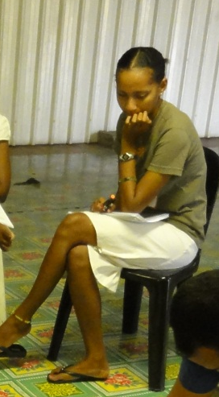
Evaluation of the Course
This occurred in two ways:
- Comments from participants every evening: They were asked to fill in a comment on a post it note about the day. These were examined by the trainers each evening and changes were incorporated into the next days programme where required. It transpired that participants had a range of use of English, which the course was delivered in. This varied from pidgin to full fluency in English-spoken, reading and writing. Some participants asked for the presentations to be slowed down and simpler language to be used. It was also clear that some people preferred interactive group sessions to ‘theoretical presentations’. As a result we increased the number of interactive sessions and simplified some of the programme.
- Evaluation Form: The second was an evaluation of 15 questions that was filled in on the last day of the course. Only 21 completed forms were handed in. There could have been 26, not counting the 2 PAs who participated all week.
The following results are therefore based on 21 out of a possible 26 participants: 77% participation rate.
Overall rating of training: The overall Score given to the training was high with 17 calling it ‘Excellent’ and 4 ‘Good’. No one chose Satisfactory and Poor. This fits in with comments made throughout the week.
“How good it was to have disabled people leading the training as you have a much better grasp of the issues and can put them across much better than legal/human rights people.”
“Many thanks for a great training.”
“Everything was excellent and thank you for your patience with everyone’s difficulties.”
“Appreciate all the information, knowledge and skills you imparted.”
Usefulness of training: When asked if “the training would help you campaign for the signing, ratification and implementation of the UNCRPD” all participants agreed, many effusively.
Women’s Rights& Young People’s Rights: When asked if the focus on a) women’s rights and b) young people’s rights would help them empower these groups of people with disabilities 20/21 agreed for women and 17/21 agreed for young people.
Understanding Models of disability: When asked if they now understood the different ways of thinking about disability Traditional, Medical and Social 17/21 agreed.
Favourite activity: When it came to naming their three favourite activities the following aggregate scores are found:
Traditional Model of Disability: 7 Role Play: 4
Tree of Rights: 6 Articles and barriers: 4
Group Activities: 5 Young People: 3
Women’s group: 4 Breaking down Articles into simple terms: 3
Interdependence of Human Rights: 3
Least favourite activity: When asked what their least favourite activities were far fewer filled this in with a number saying they liked everything. There were a range of views and only education scored 3 and all other mentions 1.
Length of the course: When asked if they had enough time to explore the issues and topics 12 people said Yes. 3 wanted a 2 week course. 1 thought it too fast and another too long. And 1 person wanted 8 days.
Language difficulties: When asked about the language the difference already recognised became apparent. 15 participants found the language used easy to understand and 6 acknowledged they had some difficulties.
What you want to learn more about in the future? When asked what they would want to learn more about in the future 3 wanted more on the UNCRPD, 3 more on involving young people, 3 more on inclusive education and 2 on how to push Governments.
Individual ideas for additional training: A number of other individual requests were made- shadow reporting, networking, administration/leadership, disability rights, disability history, positive solutions and public speaking.
Breaks: When asked if they had enough breaks in the day 16 said yes and 1 no.
More workshops: When asked if they would like to attend more workshops like this 18/21 said ‘Yes’ and no one said ‘No’.
Young People: 8 wanted more workshops. Of these 4 wanted more on empowerment and self-knowledge, 3 wanted more on leadership and 2 on self-empowerment.
Views of Women’s Group: 12 made comments and 12 found it useful. 4 wanted more women’s training in their countries.
Views about Men’s Group: 12 people thought it useful, though not all responded.
Other views: 2 people thought participants show be given a daily allowance. 1 person wanted a follow up in 6 months. 1 person wanted more examples from the Pacific and another wanted more information.

Conclusions
The training achieved all its aims and the participants’ objectives. It was highly rated by participants rating it excellent or good. Everyone who had planned to come took part. This was no small feat achieved by the good offices of the Pacific Disability Forum. In addition the contribution of Angelina Chand and Elenoa Kaisau from the Pacific Disability Forum led local regional expertise to our endeavours. Christine Kenia provided sign interpretation. Each country had brought two DPO leaders and there was a reasonable gender balance. We could have done more on Shadow Reporting, though this was covered in the Course Book.
The Papua New Guinea Assembly of Disabled People were great hosts and managed to arrange accommodation and provided support throughout our stay. Ipul, Ross, Richard and Hector, three of their Officers are to be thanked. PNGADP also arranged for a meeting with the Minister of Social Development and the Special Education Department and facilitated a sightseeing tour for the trainers. It is to be hoped that I will return to PNG with a film crew in the Summer of 2011 to make a film for the Government on Inclusive Education, if the funding can be raised.
We have everyone’s e-mails and they know they can contact UKDPC & World of Inclusion for further support and advice.
Lucy Mason aided by Moeva Rinaldo did a great job on running the Young People’s workshop. The change in the young people attending was tangible over the 6 day workshop. Growth in confidence, understanding and presentational skills was clear. They also became empowered and as a result of attending are much more likely to become leaders in their DPOs and of Youth. They have plans to become an international network and feed into the Commonwealth Youth Forum.
The holding of a separate Women’s group was welcomed by all the Women on the course and they found the solidarity empowering, but it also demonstrated deeply ingrained sexism in DPOs and the cultures of the region. I facilitated the Men’s group at the same time, to discuss how we can challenge this sexism. This was a powerful but uncomfortable experience for some. Some sexism and sexual harassment was experienced during the course from a few men, but we as trainers dealt with this by raising it with all participants as a breach of our ground rules.
The programme and training materials we had developed in advance seemed to reach the target, with some minor variations. If I was to run the course again I would make the Course Book less wordy and add a glossary of terms. The training activities all worked successfully. I adjusted as we went along to simplify content and do more interactive sessions. This seemed to work. Participants all gained in their understanding of disability rights and how they can make a big difference in the lives of people with disabilities. They developed concrete and time bound plans that will be put into practice and will bring the South Pacific countries up to speed on ratification and implementation of the UNCRPD. All who attended attested to their growth in understanding and their preparedness to carry on the struggle for disability rights, both nationally and internationally.
The solidarity, friendliness, hospitality and sharing of cultures made this a great experience and one I would be happy to repeat.
Richard Rieser 24th February 2011.
Appendix 1 Programme
24th January to 29th January 2011 Grandville Motel, Port Moresby, Papua New Guinea
Led by Richard Rieser, Lucy Mason supported by Moëva Rinaldo all of World of Inclusion and Angline Chand and Elenoa Kaisau from The Pacific Disability Forum
Arranged by United Kingdom Disabled Peoples’ Council, Funded by Commonwealth Foundation
Monday 24th January
1. 9.30-11:00 Aims and Ground Rules Presentation (A4 & A5)
2. Introductions- Who are you? Your Role? Where you are from? Give one barrier that has affected your life. Give one solution that has enabled your life as a person with disabilities. What would you most like to learn by Saturday? Activity
Break 11.00-11.30
3. What are the traditional ideas and views of people with disabilities in your culture and country? Activity (A6)
4. Who are disabled people? Activity- who is in the basket? (Article 1)(A7)
Lunch 1:00- 2:00
5. What are the barriers to disabled people’s equal treatment in South Pacific countries? Think of attitudes, environment and organisational barriers. Work country groups. Activity (A8)
6. Examine the list of rights contained in UNCRPD and identify which ones will address the barriers identified-Activity (A9 & A10 and Full and Easy Read Version)
Break
[7a. Young people form a separate group to identify key barriers for young people with disabilities.]
7. Examine a traditional view and a barrier identified and examine for each one Article of the UNCRPD that challenges it. How will this be a solution in your country? Use Easy Read version. Activity (A11)
8. Report back. Over night preparation read the UNCRPD
Tuesday 25th January 9.00am
1. Warm Up activity- The language we use? (B1)
2. What are human rights?-Universal, inherent and inalienable. Presentation (B2)
3. Activity on interrelated rights use Universal Declaration of Human Rights- International Bill of Rights and Human Rights Framework. (B3)
4. Which Human Rights instruments have your Governments Adopted? [Check lists and collate].
Break 11:00 – 11:30
5. Scenarios of Human Rights abuses. Who is responsible for Human Rights? Respect, Protect and Fulfil. (B5)
6. UNCRPD- What is important about the process of making the CRPD. Presentation (B6)
Lunch 1:30 -2:30
7. Tree of Rights Activity (B7)
7a Young people’s group work on ‘What is most important for young people in Tree of Life’
Break 4:00-4:30
8. A short history of western attitudes to disability –presentation followed by discussion on local views (B8)
9. The models of disability-traditional, medical/charity, social- presentation and activity statements sorted (B9 & 10)
10. Definitions of Disability –which should be used? Presentation and activity sorting definitions on cards. (Article 2) (B11) Implications for census and monitoring. (Article 31)
Over night preparation-Write a poem or draw a picture showing the transformation of the paradigm shift-problem in person to problem in society.
Wednesday 26th January 9.00
1. What is the Human Rights Approach to Disability? Share poems and pictures. (C1)
2. Principle of UNCRPD and Equality and Non Discrimination presentation (Article 2, 3, 5) (C2)
3. Accessibility presentation and activity (Article 9) (C4 & C5))
Break 11:00-11:30
4. The Right to Participation in Political and Public Life (Articles 29,) (C6)
5. Freedom of Expression and Opinion (Article 21). (C7)
6. Right to Life and Protection in Situations of Risk (Articles10, 11). (C8 & C9)
Lunch 1:30- 2:30
In parallel groups working to explain what key points are
7. W. Freedom from Torture and other forms of abuse (Article15, 16). (C9 W)
X. Privacy, Nationality, Integrity Home and Family (Articles17, 18, 22, 23). (C9 X)
Y. Health, Habilitation, Rehabilitation and Personal Mobility (Articles 20, 25, 26) (C9Y)
Z. The Right to Work and adequate standard of living (Articles 27, 28) (C9 Z)
Break 4:00- 4:30
8. Report Back-Drawing out main the points and presentation
Preparation a five minute presentation to local media about the importance of one of the above these rights being guaranteed to PWD in your country. You will present to your group in the morning.
Thursday 27th January 9.00
1. Presentations
2. Living Independently and with Dignity in the community (Articles 12, 19, 28) (D1, D2, D3, D4)
Make poster or leaflet
. Break 11.00-11.30
3. The Right to Education (Article 24) (D 5, D6, D7, D8 D9, D10)
Lunch 1.30-2.30
. More on Education
4. Children’s Rights (Article 8) (D11 & D12) Lucy Mason Oppression young people with Disabilities face.
Break 4:00-4:30
5. Young Peoples Group Country Groups SWOT analysis
6. Role of the State and Shadow Reporting (Article 4, 34, 35, 36) (E6.2, E6.3)
7. Report back Young People’s Group
Overnight. In groups of two people produce a story board of 8 scenes for a public service broadcast advocating rights of women or children with disabilities to a general audience.
Friday 28th January 9.00
1. Women’s Rights (Article 7) (D13 & D14)
2. Wome5n’s and Men’s Group
Break 11; 00 -11:30
3. Reporting back
4. Getting governments to sign and ratify. Forum Theatre /Role play (Article 33) (E1, E2, and E3)
Lunch 1:30-2:30
[3a. Young DP will work on mobilising and building disabled youth presence in their countries through to 3.45]]
5. Monitoring & Implementation -Examine The Pacific Regional Strategy On Disability (E4, E5)
6. Implementation, the Role of DPOs and Shadowing Reporting (Article 32, 37) (E6.4)
Factors for getting ratification/implementation
Break 4.00-4.30
7. Feedback young people’s group
8. In country groups prepare an action plan for your country. (E7 & E8)
Social event for all in the evening.
Saturday 29th January 9.00
1. 9.00 Work on Country Action Plans
10.00-Presentations-10-15 minutes and discussion all morning
Break 11:00-11:30
2. Evaluation of country presentations and what makes some more effective?
Lunch 1:00-2:30
3. Stereotypes and other issues
4. What has to be done? Taking stock
5. Closing session/.Evaluation 5. 00

Appendix 2 PDF/ UKDPC Joint Project 24 – 29 January 2011 PNG

Name as in passport | Name of Organisation | Country | Board or executive member (B) / paid or volunteer staff (S) / active member (M) | Type of Disability and mobility aid used if any | Male / Female | Requires Sign language interpreter | Requires material in Braille large print [indicate font size] | Special dietary requirement | Any other comments
Tekamangu  Bwauira | Te Toa Matoa | Kiribati | Chairperson | Polio | Male | NO | No | No
Taurano Savili | Te Toa Matoa | Kiribati | B | Amputee | Female | No | No | NO
Regina Ritiata | Te Toa Matoa | Kiribati | B | Physically | Female | No | No | No
David John Harris  P/Port no. 012534 | Nauru Disable Association | Nauru | Volunteer and an active member  (President) | Wheel chair | Male | NO | No all is well (font 14 | None | David John Harris  P/Port no. 012534
Elimina Quadina  P/port no. 011557 | Women’s Disability Group | Nauru | Volunteer  As above  (vice president) | Hearing impairment | Female | NO | Full mobility | None | Elimina Quadina  P/port no. 011557
Mr Conroy Detabene  012452 | Nauru Disable Centre | Nauru | Teacher at the Centre | Deaf | Male | Yes | Full mobility | None | Mr Conroy Detabene  012452
Ismael Leanavie | PNGADP | PNG | M | Mobility | Male | No | No |  | Goroka – Port moresby return = PGK 982.20 (SPECIAL FARES)
Elina Seko | PNGADP | PNG | M | Mobility | Female | No | No |  | Madang – Port moresby return= PGK 952.20 (SPECIAL FARES)
Livingstone Tony Kevi | PNGADP | PNG | B | Mobility | Male | No | No |  | Buka – Port morebsy return= PGK1959.30 (NORMAL FARES)
Leah Kevi | PNGADP | PNG | S | No | Female | No | No | No | Buka-portmoresby return (SAME AS TONY’S ABOVE)
Joel Viriala | People With Disabilities Solomon Islands (PWDSI) | Solomon Islands | M | Visual Impairment | Male | N/A | Font size 16 | N/A | No comments
Naomi Tai | People With Disabilities Solomon Islands (PWDSI) | Solomon Islands | M | Physical disability | Female | N/A | N/A | N/A | No comments
George Henry Tapo | People With Disabilities Solomon Islands (PWDSI) | Solomon Islands | B | polio | Male | N/A | N/A | N/A | No comments
Peter Dick | DPA  Vanuatu | Vanuatu | (B) | Physical Disability | Male | N/A | N/A | N/A | N/A
Marian Paialelesi | DPA  Vanuatu | Vanuatu | (B) | Physical  Disability | Female | N/A | N/A | N/A | N/A
Vetoho Viji | DPA  Vanuatu | Vanuatu | ( B) | 50% Vision impaired | Female | N/A | N/A | N/A | N/.A
Nofovaleane Mapusua | Nuanua O Le Alofa inc | Samoa | President | [Wheelchair user and require an accessible accommodation | Male
Sa Utailesolo | Nuanua O Le Alofa inc | Samoa | [Paid Staff] | Visually Impaired | Male |  | Large print size 24 | Workshop materials e-mail
Suria Apulu | Nuanua O Le Alofa inc | Samoa | Active Member | Physical Disability | Female
Mine Pilikosi | Fusi Alofa Association of Tuvalu | Tuvalu | President | Blind | Female |  |  |  | Need a support person
Saini Malalau Seluka | Fusi Alofa Association of Tuvalu | Tuvalu | PA for Mine |  | Female
Ioane Hawaii | Fusi Alofa Association of Tuvalu | Tuvalu | Member | Physical disability | Male
Tapua Kiga Sopoaga | Fusi Alofa Association of Tuvalu | Tuvalu | Member | Physical Disability | Male
Ulise Pilima Misa | Naunau O’E Alemaite Tonga Association | Tonga |  | Physical Disability | Male
Sami Tangitau | Naunau O’E Alemaite Tonga Association | Tonga |  | Physical Disability | Male
Siunipa Isitolo | Naunau O’E Alemaite Tonga Association | Tonga |  | Low Vision | Female |  | Large print size 24
Elenoa Kaisau | Pacific Disability Forum |  |  | Physical Disability | Female
Angeline Chand | Pacific Disability Forum |  |  | Low Vision – request for e-copy materials. | Female
14 – Male, 12 – Female....excluding PDF

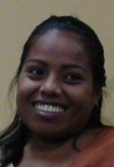
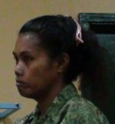
Kiribati:
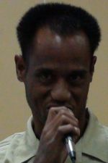

Regina Ritiata Tekamangu Bwauira Tauranu Savili
Te Toa Matoa Te Toa Matoa Te Toa Matoa
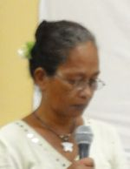
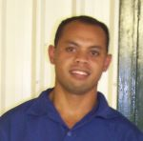
Nauru:
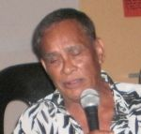

David John Harris Conroy Detabene Elmina Quadina
(Nauru Disabled Association) Nauru Disabled Centre Women’s Disability Group

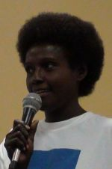
Papua New Guinea:
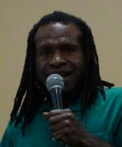
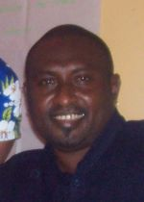
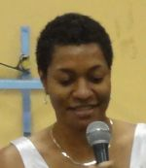

Ismael Leanavie Livingstone Tony Kevi Elina Seko Leah Kevi
PNGADP PNGADP PNGADP PNGADP
Solomon Islands:
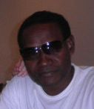
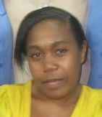
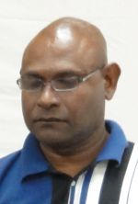

Joel Viriala Naomi Tai George Henry Tapo
PWDSI PWDSI PWDSI

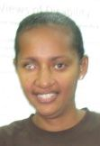
Vanuatu:
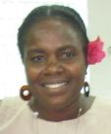
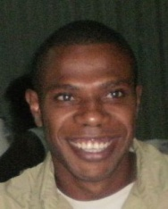

Marian Paialelesi Peter Dick Vetoho Viji
DPA DPA DPA

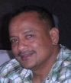
Samoa:
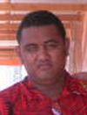
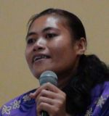

Nofovaleane Mapusua Sa Utailesolo Suria Apulu
Nuanua O leAlofa inc Nuanua O le Alofa inc Nuanua O le Alofa inc

Tuvalu:
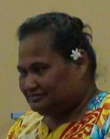
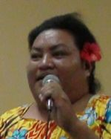
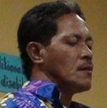
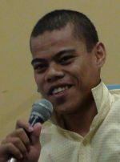

Mine Pilikosi Saini Malalau Seluka Ione Hawaii Tapua Kiga Sopoaga
Fusi Alofa Fusi Alofa Fusi Alofa Fusi Alofa
Association of Tuvalu Association of Tuvalu Association of Tuvalu Association of Tuvalu

Tonga:
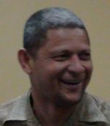
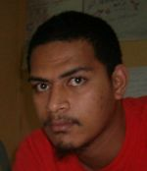
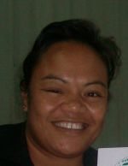

Siunipa Isitolo Sami Tangitau Ulise Pilima Misa
Naunau O’E Alemaite Naunau O’E Alemaite Naunau O’E Alemaite
Tonga Association Tonga Association Tonga Association

Pacific Disability Forum:
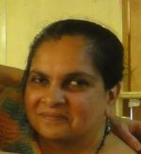
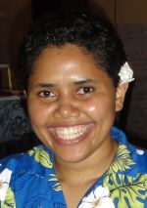

Elenoa Kaisau Angeline Chand
PDF PDF

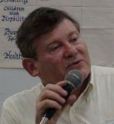
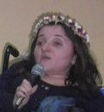
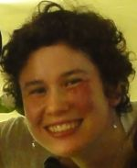
World of Inclusion: UK

Richard Rieser Lucy Mason Moëva Rinaldo
World of Inclusion World of Inclusion World of inclusion

