**Report on the data gathering and analysis**

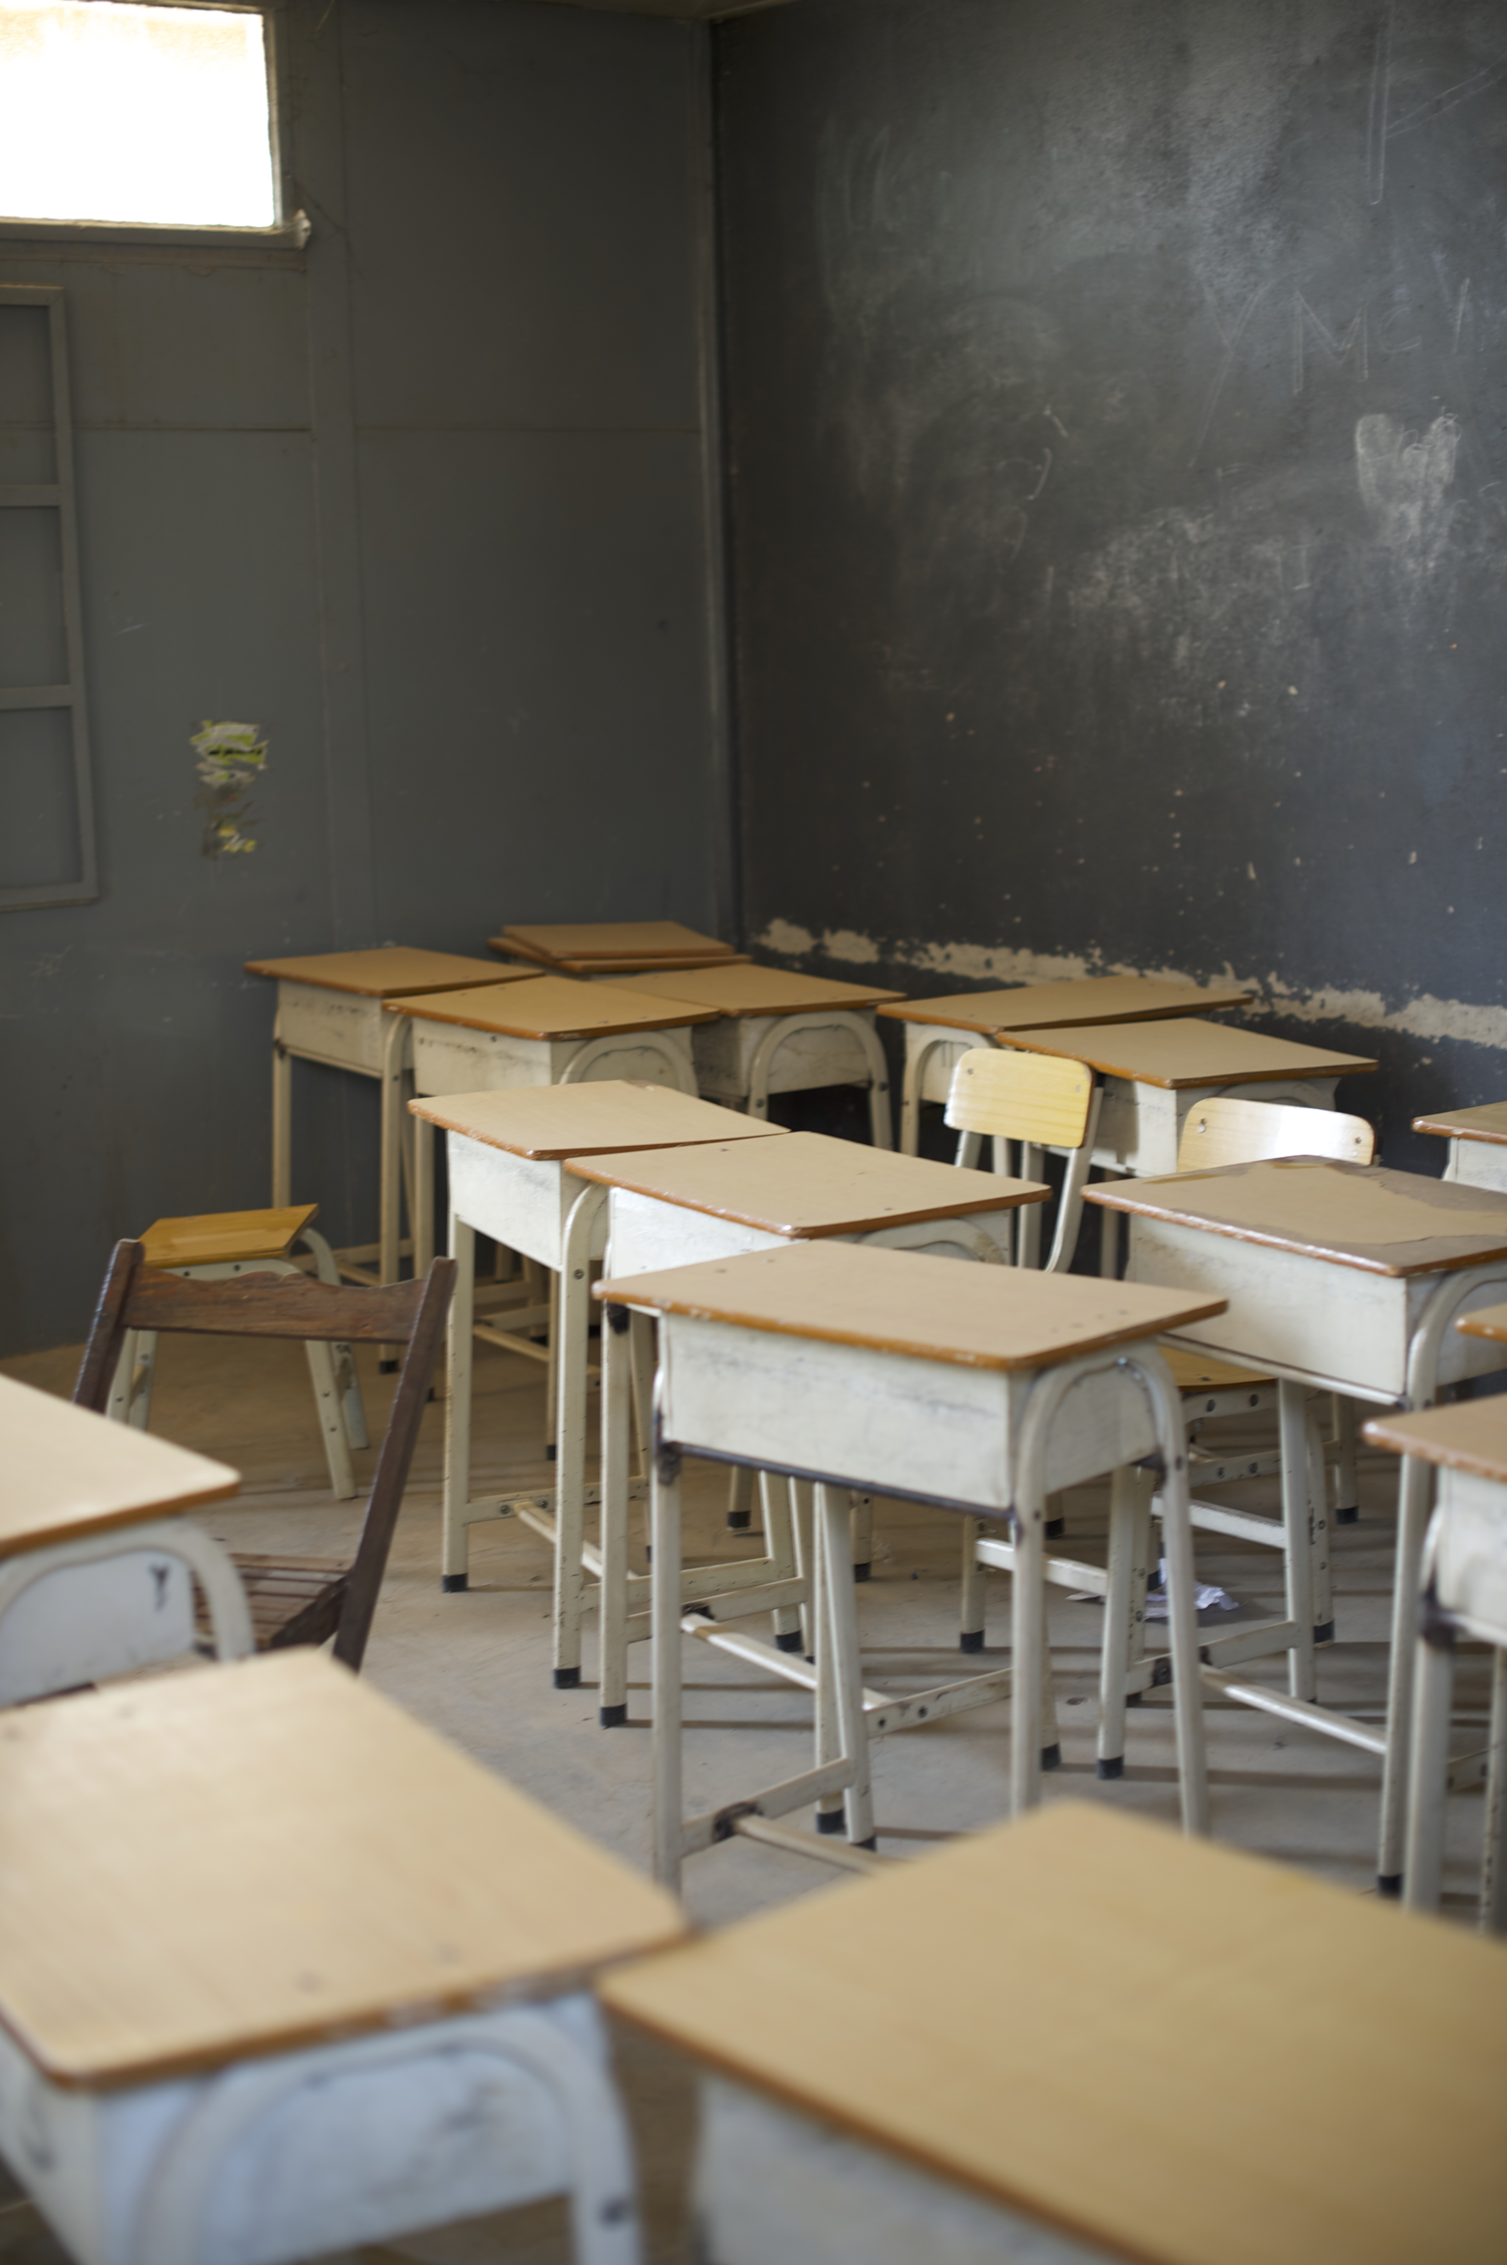

by Alexander Hauschild / EENET for Richard Rieser / World of Inclusion, 10.6.2014

**Table of Content**

Data gathering and delivery 4

Purpose 5

Activities 6

Data digitalisation 8

Strength and weakness of the data collection and the process 9

Data overview 10

Aweil 10

Yei 13

Juba county 16

Morobo 19

Mundri East 22

Mundri West 25

Rumbek 28

Torit 31

Wau 34

Aggregated data for barriers 37

Aggregated data for educational preferences 38

Summary of questionnaires answers including photo elicitation activities and facilitator comments 39

Responses to photo pairs – nominal 42

Summary of results of photo pair activity 46

Responses by headmasters 47

Comments by facilitators 53

Conclusion 54

Tools used in data gathering 56

i. Questionnaire for teachers 57

ii. Power point presentation 61

iii. Graphic representations of the different ways education can be provided for children with disabilities and other marginalised groups 74

iv. A series of photographs based on the experiences of children with disabilities in African schools to elucidate responses 77

v. Seven matched pairs of photographs focussing on the education of children with disabilities in an African school context for which respondents have to express a preference 79

vi. School self-assessment tool 83

vii. Guidance for facilitators to make an assessment of the situation in the schools they visit 88

# Data gathering and delivery

Alexander Hauschild went first to Juba 23rd February to help plan with the project group and trial out the survey materials and meet with DPOs.

A meeting was held on the 27th February with DPOs, to invite DPOs’ opinions and inputs for the policy framework on inclusive education that will be developed. The outcome was broadly supportive and a number of barriers were identified. Representative for Deaf people thought separate sign language schools were best, but when assured that inclusion would lead to mainstream schools resources for deaf children by teaching sign and by having interpreters were assured. In attendance were:

* South Sudan Deaf Development Concern (SSDDC)
* South Sudan Association of the Visually Impaired (SSAVI)
* Union of the Physically Disabled (UPD)
* Equatoria State Union of the Visually Impaired (ESUVI)
* South Sudan Wheelchair Basketball Association (SSWBA)
* One association was for parents of children with intellectual disabilities / epilepsy / nodding disease, formed by the CBR organisation, Usratuna. We had one parent of a child with epilepsy attending the meeting. South Sudan National Association of the Deaf was invited but did not attend.

There was agreement on inclusive education as a way forward.

In the second week training sessions with the facilitators were held. The Light for the World Office in consultation with the MOEST selected 8 counties and facilitators to carry out interviews and focus groups with 6 schools in each area 1 secondary and 5 primary schools.

Facilitators were identified in:

* Mundri-West, Western Equatoria
* Mundri-East, Western Equatoria
* Yei, Central Equatoria
* Morobo, Central Equatoria
* Rumbek, Lakes
* Wau, Western Bahr el Ghazal
* Aweil, [Northern Bahr el Ghazal](http://en.wikipedia.org/wiki/Northern_Bahr_el_Ghazal)
* Juba, Central Equatoria
* Torit, Eastern Equatoria (reserve)

Two facilitators from each area plus NGOs on the project coordinating group attended 2 day, in first week March, trainings on carrying out the field school visits, focus groups, activities and questionnaires. The tasks required of them were to select at least 9 schools and carry out the activities outlined in the Diagram below in 6 schools.

## Purpose

* WHY: To facilitate the development of the MoEST national policy framework on inclusive education
* HOW: Find out what stakeholders (teachers, students, parents, county officials) think about inclusive education for children with disabilities
* OUR APPROACH: Awareness-raising/consensus-building on inclusive education. Interviews and focus group discussions



Facilitators were briefed by Alexander Hauschild on the values and legal framework, the different types of possible provision what is the difference between exclusion, segregation, integration and inclusion when applied to children and students with disabilities.

MOEST briefed facilitators on the chosen route of inclusion and resource centres that they have adopted. Toyin Aderemi Light for the World Programme Manager , South Sudan then provided a presentation on the ethics of facilitating, allowing participants control and to be comfortable with the process while carry out their function. Facilitation function was defined as:

* Means provision of guidance and direction to the group
* You must be confident and lively
* Listen actively
* No right or wrong answers/responses
* Allow participants to use the language they are comfortable with
* Do not dominate the discussions. Allow participants to talk more
* Make sure that discussions are not deviating from the topic
* If participants deviate from the discussion, bring them back in a polite way
* Encourage everybody to participate, but do not force them
* Probe further when more information or details are necessary .
* If focus group use a language other than English that the participants are comfortable with then the facilitator needs to translate into English responses.

## Activities

1. **Heateachers.** Start with an interview with the headteacher of selected schools. They have are to audio record this. A questionnaire was pre prepared, but they can ask supplementary questions to clarify. The heads can also undertake photo elicitation an matched photo pairs activity.
2. **School situation.** The facilitator should use the digital moving camera they have been supplied with to capture the school building , it’s surroundings and some of the interaction in the classroom between teacher and children. This is limited to 20 minutes per school.
3. **Teachers.** A focus group of up to 6 teachers to answer questionnaire questions and undertake the photo elicitation and matched pairs of photos preference activities To be audio recorded.
4. **Mapping.** Also ask for at least one class of older children to undertake the mapping activity of children out of school in their locality. One class in pairs each have a section of the school catchment area and record numbers of children not in school and how many may be children with disabilities. Teacher has a master map.
5. **Children.** A focus group of 6 children from the school (3 should be children with disabilities if possible) Use questionnaire to guide discussion and then record results photo elicitation and matched pairs exercise.
6. **Parents.** A focus group of parents from the County to be facilitated using questionnaire and

photo elicitation and responses to matched pairs of photos. To be audio recorded

1. **District Officers.** Focus Group of District Officials to discuss the findings of the
2. **Feedback from Facilitators.**
   1. What is your impression of the situation of the schools you have visited? Are you under the impression that they are ready for including children with disabilities? (Remember inclusion is about identification, enrolment, participation  and achievement). In which respects are they ready?
   2. Do you think the government officials you have met have the will and power to influence the education system at county level to become more inclusive?
   3. Among all the different stakeholders (parents, children, teachers, head teachers, and government officials) you have visited, who has the best understanding of inclusive education? Why do you think this?
   4. Which stakeholder group will have the strongest resistance to inclusive education? Please explain why?
   5. Do you think the survey tools were useful and according to the  purpose of the survey? Please explain your answer?

Three weeks was allocated for this process and data was gathered at LFTW Office Juba

The data has been picked up by Light for the World in Juba on Friday, 21st March 2014 and has been taken to the Netherland’s office. The data has reached Jakarta on 8th April 2014. Due to Eastern, the release of the by the post office has taken much longer than usual. On 14th April 2014, I decided to drive to the post office’s customs office to speed up the process. I could persuade the person in charge to skip door delivery and hand me the data.

# Data digitalisation

Data digitalisation started on 21st April and was finished on 7th May 2014. Here is an overview on the working days:

21st April 2014 Half day typing South Sudan surveys

22nd April 2014 Half day typing South Sudan surveys

23rd April 2014 Half day typing South Sudan surveys

24th April 2014 Half day typing South Sudan surveys

25th April 2014 Half day typing South Sudan surveys

26th April 2014 Half day typing South Sudan surveys

1st May 2014 Full day typing South Sudan surveys

2nd May 2014 Full day typing South Sudan surveys

3rd May 2014 Half day typing South Sudan surveys

4th May 2014 Half day typing South Sudan surveys

5th May 2014 Full day typing South Sudan surveys

6th May 2014 Full day typing South Sudan surveys

7th May 2014 Half day typing South Sudan surveys

# Strength and weakness of the data collection and the process

The data collection covers a wide range of stakeholders including government officials, headmasters, teachers, parents and children. Therefore, it should give the consultant a good overview on the current situation in the field.

However, the data collection procedure has its limitations:

* Training on data selection tools: The training was only 1.5 days due to travel schedules and budget limitation. Therefore, the survey was prone to misinterpretation of data collection tools by the administrators.
* Selection of administrators: The selection of administrators was done without reviewing several candidates for each region. During the training, some administrators seemed to be more suitable than others.
* Selection of schools: The selection of schools might not be representative. It was in the hands of the administrators to select the schools.
* Civil war: The data collection does not cover regions that are affected by the current civil war. Therefore the policy needs to anticipate the needs of learners in theses regions by consulting third party literature.

The quality of the data gathered is of different quality. Some administrators have put a lot of effort into taking down notes, going through all questions and marking the survey tools, while others have put less effort into this. This reflects on the quality of the data gathered. Some survey forms are incomplete and it seems that the administrators did not know how to use them or did not bother to use them correctly.

Still, the data gathered gives a strong indication that South Sudan’s population wants an inclusive education system that embraces differences and includes all learners without discrimination.

# Data overview

## Aweil

## Yei

## Juba county

## Morobo

## Mundri East

## Mundri West

## Rumbek

## Torit

## Wau

# Aggregated data for barriers

# Aggregated data for educational preferences

# Summary of questionnaires answers including photo elicitation activities and facilitator comments

The results of the survey are clear. The fact is that South Sudan is at the very beginning of the journey towards inclusive education. Only a very small number of children with disabilities are currently enrolled in schools. All stakeholders interviewed agree that inclusive education is the best solution to educate all children including children with disabilities. However, they identified many challenges ahead. The general consensus that inclusive education is the best way forward needs an implementation framework. The survey showed that government officials are waiting for instructions from the central government, and headteachers are asking for guidance from the government and NGOs. Teachers blame parents for being ignorant of the rights of their children with disabilities and parents blame teachers for not having sufficient training and expertise to be able to successfully include children with disabilities. Students who were interviewed during the survey have most positive attitude toward inclusion. They state that students with disabilities should study together with their peers in mainstream schools and that schools and curricula should be made accessible for all students in South Sudan.

Parent should register this children to school and teacher should accept the disable to learn by being friendly to the disabled child and advise the parents to bring him/her to school and teacher, pupils give support to those children.

Statement from a students interviewed in Juba County

They can school together with children so that they will not feel isolated or neglected.

Statement from a students interviewed in Wau

Yes, talk to the parents of the disable to allow then send the disable to the school.

Statement from a students interviewed in Torit

The policy, which is under development, must ensure that the role, responsibility and necessary actions of each stakeholder group – government officials, headteachers, teachers, parents, students, and NGOs – is clearly identified. In addition to this, there is a need for major stakeholders in South Sudan to have a schedule that contains detailed short, medium, and long-term interventions. A body that monitors this implementation must be established. Such a body must intervene if a stakeholder does not function as designated and offer high quality capacity building to close the gap between the implementation plan and action in the field. Only if all stakeholders move together has inclusive education a chance in South Sudan.

Initial challenges for inclusive education that need to be addressed are:

* Attitudes toward children with disabilities:   
    
  The rights of children with disabilities are still heavily neglected according to the results of the survey. Some parents of children with disabilities do not value their children. They do not send them to school. Teachers and headteachers do not know how to include children with disabilities in the classroom.  
    
  Nationwide awareness campaigns that include mentioning the rights mentioned in the UNCRPD regarding the right of persons with disabilities are necessary to ensure that attitudes towards persons with disabilities change over time. Especially parents of children with disabilities complain about the lack of awareness in the South Sudanese society.
* Identification and enrolment of children with disabilities:  
    
  Increased awareness and good attitudes will hopefully lead to greater identification of children with disabilities and enrolment of children with disabilities. This must include proper assessment schemes and professionals that guarantee good quality assessment. Capacity building for all aspects will be necessary in South Sudan.
* Teacher training:  
    
  Teachers and headteachers do not have sufficient skills and understanding to include children with disabilities in the teaching and learning process. This very often leads to corporal punishment for children with disabilities. Teacher training should start with information about general inclusion, not so much focussing on individual impairments. It is important that all teachers have a solid understanding of the social model of inclusive education, their role in implementing inclusive education, and that they develop the right attitudes in approaching persons with disabilities. When this foundation is developed more specialised training should be implemented.
* Physical accessibility of school:  
    
  Physical accessibility includes challenges within the school premises, challenges e.g. bad roads on the way to school, as well as long distances from the home of the students to the school. Schools and communities have to think about solutions on how to accommodate children with disabilities.
* Toilet facilities:

Many schools have no toilet facilities. Those that do are mainly not accessible for students with disabilities and need rebuilding. During planning for new toilets, accessibility guidelines for children with disabilities must be used.

* Assistive devices:  
    
  The survey has shown almost no assistive devices are available for students with disabilities. Some of the answers in the photo elicitation indicate that government officials, headteachers and teachers are not aware of the availability of, for instance, hearing aids. The government must find ways to make available assistive devices. The current civil war in the country will increase the need for assistive devices.
* Poverty:  
    
  Poverty is a multidimensional challenge. It affects the ability to provide food for children, the ability to use transport, to pay school fees and the ability to maintain good health etc. The government must establish schemes to support families that live in extreme poverty. Children with disabilities are more affected than other children, due to their individual needs.
* Gender balance and early marriage:  
    
  Poverty may lead many families to the decision to send the male children to school, while the female children stay at home to help in the household and fields. Early marriage is a challenge that keeps young girls out of education and is caused by poverty and custom.
* Large classes:  
    
  Classes in all grades can be up to 80 students. Teachers working in large classes need training on how to manage large classes. The government should focus on reducing the number of students per classroom by building additional classrooms, as well as training and hiring more teachers.
* Braille and Sign Language  
    
  The survey has shown that many headteachers and teachers are worried about communication with children hearing and visual impairment. They find it necessary that training on Braille and Sign Language will be provided for them.

## Responses to photo pairs – nominal

### Summary of results of photo pair activity

|  |  |  |  |  |  |  |  |  |  |  |  |  |  |  |
| --- | --- | --- | --- | --- | --- | --- | --- | --- | --- | --- | --- | --- | --- | --- |
|  | **A1** | **A2** | **B1** | **B2** | **C1** | **C2** | **D1** | **D2** | **E1** | **E2** | **F1** | **F2** | **G1** | **G2** |
| **Aweil** | 20 | 2 | 1 | 20 | 17 | 5 | 1 | 22 | 4 | 18 | 21 | 0 | 0 | 20 |
| **Yei** | 44 | 9 | 21 | 25 | 35 | 18 | 12 | 37 | 4 | 51 | 53 | 3 | 4 | 48 |
| **Juba** | 13 | 1 | 7 | 7 | 10 | 5 | 2 | 12 | 0 | 14 | 14 | 0 | 3 | 11 |
| **Morobo** | 19 | 1 | 2 | 18 | 17 | 2 | 1 | 19 | 0 | 20 | 20 | 1 | 0 | 19 |
| **Mundri East** | 15 | 2 | 1 | 16 | 17 | 0 | 1 | 16 | 1 | 16 | 17 | 0 | 0 | 17 |
| **Mundri West** | 10 | 2 | 3 | 11 | 10 | 4 | 4 | 10 | 0 | 14 | 14 | 0 | 0 | 14 |
| **Rumbek** | 16 | 1 | 4 | 13 | 14 | 4 | 1 | 16 | 1 | 16 | 15 | 2 | 3 | 14 |
| **Torit** | 19 | 1 | 6 | 12 | 11 | 8 | 6 | 14 | 1 | 19 | 17 | 2 | 6 | 14 |
| **Wau** | 13 | 10 | 7 | 15 | 12 | 11 | 6 | 16 | 1 | 21 | 20 | 2 | 2 | 21 |
| **IDEAL**  **CHOICE** |  |  |  |  |  |  |  |  |  |  |  |  |  |  |

The results of this activity are clear. Almost all counties have selected the chosen the ideal pictures supporting inclusion. Only in Juba County did interviewees are draw on selection of picture B1 and B2. In Yei interviewees chose B2 only by 25 to 21.In all other choices there was a clear majority in favour of the picture demonstrating inclusive practice. B1 shows a special class for Blind children where every child has a Perkins Brailler, while B2 shows one blind child with a Perkins Brailler in a more crowded ordinary classroom. In C1 and C2 showing signing in a mainstream class and a special deaf class in Wau scores 12 to 11 and Yei 35 to 18. There was clearly more ambiguity on the inclusion of blind and deaf children than other groups amongst some groups of respondents. However overall the Photo Elucidation strongly backed the choice of inclusive education.(Yellow colour means a draw).

## Responses by headteachers

According to the headmasters interviewed the most important issues that need to addressed are:

* **Teacher training**, teachers do not have sufficient skills in teaching children with disabilities. There is disagreement on how long capacity building courses should be. Some headmasters prefer short in-service trainings while other would like to have 2-year courses for their teachers.
* The **physical accessibility** of schools including all its facility is not yet convenient for students with disabilities. This includes transportation issues for students to school due to bad roads, and overcrowded classrooms.
* There are no **assistive (learning) devices** available. Some schools are even lacking basic furniture and school books.
* **Awareness and advocacy programmes** for students and parents of children with disabilities are necessary to persuade parents to send their children to school and reduce bullying.

|  |  |  |  |  |  |  |
| --- | --- | --- | --- | --- | --- | --- |
| **In order to support children with disabilities joining your school, what do you think need to be done and by who? For example:** | | | | | | |
|  | **i) Changes of attitude** | **ii) Changes to school buildings and environment** | **iii) Changes to organisation of teaching and learning** | **iv) Changes to the support provided to schools** | **v) Changes to the type of training provided** | **vi) Changes to the types of specialist advice provided tot teachers** |
| **Rumbek Nhial Primary** | Construction of learning spaces for children with disabilities. | Boarding schools for children with disabilities. | Training of the teachers on how to teach children with disabilities. | Computer training for the teachers to easy the work. | English intensive course & knowledge & teaching process. |  |
| **Rumbek Girls Primary** | 1. Support from both teachers and parents. 2. Government to help for free education. 3. Parents to provide wheel chairs. | 1. Additional to learning space 2. Fencing of the school 3. Training to teachers to teach children with special needs | Training of teachers to teach both children with disabilities and normal children | Changing of environment e.g. building of more learning space | Training of teachers to teach disabilities e.g. teaching of the deaf and blind | Report to the district education director for more advice |
| **Rumbek Ager Gum Primary School** | * Discrimination * Improvement of learning spaces | * Learning spaces * Learning & teaching materials | * Hearing materials for deafs * Train teachers oh how to teach children with disabilities | Fair distribution of school materials | Long term training like month period | Somebody who has a background on how to teach children with disabilities |
| **Rumbek Comboni School** | Negative attitude towards children with disabilities | Improve sanitation & water plus provision of school feeding | Training teachers on how to teach children with disabilities | Provide wheel chairs toe the disabled children & school learning & teaching materials | 6-9 months training is better than the short term training | Specialist that stay in school all the time |
| **Juba St. Josephine Bakriala Primary School** | Awareness to the community. This should done by the community leaders and others stake holders | School's have to be build with ramps which enable movements of the impaired and this has to be done by P.T.A and SMC | These change have to suit the impaired and this has to be done by his teachers |  | To learn how to attend to children who are impaired in inclusive environment. |  |
| **Juba Lybia 1 Primary School** | To encourage pupils to love each other despite their physical health weather disable or able | The school building must be structured according to needs of all pupil able and disable | Methods must meet the need of disable pupils | Well the pupil with disabilities need extra support in school in order to motivate them | Them training provided by teacher to the learners with disabilities must fit condition |  |
| **Juba St. Theresia Primary** | Parents and teachers | Ministry of education & parents | Teachers | Ministry education | * Ministry of education * School administration | * Ministry of education * Church administration |
| **Juba AIC Nursery & Primary School** | Talking to the community. This should be done by community leaders | Building have to bear features which enable movements of the impaired and this has to be done by PTA | These changes have to suit the impaired and this has to be done by them and teachers |  | * Sign language teachers * Braille |  |
| **Juba Gudele East One Primary** | * Of the parents * Of the community * Of the colleague learners in the school | * The ramps of the classes * The latrines should be clean * Needs specialist latrines for disable | Needs training of the teachers especially for sound language and Braille to be in school to make effective learning | Teaching aids materials should be provided by the government of NGO's | To provided knowledge to the disabilities with teaching aids materials | The material for sign language |
| **Mundri West Kartika I Primary** | Awareness raising will be done with help from churches, school, parents and general community during funerals | * Modifications to pit latrine, playground, classroom, school garden for children to benefit from the changes * Parents PTA and community contribution | Teaching of teachers on skills like sign language and Braille materials should be provided by government and NGO's to schools | Hearing aid materials and braille materials should be provided by Government | Use of teaching aids which will be provided by the community, Government and NGO's Lessons should be extended by hours for slow learners | Supervisors to visit teachers in classrooms and advice them on improvement to be done on both classes and school environment Country supervisor to support, supervisor who will finally support teacher in school |
| **Mundri West Baya Primary School** | * Encouraging positive altitude by helping the children with disabilities, with disabilities, with devices and encourage their parents to bring them to school. Parents giving support to their children to go to schools * Teacher and community to do this | * Improve entrances and paths in the school to be smooth and wide for disabled children to use School PTA an NGO's | * Teacher should first identify the needs of the disabled and then adjust the pace of the lesson * The teachers will help achieve this change | * By the support in a way that children with disabilities can benefit e.g. buildings with wide doors * NGO's | * Teachers to be brained on skill e.g. Braille and sign language * Government and NGO's | Ensure that teachers get experience in teaching children with disabilities |
| **Mundri West Kotobi Upper Primary School** | * Sensitive parents and community for them to know value of education * Chiefs, community, government, parent and NGO's will participate the sensitization | * Make a conducive environment for learning; put fence doors in classrooms, bring desk in classes, make teachers some early * PTA and school management to ensure the changes are done, government to support too | * Have trained teachers in the school, have timetable, records to show progress of children learning in classrooms train teachers in skill like Braille * NGO's and government to do this | * There is need for enough books for all children including materials for the blind pupils * Government and NGO's like SEM | * Teachers to give close attention to children with disabilities, train move teachers on skill like sign language and Braille * Organizations and government | Teachers need more support from organizations for them to support children in the learning process |
| **Mundri West Mbara Primary School** | * Training of parents * To be done by organisation e.g. SEM | * To put ramps on classroom doors * Government will help to put the ramps into schools | * To have enough teachers and have enough learning aids in the school * Organisations will help bring the teachers and learning aids | * To bring desks, exercise books, chalks in the school and put a fence round the school * By government and NGOs | * Need more training to teachers to train the children better and encourage them * NGO’s and government | They need to train teachers in the classroom on how to adjust lesson plans and scheme of work. |
| **Mundri West Senior Secondary School** | * Teacher having a positive attitude to student and supporting them in learning * Make community aware that disability is not inability. To be done by persons with disabilities, community leader, government, parents | Make renovations in the school to be friendly to school learners To be done by UNHCR, NGO's | * Include teacher with skill of teaching the blind in the school * Ministry of education | * Consider children with disabilities when making development or opening services in the school * School administration | * School complies to the curriculum being used. Expert in braille and sign language should be involved * School teachers | * Have workshops/ seminars with topics on disability * NGO's dealing with disability to give recommendations to ministry of education |
| **Mundri West Adventist Primary** | * Through awareness raising to both children and parents * By government organisation and community | * Classroom need to be added more. Ramping entrance of classrooms * Entre communities, teachers, government and NGO’s | * Giving special care, organising sitting position of hearing impaired pupils and for those with visual impairment * Teachers concerned in the classroom | * Availing enough books for all children including those with visual impairment. There are no books for the blind in the school. * Through government, NGO’s | * Teacher skills to be improved for them to teach all children with disabilities. * Through government and NGO’s | * Give more support to teachers to include children with disabilities in school. * Through entre community, government and NGO’s |
| **Wau Holy Trinity Primary** | Teachers through disciplining them according to rules and regulation | Government any organisation | Teachers through giving different teaching methodology | Government , any NGO | Government | Government |
| **Wau St. Joseph Basic School** | Not all children 100% support children with disabilities morally and psychologically other prefer to stay at home | There is need for better school buildings and environment to suit maximumly children with disabilities | Once there is effective learning and teaching environment for those with disabilities, there should be change in the organization of teaching and learning | We have not had any foreign support yet apart from the moral one we give to those with disabilities | We would be grateful if the training is conducted for us to talk about change or not | We have not also experienced this once |
| **Wau St. Raphael Basic School** | * Respect them as they are * They should not be abused by anyone | Avoiding building high steps | Pupils with disabilities should provided with learning tools based on their impairment | Other NGO should assist to the school with some basic needs | * Teachers refreshment * Training in the field of disabilities | Provision of essential information needed |
| **Wau St. Michael Primary** | I do encourage children with disabilities to join my school because to give them high moral and ambitions to bean educated person in their society | If the disables children in school are many they are very respective, so the environment should be change because able and disable can more | Actually disable children they are need of assistance from organization to support them in learn and teaching | Support provided to schools to encourage disable children to join school with able children specially those who have physical problems | According to my understanding training should be provided to children with disabilities | Teachers are the very one can build the nation in a very guard, so teachers can in collaboration with disabilities and if possible they can provide special teachers who are specialist in dealing with disable children particular those who here hearing problem |
| **Wau John Paul Secondary School** | Government through ministry of social welfare and NGO's has to train the community | New structures has to be build to allow the children with disabilities to have equal education | Teachers has to consider the pupils with disabilities not to left them behind | Government and NGO's has to support such children so as to motivate their learning | Teachers should be train in the areas of children with disabilities | Government and NGO's has to advice the teachers as the specialist in term of the night to education for the children with disabilities |
| **Wau Hai Salam** | They are many disable children who don’t have access | From the parents and community towards disable children | From NGO's, Government and community or church faith base organisation | From ministry of education and teachers | From government to change ways of construction of schools and support teachers with training and necessary scholastic materials | From government and NGO's in training teachers and provide them with necessary materials |
| **Mundri East Lunjini Girls Academic Primary (9011)** | Awareness on altitude change | * Make classroom accessible through ramps * Construct disability friend PI + Latrine | Training of teacher on management of CWD, CWD's should sit in front away from sunlight | * Government should support service money * NGO's should put ramps * BOG develop policy | * Teacher should trained on how they can support CWD's * Teacher should trained on Braille and sign language | * Teacher should follow instruction how to * Teacher Braille and sign language |
| **Mundri East Gwori Primary School (90310)** | * Awareness plus support to CWD's * Removed of the Braille that stop them form coming | * Construct ramps * Make accessible pit latrines * Window to get more light | Train special teacher for the children | School to be fenced in order to prove safety to children | For special teacher on sign language and Braille teachers | * Special attention the CWDS * Be friendly to them CWDS * Provide remedial class room |
| **Mundri East Dosho Primary (9294)** | * Parent have to change the atlitude of not sending PCWD's to school * Teachers should change negative attitude to word CWD's | * If government is constructing school building should be with ramps wider windows doors * School management committee, teachers and pupils should make sure that environment is clear and accessible for CWDS | School management committee should make sure teaching can be organize in way all children access to teaching. Regardless of ability. Teacher should organize their teaching by placing CWD in place where HE/SHE can access teaching | It government provide sign and Braille teacher SMC should make sure that sign and Braille is working at school | This can be done by government | School management committee (SMC) should advice specialist to provide quality education to CWD's |
| **Mundri East Lui Girls Secondary School (90017)** | Awareness to parents to send WDS to school | Government – NGO – to make classes accessible | Training of teacher on Braille + sign language | Government –provide to school money for service | Long term training to teachers on inclusive Braille+ sign language | * Teachers to form on training teachers * Stick to instruction and providing remedial class to WDS |
| **Mundri East Kediba Upper Primary (90296)** | This can be done by organisation by taking teachers for in which change their attitude toward CWD's | This can be done by government organization can also helping other part in order to provide safety | It also can be done by government through trainings and it can also be done NGO's can raise finds for the training of teachers | It can be done Government through trainings and it can also be done NGO's too | There will be quality education that can meet the needs of children with disabilities | This could be resources available. E.g. when they are trained they can provided with things like Braille materials |
| **Mundri East Mideh Basic Primary (0932)** | By the teachers and community plus through awareness | By PTA and school management committee and community | -Ministry, country and pay school supervisor | Changes for the teachers community who can support to the school | Government to provide the training | Stick to help the CWD's in school |
| **Torit Model Primary 005** | Awareness to the parent to send their disable children school | The building classroom should be improve with ramps when constructing another classroom | To trained teachers on how to handle the disable children | Provision of wheelchair and other equipment to support the disable to our school | The training should be time |  |
| **Torit Stone Primary 001** | Through awareness by the community leaders | Improve in the stunt by the community leader | Through training of teachers by the government | Support should be provided by government and parents | Teachers should be trained and this program trough in service | Monitor support and termly or monthly basic |
| **Torit Grace Community Primary** | Awareness should be done for parent and by government | School and latrine in should be build with ramped and adopted. Toilet for children with disability | Government should provide learning materials that can favour children with disability | The head teachers should put more effort to also support the children with disability enrolled in his/her school | Training the teachers on how to handle children with disabilities e.g. special need education' |  |
| **Torit Day Secondary** | Awareness to the community | Building the ramp and friendly toilet | Additional training for special need at the special need college | Provision of scholarship to disable children | Government should provide in service training to teacher to handle learners with disabilities | Proper training not workshop 2 years not regular course |
| **Torit East Primary** | Awareness should be done for parents | Building school with ramps or adopted toilet and deaning environment | Enough teaching materials should be brought e.g. Braille machine | Providing children with schoolarship and building boarding school | Training teachers on how to handle children with disabilities | Training teachers on using the sign language for teaching the deaf children |
| **Morobo Panyana Primary** | * Community sensitization on special needsd education by government, NGOs, pupils etc. * CWDs should be supported when it comes to the learning process | Adapt structures like toilets, school building and the compound to cater for CWDs by concerned NGOs, government and school administration | * Training of teachers in inclusive program by trained specialists * Training of CWDs is also important | * Provision of material / learning materials to CWDs * Construction of adapted toilets * Provision of assistive devices | * Teachers need to trained on the use of materials or learning aids like braille, sign language etc. * Need for teacher training | * They need to get skills in all areas of special needs. * There is also need for motivations. * There must be follow up in terms of implementation. They should be supervised by the top management. |
| **Morobo Nyei Primary** | * Sensitization by teachers and educational officers * Support in terms of training for teachers by the government | * Good structures should be build with ramps * Handmarking * Creating talking environment | * Provision of enough teaching and learning materials * Training of teachers | * Bringing children to school by parents * Provision of learning materials by government or NGOs * Development of trained teachers in inclusive education | Provision of special needs training through long distance training | The teachers should be advised to handle CWDs with care |
| **Morobo Kenyara Secondary** | * Government through imposing laws governing the education of disabled children * Government to train many teachers to cater for children with disabilities | * Building the foundation ramps instead of stairs at entry points * Covering of pot holes * Clean roads | * Remedial teaching * Child centred methods * Evaluation of learner actvities | * Enough instructional materials * Modification of the environment | Special training on inclusive education | Specialists that draw programmes of helping students with disabilities |
| **Morobo Kendila Primary** | Massive sensitization of parents on education of children with disabilities by the educationalists | * Building of ramps at every entries to the school or class * Ensure ventilators for sufficient light circulation | * Training of teachers in areas of inclusive education * Teach using appropriate teaching / learning resources | * Construction of adaptive sanitary facilities * Provision of teaching / learning resources for children with disabilities | Training of teachers in skills of managing the children with disabilities | Equal treatment of the learners regardless of their disabilities in school / classrooms |
| **Morobo Panyume Primary** | * Need of sensitization, awareness raising * Training of teachers | * Construction of pathways / ramp at doors * Provision of assistive devices e.g. wheel chairs | * Provision of learning materials e.g. braille * Inclusion of experts in special needs | * Awareness to the parents * Encouraging parents to bring disabled children to school * Provision of meals to CWDs to keep them in school | In-service training by NGOs and government officials | Through combing both able and disabled |
| **Morobo Kaya Primary** | * School administration to call for meeting with parents * Provision of scholarships from government, NGOs to children with disabilities | * Construction of big entrance and ramps * Adaption of the school building e.g. toilets and playing grounds | The CWDs need to be involved in learning process e.g. in clubs, games and sports | * Need for assistive devices for CWDs by organizing NGOs * Assessment and evaluation of CWDs by head teacher and teacher | * Teacher should be given refreshment course at least for two months * Motivation to teacher and CWDs | The specialist from county, ACROSS and other NGOs should encourage teachers, when it comes to children with disabilities |
| **Yei, 385** | * Awareness to the parents * Training of teachers to cater CWD | * Awareness to the parents * Training of teachers to cater CWD | Training teachers on special needs and sign language | - NGO should provide support | Training of teachers on special needs for CWD | Advice awareness to provided to teachers |
| **Yei, 8223** | * Awareness raising * Help providing hearing material, building ramps for accessibility * Cooperation with NGO/ACROSS * Training of teachers | - Ramps - Adapted toilets | * Awareness raising * Training of teachers by government / NGOs on sign and braille | * Conducive learning space, sitting facilities provided * Teacher provide awareness to parents | Trainings should b provided by the government and NGOs especially on sign language and braille | * Teachers should know the importance of inclusive education for children with disabilities * Treating PWD equally |
| **Yei, 168** | Rules and regulations so that CWD right education | School building ramps | * Special teaching * Classes for the slow learners * Pictures illustration charts | * Opportunities to CWD to learn free by the administration of the school * Provision of support e.g. school fees | More training on CWD managements by NGO, government | * Heavy punishment, especially with disabilities * Teacher should respect CWD |
| **Yei, 50** | Teachers, team work, parent and the community | Constructions of rooms and toilets | * Support all learners with special needs who need support * Remedial teaching for CWD * Lobby from NGOs to gov | * More training of teachers on sign language improve quality of education | 2 years training of teachers | Teacher to provide with guidance and counseling |
| **Yei, not listed** | * Inflexible curriculum * Positive attitude towards PWD * Training of experts | * free structure * Encourage them going to school * Special care * Structure needs adjustment to able accessible | Provide braille machine, sign language | * Government & NGOs provide support to PWD * Devert the curriculum to cater for PWD | Depend on type of PWD | * Encourage teachers not discourage * Provide special attention |
| **Yei, Goya Primary** |  | Improvement of the ramps | Training on SNE, sign language for the teacher | * Provision of braille machine * Sign language |  | No discrimination |
| **Aweil, 4430** | Parent, Community, Government, Parents and teachers through awareness raising and support | Government and partners to laid construction policy | Teachers | Government, Teachers, Parents, community and parents | Government and partners | Assistive devices and specialize learning and teaching |
| **Yei, 40274** | Parents, Community and organization and teachers | Government and education partners | Government, Teachers and education partners | Specialize materials by government and partner | Sign language training by government and partners | Braille |
| **Yei, 40633** | Parents, Teachers, Community, Government and partners | Government and partners | Teachers, Government and partners | Government and partners | Government and partners | Government and partners |
| **Yei, 40427** | Government, Teachers, Parents community and partners | Government and partners | Teachers Government and partners | Government and partners | Government and partners | Government and partners |
| **Yei, 40003** | Government, Teachers, Parents community and partners | Government and partners | Teachers and Trainees | Government, Community and partners | Government and partners | Government and partners |
| **Yei, 40500** | Government, Community and education partners | Government and education partners to laid construction policy | Government, Teachers and education partners | Government and partners | Government and partners | Government and partners |

## Comments by facilitators

**Question 1 about the facilitators’ impression of the school:**

* Schools are not physical accessible.
* Schools are not clean and hygienic.
* Some schools already include students with physical impairment.
* Schools fear that ‘nodding disease’ could spread to other students.
* High students – teacher ratio, up to 90 to 1.
* Students are welcoming children with disabilities.
* Teachers have not been prepared for inclusion.
* No teaching/learning materials.
* Curriculum is not flexible

**Question 2 about will and power of government officials to make the education system on county level more inclusive:**

* Government officials demand more awareness raising for parents of children with disabilities.
* They recommend developing a policy on inclusive education.
* Some areas have bylaws that protect the rights of children with disabilities.
* They think it is the duty of the national government to implement inclusive education.

**Questions 3 about the stakeholders understanding of inclusive education:**

* Some primary school teachers trained by SEM have good understanding.
* County gender officer.
* Parents of children with disabilities.

**Question 4 about the stakeholder group with the strongest resistance to inclusive education:**

* Headteachers and primary school teachers because it is a new concept for them.
* County officials do not seem to be willing to make a big effort.

**Question 5 on the survey tools**

* They gather the views of all stakeholders.
* They are not biased and open ended which leaves room for the respondent to explain.

# Conclusion

Field work in nine counties in six states confirms that headteachers, teachers, parents, children and district officials agree that Inclusive Education is the overwhelmingly preferred option. This means all children learning together in the one school. The children were the keenest and had the most specific knowledge of what accommodations to make. The teachers were most concerned with resources and training. Parents were sceptical of other parents’ commitment to their children with disabilities. The district officials generally did not view the development of inclusive education as their responsibility, but thought it was the role of central government and NGOs. The inflexible grade and examination system and lack of differentiated curriculum materials was another major barrier.

Examining the responses of focus groups and individuals for the identification of barriers represented on the spider diagrams, some interesting differences in emphasis emerge. In Morobo, Mundri East, Aweil and Torit counties, respondents most identify distance from school as a barrier for CWD, highlighting the difficulty of travel and lack of transport. In Torit and Mundri West lack of appropriate teacher training is highlighted, while in Wau poverty is seen as the biggest barrier to CWD attending school- paying fees. In Yei and to a lesser extent in Morobo, negative attitudes are seen as a major barrier, while in Aweil lack of resources is focussed upon. Lack of school accessibility is identified as barriers in Morobo, East &West Mundri and Aweil. In aggregate distance and accessibility ranked first, followed by ignorance and discrimination and third lack of teacher training.

We asked facilitators to complete an observation protocol of pedagogy and school organisation, which either facilitates or prevents inclusive practice. This was completed for classrooms in around half of the 50 odd school visited. In terms of the classroom, in over 15 classrooms there were no learning materials on the wall and in 12 it was recorded the walls were not painted, which causes difficulties for visually impaired children. In 12 classrooms the desks were arranged in rows facing forward and the dominant mode of teaching was repetition and questioning. Only in 2 classrooms were there more flexible teaching methods being used. The other major finding was in the majority of classrooms there were a lack of learning materials or any specialised equipment for the 1-3% of pupils with identified impairments. Only 2 observations reported curriculum differentiation in use. Some schools were adapted for wheelchairs, but in the majority there were no ramps and doors were not widened. There was gender imbalance in most classes but this varied considerably by county. The teaching methods in most class rooms are still teacher centred. More innovative learning techniques like group work, and peer teaching need to be introduced to the teachers in most places. Teaching and learning materials are not sufficiently present. Even books are in a lot of schools not available. Assistive devices are almost not available. Only a very small number of students with a physical impairment have access to a wheelchair. A general observation is that classes in South Sudan a large. Up until 80 students are in one class.

The development of Inclusive education is a process which must impact across all educational development in South Sudan. It is the only path which will eventually access all learners to quality education and will have far reaching impacts on the future South Sudan and deliver the vision of South Sudan in 2040. For IE to be achieved will require a buy-in from all stakeholders in the community and consistent support both from Government nationally and at state level.

The survey was implemented in areas of South Sudan where there is no civil war. It seems at the moment that the war is not coming to an end despite this month’s cease-fire and peace agreement. New reports about dramatic food shortages predict that *some 7.3 million are at risk of hunger, at least 4 million people face alarming food insecurity, particular in Unity and Jonglei state, and an estimated 223,000 children face severe acute malnutrition* (source: <http://www.bbc.com/news/world-africa-27491638>). The total population of South Sudan is currently 10.84 million people (source: <http://www.worldbank.org/en/country/southsudan>). This means 67% of the population are at risk of hunger. Given these facts, inclusive education in emergencies must be considered.

# Tools used in data gathering

1. A series of questionnaires for headteachers, teachers, schoolchildren, parents and district officials
2. A PowerPoint presentation for use in consciousness raising
3. Graphic representations of the different ways education can be provided for children with disabilities and other marginalised groups
4. A series of photographs based on the experiences of children with disabilities in African schools to elucidate responses
5. Seven matched pairs of photographs focussing on the education of children with disabilities in an African school context for which respondents have to express a preference
6. School self assessment tool
7. Guidance for facilitators to make an assessment of the situation in the schools they visit
8. Instructions for teachers to help children map the number and location of school age children who do not attend school in the school catchment. (This last proved unworkable due to the time scale and lack of training of facilitators)
9. An activity to be carried out in focus groups to identify barriers of attitude, environment and organisation to the inclusion of children with disabilities and other marginalised groups and to record solutions to these barriers
10. Feedback from facilitators.

## i. Questionnaire for teachers

School ID:\_\_\_\_

Name: \_\_\_\_\_\_\_\_\_\_\_\_\_\_\_\_\_\_\_\_\_\_\_\_\_\_\_\_\_\_\_\_\_\_\_\_\_\_\_\_\_\_\_\_\_\_\_\_\_\_\_\_\_\_\_\_\_\_\_\_\_\_\_

State: \_\_\_\_\_\_\_\_\_\_\_\_\_\_\_\_\_\_\_\_\_\_\_\_\_\_\_\_\_\_\_\_\_\_\_\_\_\_\_\_\_\_\_\_\_\_\_\_\_\_\_\_\_\_\_\_\_\_\_\_\_\_\_\_

Name of School:\_\_\_\_\_\_\_\_\_\_\_\_\_\_\_\_\_\_\_\_\_\_\_\_\_\_\_\_\_\_\_\_\_\_\_\_\_\_\_\_\_\_\_\_\_\_\_\_\_\_\_\_\_\_

District: \_\_\_\_\_\_\_\_\_\_\_\_\_\_\_\_\_\_\_\_\_\_\_\_\_\_\_\_\_\_\_\_\_\_\_\_\_\_\_\_\_\_\_\_\_\_\_\_\_\_\_\_\_\_\_\_\_\_\_\_\_\_

City: \_\_\_\_\_\_\_\_\_\_\_\_\_\_\_\_\_\_\_\_\_\_\_\_\_\_\_\_\_\_\_\_\_\_\_\_\_\_\_\_\_\_\_\_\_\_\_\_\_\_\_\_\_\_\_\_\_\_\_\_\_\_\_\_\_

Other info: \_\_\_\_\_\_\_\_\_\_\_\_\_\_\_\_\_\_\_\_\_\_\_\_\_\_\_\_\_\_\_\_\_\_\_\_\_\_\_\_\_\_\_\_\_\_\_\_\_\_\_\_\_\_\_\_\_\_\_\_  
  
Contact information (HP, email, etc…): \_\_\_\_\_\_\_\_\_\_\_\_\_\_\_\_\_\_\_\_\_\_\_\_\_\_\_\_\_\_\_\_\_\_\_\_\_

Questions [Facilitators can ask supplementary questions, to make sure of getting full answers. If you have teachers from several classes fill in the data for several classes and enter how many classes.]

1. How many children are in your class?
2. How many boys and girls?
3. How many children with disabilities are in your class? E.g. Visual Impairment, Hearing impairment, Physical Impairment, Epilepsy / Nodding, Learning Difficulty, Speech Impairment, Other
4. Number of Girls/ Number of Boys with disabilities

|  |  |  |
| --- | --- | --- |
| **Impairment** | **Girls** | **Boys** |
| Visual Impairment (Can’t see or reduced sight) |  |  |
| Hearing Impairment (Can’t hear or reduced hearing) |  |  |
| Physical impairment (Can’t walk or reduced mobility) |  |  |
| Cognitive Impairment (Thinks more slowly) |  |  |
| Epilepsy/Nodding ( Has fits or loses consciousness) |  |  |
| Speech Impairment ( Does not speak or difficulty) |  |  |
| Other (Autism, ADHD, Diabetes) |  |  |

( How many classes? )

1. Have there been other attempts to include children with disabilities in your school? If yes, please describe.
2. What are the main barriers for all children to access education? How do you organize your class to make sure that all children are benefiting from your instructions? What kind of challenges do you experience? What do you think are the major hindrances to children enrolling in your school?
3. What are specific barriers for children with disabilities? –See barriers card.
4. Do you know of children with disabilities in your community that are not in school? How many do you think there are?
5. What kind of support/resources from the school, community and the government do you and your fellow teachers need to ensure children with disabilities enrol in your school and can participate in the teaching and learning processes?
6. Do you think teachers require additional training to be able to support children with disabilities in the class? If yes what kind of training?
7. What else needs to happen to make the inclusion of children with disabilities generally happen in schools?

**Variation in Questions for Children’s Group**

1. How do you, your friends and the teachers support those children who can’t hear see, talk or walk in your class to read and write?
2. Do the parents of the children and other people come to school to support your teacher in class with these children (children with disabilities)?
3. Are there other children who can’t see, walk, hear, talk or are sick that you know in your community that are not in school? If yes, can you tell us why they are not coming to school?
4. Looking at the card about things that stop children with disabilities coming to school, what do you think are the most important things that stop them?   
   Could you count for us how many of these children with disabilities you know in your community that are not in school?  
   Do you think children with disabilities should come to school with you? If yes, what do you think the parents and the teachers should do so that those children can come to school? What can you and your friends do so that those children can come to school and read and write? What else needs to change to make this happen?
5. What do you prefer: those children schooling together with you here in this school or that they should be taken away to a boarding school far from home?

**Variations in Questionnaire for District Official (after giving data for the whole district)**

1. Based on the data you provide and your experience in this area, can you estimate the % of children with disability that are out of school?
2. Have there been attempts by your office or other agencies in this area to have children with disabilities enrolling in the regular schools. If yes, could you please explain to us how these is being achieved?
3. What do you think hinders children in the District enrolling in local schools?
4. Looking at this card could you rank which of these issues that hinder children with disabilities from enrolling in local schools, are relevant to your area?

[See barriers activity card]

1. Do you know of children with disabilities in your District that are not in school? How many do you think there may be in the District?
2. In order to support children with disabilities joining local schools what do you think needs to be done and by who? For example:
   1. Changes of attitude
   2. Changes to school buildings and environment
   3. Changes to the organisation of teaching and learning
   4. Changes to the support provided to schools
   5. Changes to the type of training provided
   6. Changes to the types of specialist advice provided to teachers.
3. Your office is very important in ensuring access to school for all children. In order for you to support schools and the community to enrol children with disabilities, what would:

* You and your colleagues require?
* Other departments at the county level that support schools?
* Teachers in these schools?
* Head teachers, school management committee and PTAs?

1. What do you think would be the best way to organise training?
2. Other changes you think will be necessary?

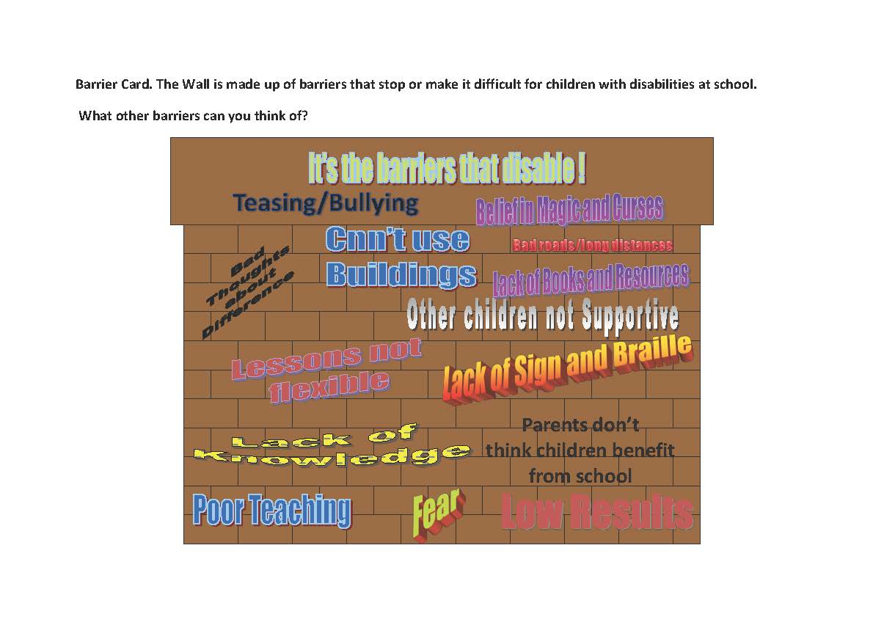

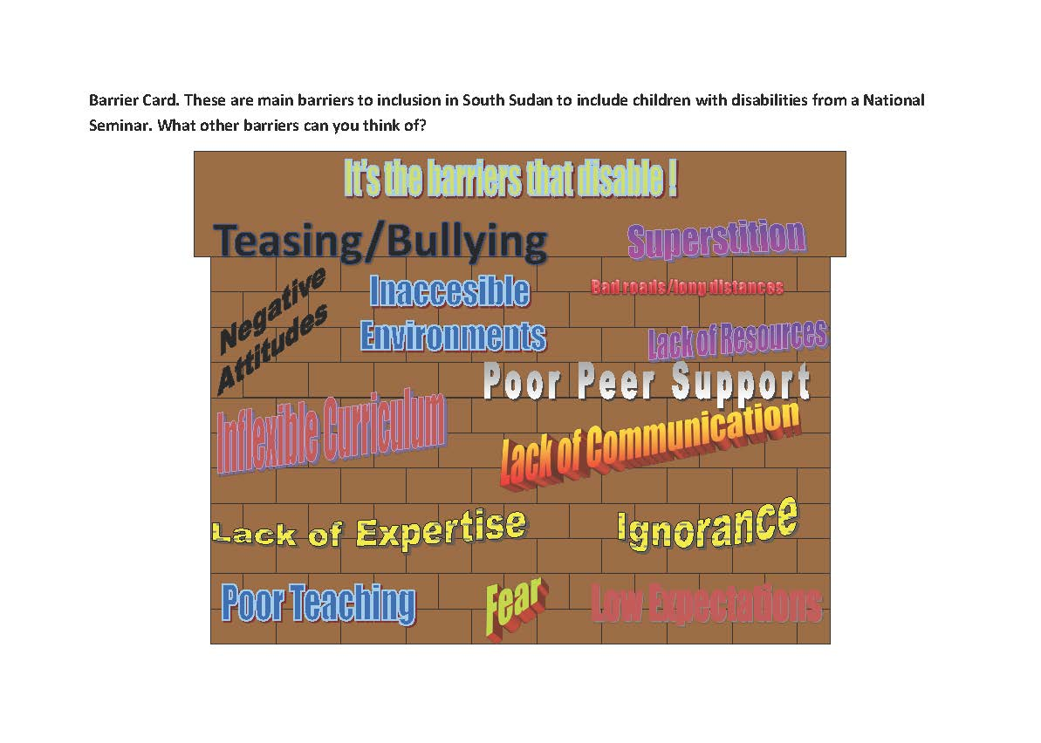

## ii. Power point presentation

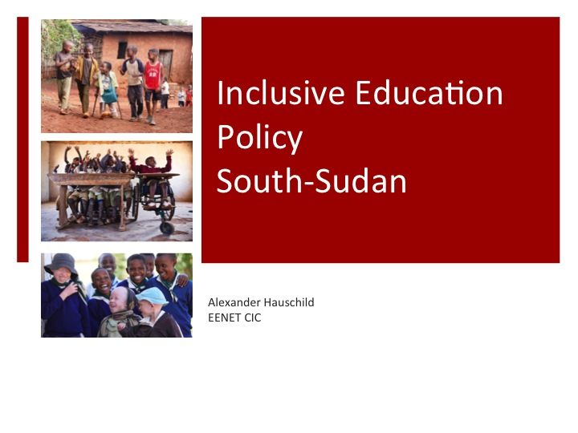

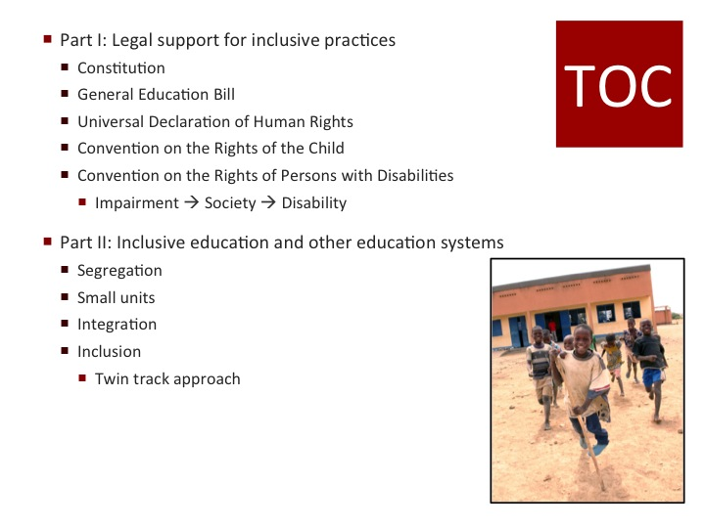

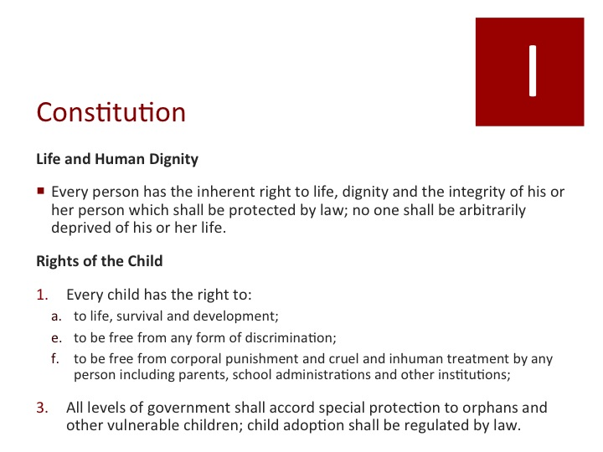

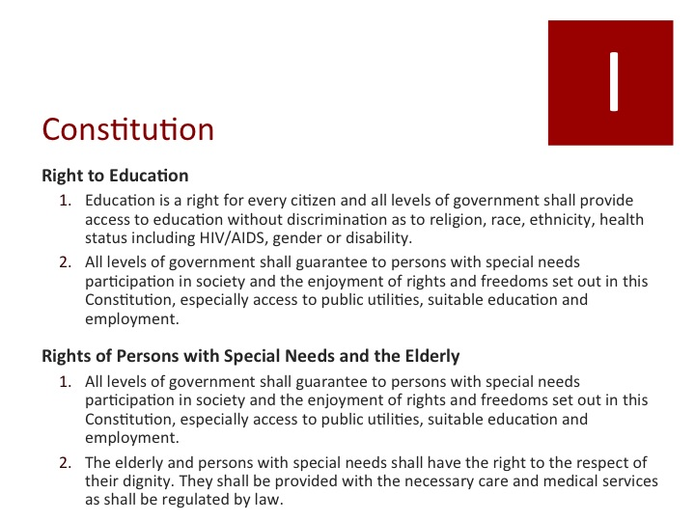

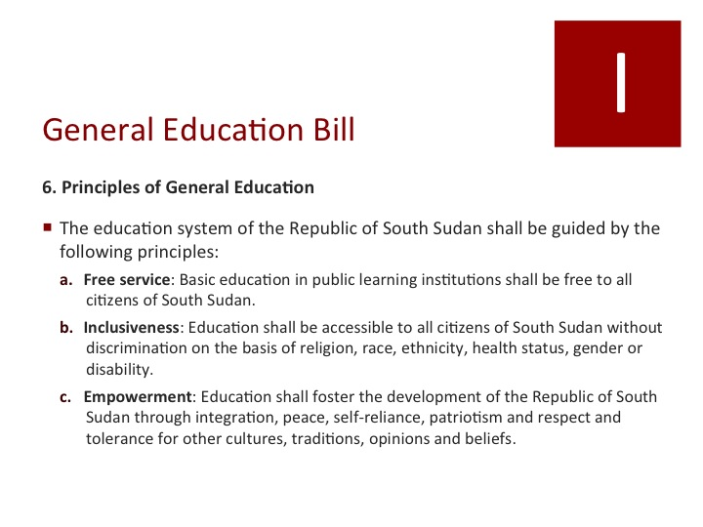

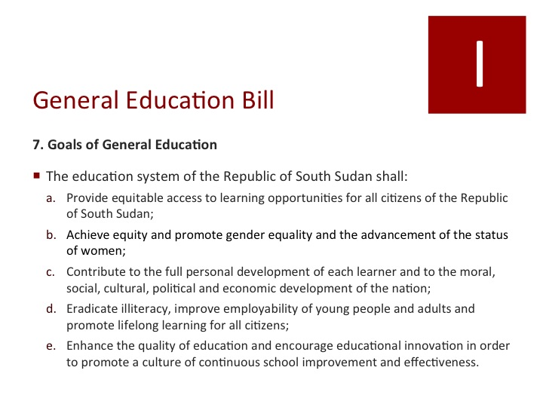

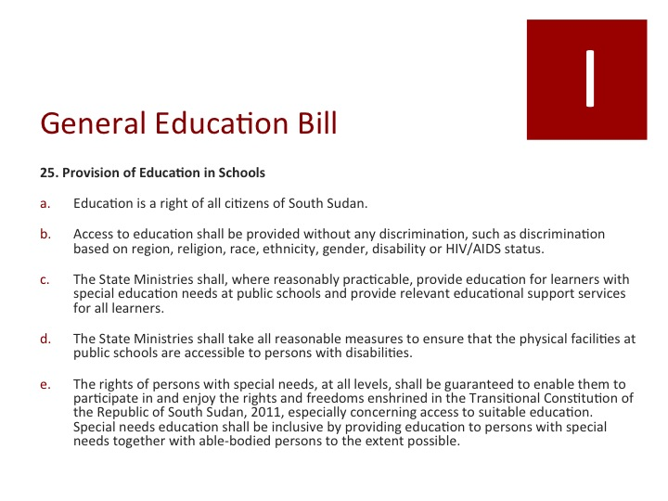

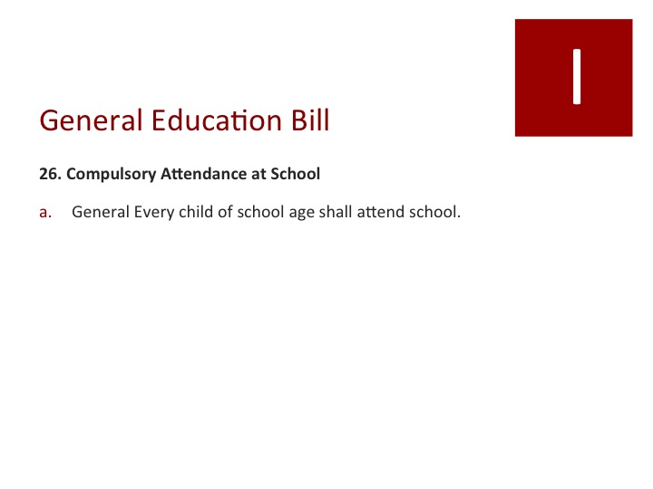

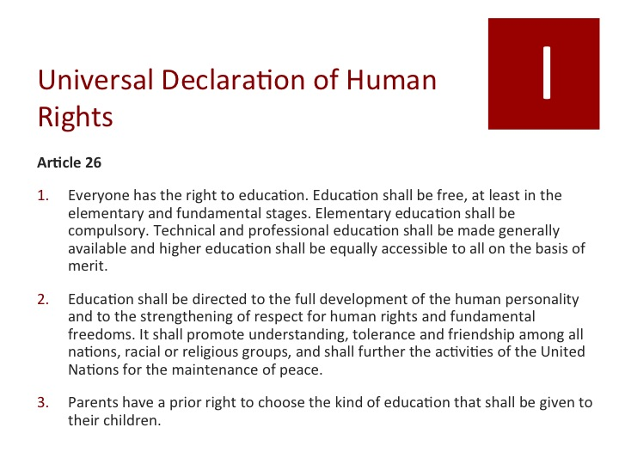

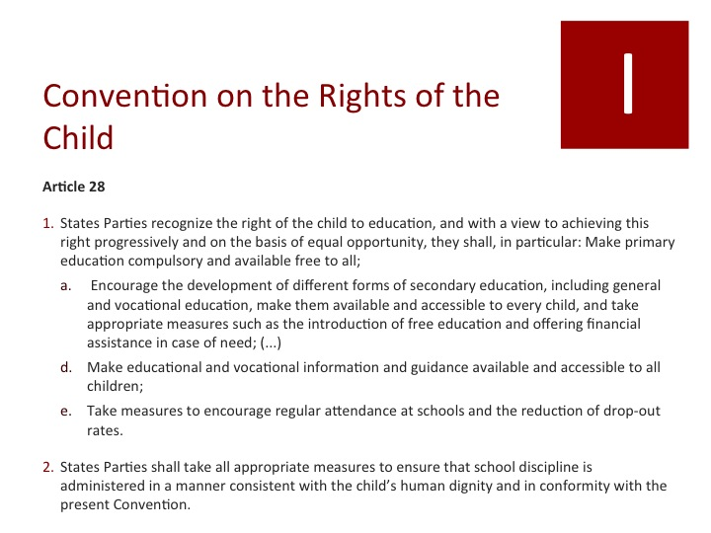

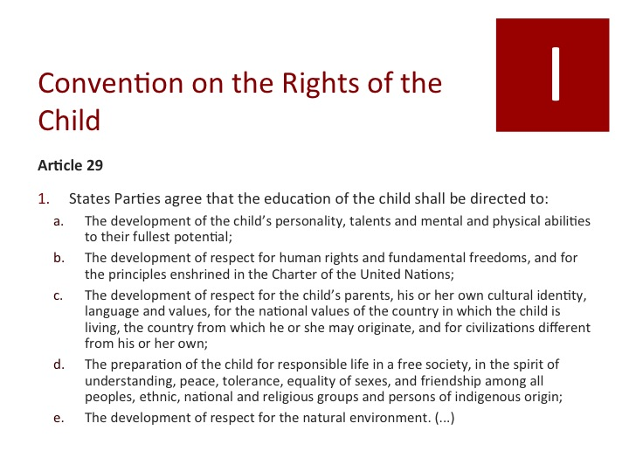

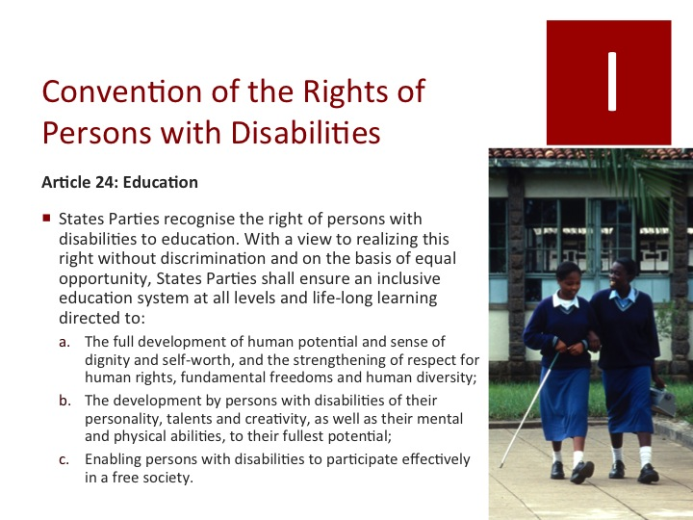

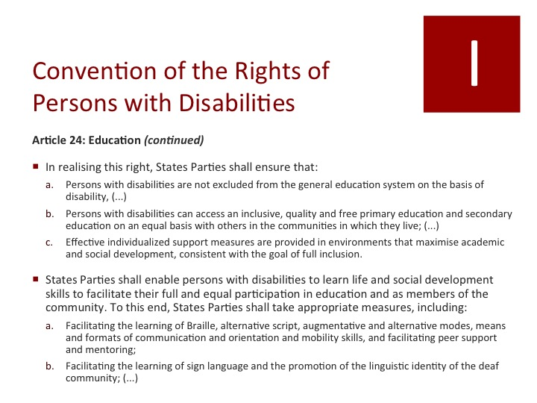

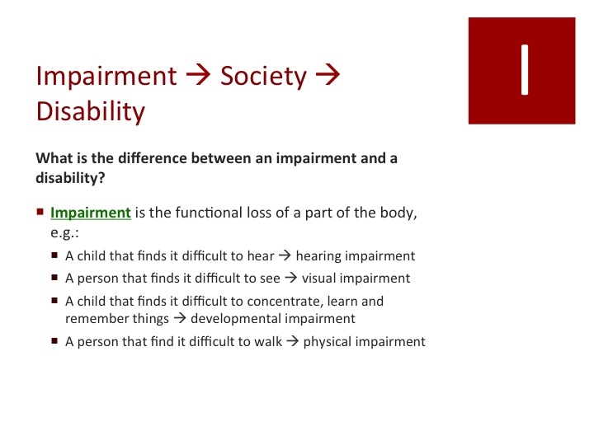

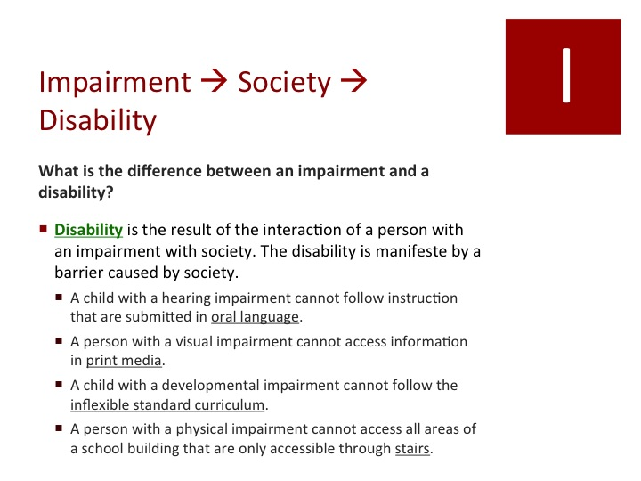

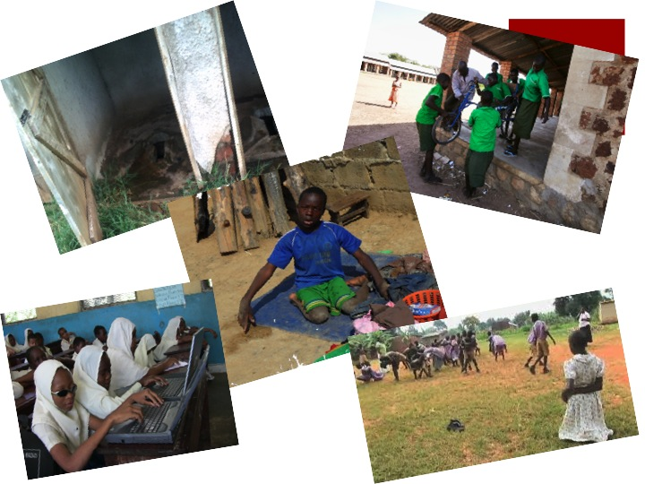

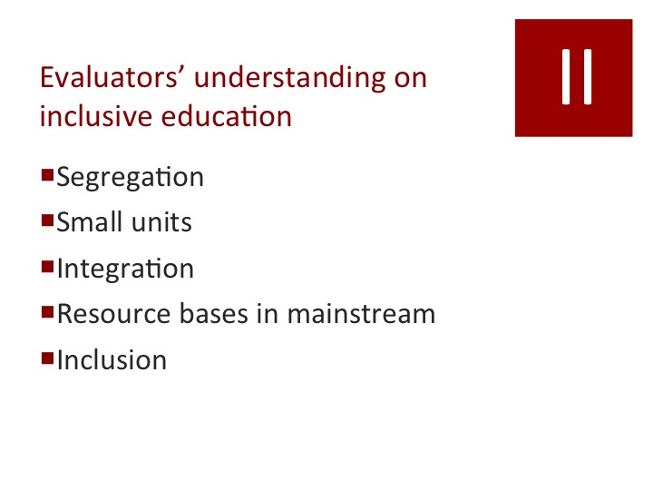

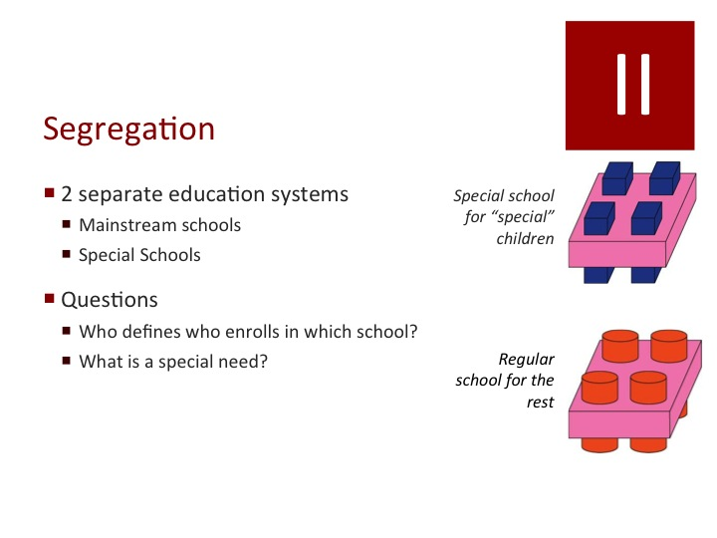

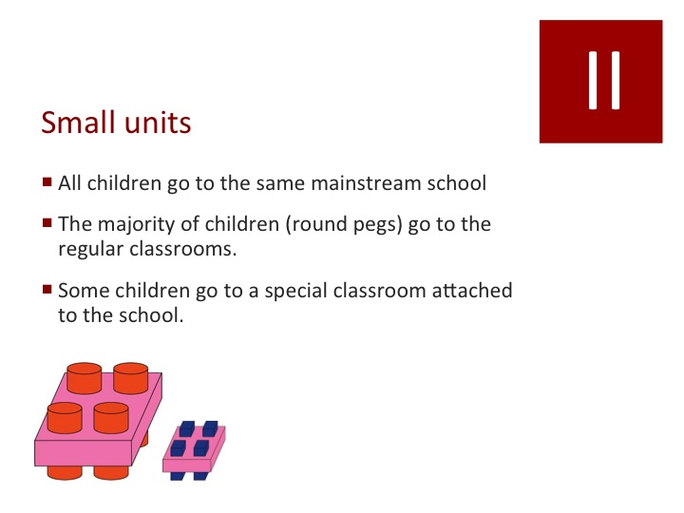

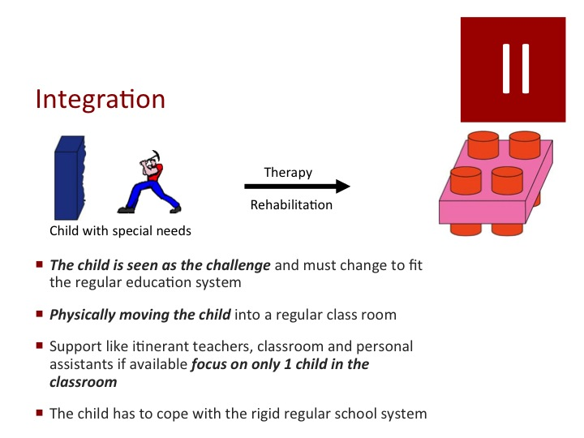

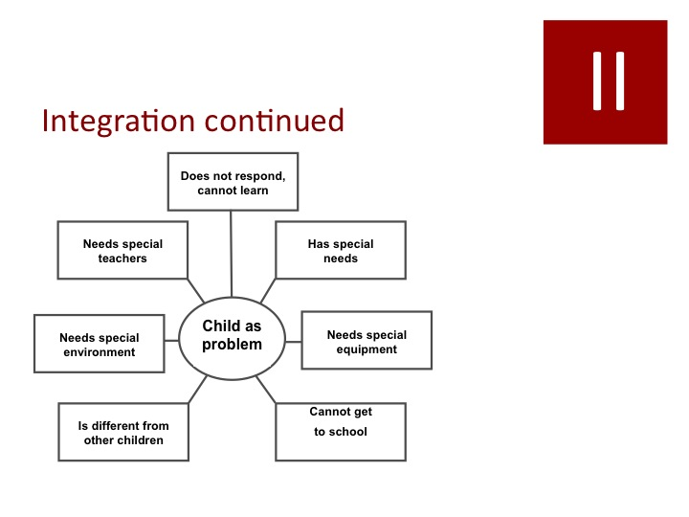

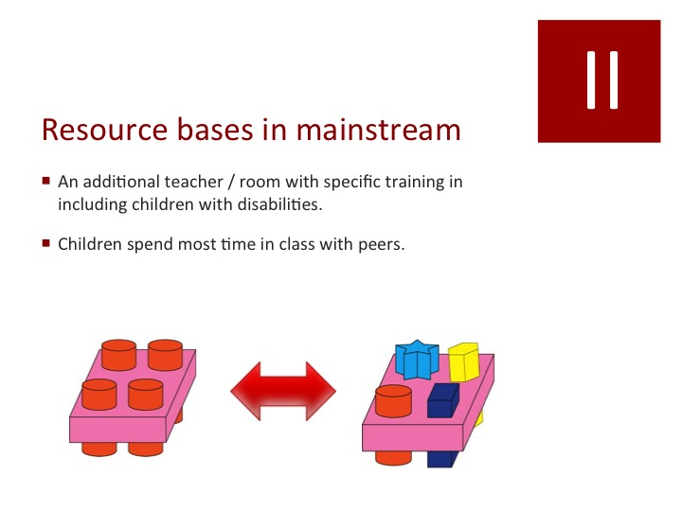

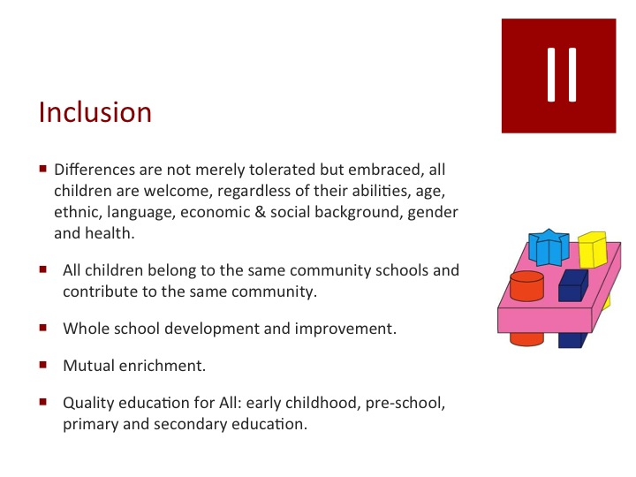

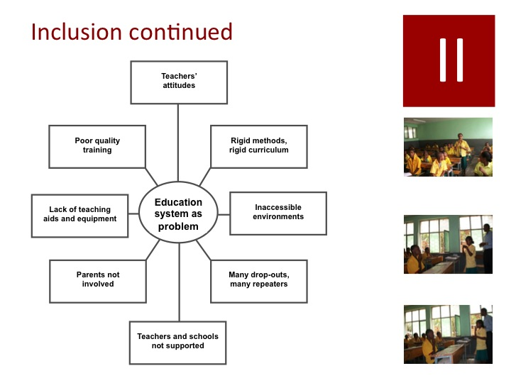

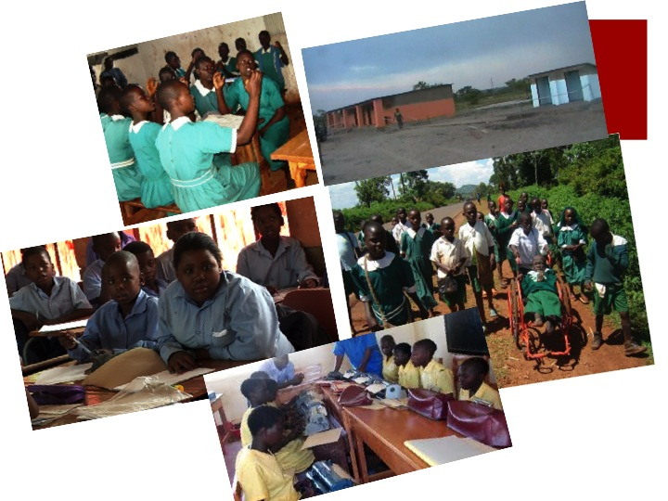

## iii. Graphic representations of the different ways education can be provided for children with disabilities and other marginalised groups

|  |  |  |  |  |  |  |  |  |  |  |  |  |  |  |  |
| --- | --- | --- | --- | --- | --- | --- | --- | --- | --- | --- | --- | --- | --- | --- | --- |
| To which school should children with disabilities go?  **Who are children with disabilities?**   * A child that finds it difficult to hear 🡪 hearing impairment * A person that finds it difficult to see 🡪 visual impairment * A child that finds it difficult to concentrate, learn and remember things 🡪 developmental impairment * A child who has fits—Epilepsy/Nodding Disease * A person that find it difficult to walk 🡪 physical impairment   **Segregated education system with mainstream schools and special schools**   |  |  | | --- | --- | | **inclusion-1**  **Special school for children with disabilities** | **inclusion-2**  **Mainstream school for the others** |   **Small units**   * All children go to the same mainstream school * The majority of children (round pegs) go to the regular classrooms. * Some children go to a special classroom attached to the school.   **inclusion-2inclusion-1**  **Integrated education**   * *The child is seen as the challenge* and must change to fit the regular education system * *Physically moving the child* into a regular class room * Support like itinerant teachers, classroom and personal assistants if available *focus on only 1 child in the classroom* * The child has to cope with the rigid regular school system  |  |  |  |  | | --- | --- | --- | --- | | **inclusion-3** | **worker** |  | **inclusion-2** | | **Child with special needs** | | **Therapy & rehabilitation** | **Mainstream**  **school** |   **Resourced School**   * An additional teacher/room with specific training in including children with disabilities. * Children spend most time in class with peers.  |  |  |  | | --- | --- | --- | | inclusion-2 |  | inclusion-4 |   **Inclusive education**   |  |  | | --- | --- | | * Differences are not merely tolerated but embraced, all children are welcome, regardless of their abilities, age, ethnic, language, economic & social background, gender and health. * All children belong to the same community schools and contribute to the same community. * Whole school development and improvement. * Mutual enrichment. * Quality education for All: early childhood, pre-school, primary and secondary education. | **inclusion-4** | |

To which school should children with disabilities go? [Facilitator explains the different parts of the diagram and then hold a discussion with group and get them to choose and record the reasons for their choice. If there are different views record these.]

○ Segregated education

○ Small units

○ Integrated education

○ Resourced school

○ Inclusive education

Reasons for Choice(s)

## iv. A series of photographs based on the experiences of children with disabilities in African schools to elucidate responses

|  |  |
| --- | --- |
| Picture Elicitation [Facilitator show pictures and draw out responses and record them.] |  |
| **Comments on picture 1:** | **1 TanZAnia-Alex_0066.jpg** |
| **Comment on picture 2:** | **74 Disabled Girl and Friens 2 Leseli.jpg** |
| **Comment on picture 3:** | **483951_10150903579032142_599443176_n.jpg** |
| **Comment on picture 4:** | **250511_10151066120732142_708997237_n.jpg** |
| **Comment on picture 5:** | **ConcentrationCBM.jpg** |

## v. Seven matched pairs of photographs focussing on the education of children with disabilities in an African school context for which respondents have to express a preference

Attitude on picture sets. [ Facilitator to mark which picture in each set is preferred by the group and say why?]

**Set A:**  picture 1  picture 2

Why?

**Set B:**  picture 1  picture 2

Why?

**Set C:**  picture 1  picture 2

Why?

**Set D:**  picture 1  picture 2

Why?

**Set E:**  picture 1  picture 2

Why?

**Set F:**  picture 1  picture 2

Why?

**Set G:**  picture 1  picture 2

Why?

|  |  |  |
| --- | --- | --- |
| **A1** | **A2** | |
| Macintosh HD:Users:Alex:Documents:Work:EENET:2014 LFTW South Sudan:2014-01 Nairobi follow-up:A ~ Group work.JPG | DRC 1026833-1291231.jpg | |
| **Classroom that promotes child centred learning through group work, peer support, cooperative learning.** | **Traditional classroom where the teacher gives the instructions, a one size fits all approach.** | |
| **B1** | | **B2** |
| C:\Users\Richard\Pictures\South Sudan Tools\Blind Class.jpg | | **kenya-braillers.jpg** |
| **Blind students taught together away from their non-disabled peers learning to use Perkins Brailler machine** | | **Blind students included with peers using Braille Machine.** |

|  |  |
| --- | --- |
| **C1** | **C2** |
| **11 girls  all learning signing Uganda.jpg** | **2013-06-Uganda-deaf-school-3.jpg** |
| **Whole class in mainstream learn sign language together Deaf members of the class.** | **Deaf children in a separate special school for the Deaf using sign** |

|  |  |
| --- | --- |
| **D1** | **D2** |
| **school-for-the-mentally-handicapped.jpeg** | **M-Masana-2.jpg** |
| **Students with cognitive impairments at a special school for these cognitive impairments** | **Student with cognitive impairments included in mainstream class with extra support.** |

|  |  |
| --- | --- |
| **E1** | **E2** |
| a8d0872d201a3f17406684fd9420ef1c-740x385-0.500x0.500.jpg | Zambia Aceesible School.jpg |
| **New Build School no ramps or adapted toilets** | **New build school ramped with adapted toilets** |

|  |  |
| --- | --- |
| **F1** | **F2** |
| **Picture3.jpg** | **child21.jpg** |
| **Provision of wheelchair and peer support get boy with disability to school** | **Boy with disabilities isolated and excluded from school** |

|  |  |
| --- | --- |
| **G1** | **G2** |
| **images (1).jpg** | **stills-2.jpg** |
| **Girl with disabilities left out of PE because peers and teacher not include her** | **Girl with disabilities supported by peers at lunchtime** |

## vi. School self-assessment tool

**School Policies and Administrative Support**

Your school:

\_\_\_\_\_ has a mission and/or vision statement and policies about inclusive, learning-friendly education, including a policy against discrimination;

\_\_\_\_\_ has a master list of all school-age children in the community, whether enrolled or not;

\_\_\_\_\_ conducts regular campaigns to encourage parents to enrol their children, ones that emphasize that ALL children should be enrolled and are welcome;

\_\_\_\_\_ has copies of documents or resources at national or regional levels that address inclusive education for children with diverse backgrounds and abilities;

\_\_\_\_\_ knows which professional organizations, advocacy groups, and community organizations offer resources for inclusive education;

\_\_\_\_\_ shows in specific ways that school administrators and teachers understand the nature and importance of inclusive education;

\_\_\_\_\_ has prepared a list of barriers that prevent the school from fully developing an ILFE and a list of ways to overcome these barriers;

\_\_\_\_\_ is aware of and is changing school policies and practices—such as costs and daily schedules—that prevent some girls and boys from receiving a quality education;

\_\_\_\_\_ provides flexibility to teachers to pursue innovative teaching methods for helping all children to learn;

\_\_\_\_\_ has links with the community, is responsive to the needs of the community, and provides opportunities for exchanging ideas with the community to bring about positive changes in inclusive practices;

\_\_\_\_\_ responds to needs of the staff and is not exploitative;

\_\_\_\_\_ has effective support, supervision, and monitoring mechanisms in which everyone participates in learning about and documenting changes in inclusive practices, as well as in making future decisions.

**School Environment**

Your school:

\_\_\_\_\_ has facilities that meet the needs of all students, such as separate toilets for girls and ramps (not stairs) for physically disabled students;

\_\_\_\_\_ has a welcoming, healthy, and clean environment;

\_\_\_\_\_ has a steady supply of clean, safe drinking water and serves or sells healthy, nutritious food;

\_\_\_\_\_ has (or has a plan to develop) a diverse school staff (women and men with different backgrounds in race, ethnicity, physical ability, religion, language, socioeconomic status, etc.);

\_\_\_\_\_ has staff, such as counsellors and bilingual teachers, who can identify and help with the students’ special learning needs;

\_\_\_\_\_ has processes and procedures in place that help all teachers and teaching staff, parents and children to work together to identify and assist with students’ special learning needs;

\_\_\_\_\_ focuses on teamwork among teachers and students;

\_\_\_\_\_ has links with existing health authorities who provide periodic health examinations for children. Teachers’ Skills, Knowledge, and Attitudes of Teachers. . .

\_\_\_\_\_ can explain the meaning of “inclusive” and “learning-friendly” education and can give examples of ILFEs;

\_\_\_\_\_ believe that all children—girls, poor or wealthy children, language and ethnic minority children, as well as disabled children—can learn;

\_\_\_\_\_ are involved in finding school-age children who are not in school to see that they get an education;

\_\_\_\_\_ know about diseases that cause physical, emotional, and learning disabilities; and can help unhealthy students to get proper care;

\_\_\_\_\_ receive annual medical examinations, along with other school staff;

\_\_\_\_\_ have high expectations for ALL children and encourage them to complete school;

\_\_\_\_\_ are aware of resources that are available to assist children with special learning needs;

\_\_\_\_\_ can identify culture and gender bias in teaching materials, the school environment, and in their own teaching, and can correct this bias;

\_\_\_\_\_ help students learn to identify and correct gender and culture bias in learning materials;

\_\_\_\_\_ adapt curriculum, lessons, and school activities to the needs of children with diverse backgrounds and abilities;

\_\_\_\_\_ use content, language, and strategies in their teaching that help all students to learn;

\_\_\_\_\_ can assess children’s learning in ways that are appropriate to the children’s abilities and needs;

\_\_\_\_\_ are reflective and open to learning, adapting, experimenting, and changing;

\_\_\_\_\_ are able to work as a team. Teacher Development. . .

\_\_\_\_\_ attend workshops or classes on developing an ILFE classroom and school, receiving advanced professional training on a regular basis;

\_\_\_\_\_ give presentations to other teachers, parents, and community members on developing an ILFE classroom;

\_\_\_\_\_ receive ongoing support for improving their understanding of subject matter content (such as mathematics);

\_\_\_\_\_ receive ongoing support for developing teaching and learning materials ;

\_\_\_\_\_ receive ongoing support from school administrators through regular observation and a written supervisory plan;

\_\_\_\_\_ have a work area or lounge where they can prepare lesson materials and share ideas;

\_\_\_\_\_ can visit “model” inclusive schools.

Students

\_\_\_\_\_ ALL school-age children in the community attend school regularly.

\_\_\_\_\_ ALL students have textbooks and learning materials that match their learning needs.

\_\_\_\_\_ ALL students receive regular assessment information to help them monitor their progress.

\_\_\_\_\_ Children with diverse backgrounds and abilities have equal opportunities to l earn and to express themselves in the classroom and at school.

\_\_\_\_\_ ALL children are followed up if their attendance is irregular.

\_\_\_\_\_ ALL children have equal opportunities to participate in all school activities.

\_\_\_\_\_ ALL students help to develop guidelines and rules in the classroom and in the school regarding inclusion, non-discrimination, violence, and abuse.

Academic Content and Assessment

\_\_\_\_\_ The curriculum allows for different teaching methods and learning styles, such as discussion or role-play.

\_\_\_\_\_ The content of the curriculum relates to the everyday experiences of ALL children in the school whatever their background or ability.

\_\_\_\_\_ The curriculum integrates literacy, numeracy and life skills into all subject areas.

\_\_\_\_\_ Teachers use locally available resources to help children learn.

\_\_\_\_\_ Curriculum materials include pictures, examples and information about many different kinds of people, including girls and women, ethnic minorities, people of different castes and social/economic backgrounds, as well as people with disabilities.

\_\_\_\_\_ The curriculum is adapted for different learning rates and styles, particularly for children with learning disabilities.

\_\_\_\_\_ Children with learning difficulties have opportunities to review lessons and improve upon them, or to have additional tutoring.

\_\_\_\_\_ Curriculum and learning materials are in the languages children use in and out of school.

\_\_\_\_\_ The curriculum promotes attitudes such as respect, tolerance and knowledge about one’s own and others’ cultural backgrounds..

\_\_\_\_\_ Teachers have various assessment tools to measure students’ knowledge, skills and attitudes, rather than only depending upon examination scores.

Special Subject Areas/Extra-curricular Activities

\_\_\_\_\_ Children with physical disabilities have opportunities for physical play and development.

\_\_\_\_\_ Girls have the same access to and opportunities for physical play (such as equal time on the football field) and other extracurricular activities as boys.

\_\_\_\_\_ All children have opportunities to read, write and learn in their own language.

\_\_\_\_\_ The school shows respect for children of all religions; children have opportunities to learn about different religious traditions, as appropriate, during the school day.

**Community**

\_\_\_\_\_ Parents and community groups know about inclusion and are able to help the school become an inclusive school.

\_\_\_\_\_ The community helps the school reach out to ALL children who have been excluded from school.

\_\_\_\_\_ Parents and community groups offer ideas and resources about the implementation of inclusive education.

\_\_\_\_\_ Parents receive information from the school about their children’s attendance and achievement.

## vii. Guidance for facilitators to make an assessment of the situation in the schools they visit

**The Facilitators after interviewing the headteacher were asked to tour the school and record what they saw in one class on the school observation sheets below.**

**School observation checklist.**

School: Class:

Classroom/lesson

|  |  |  |
| --- | --- | --- |
| **Look at:** | **I saw…** | **I thought…** |
| ***Decoration and resources:***   * Walls decorated? * What sort of materials on walls? * Made by teachers, by pupils, etc? * Other materials in room? * Static or interactive materials? * Themes of the materials? |  |  |
| ***Layout and environment:***   * Desks in rows/groups? * Flexible, easy to change layout? * Areas in room for different activities? * Any adapted seating arrangements? * Space per pupil? * Lighting and heating? * Accessibility? |  |  |
| ***Teaching:***   * Teaching methods used? * Differentiation of lesson/methods for different learners? * Enthusiasm and energy? * Empathy with / listening to pupils? * Teacher’s awareness of pupils’ needs? * Use of teaching and learning materials? * Range of methods/pace during the lesson? * Gender of teacher? * Gender-equal teaching? * Use of classroom assistants? * Discipline methods? |  |  |
| ***Pupils:***   * Engagement with lesson? * Interaction with other pupils? * Use of learning materials? * Behaviour? * Approach/attitude towards teacher? * Gender balance in class? * Gender-equal interactions? * Self-presentation? * Freedom of expression? |  |  |

**Playgrounds / playtime / lunch break**

|  |  |  |
| --- | --- | --- |
| **Look at:** | **I saw…** | **I thought…** |
| ***Environment:***   * Space and layout? * Surface material? * Accessibility? * Equipment? * Safety? * Eating areas? |  |  |
| ***Pupils:***   * Games played? * Interactions with each other? * Peer support? * Interactions with staff? * Gender relations? |  |  |
| ***Staff:***   * Who is present? * Gender balance? * What role are they taking? * Interactions with pupils or other staff? |  |  |
| ***Processes:***   * Rules and regulations? * By whom and how implemented? * Methods for ending lessons/ breaks? * Supporting learners needs outside classroom (eating, toilet etc)? |  |  |